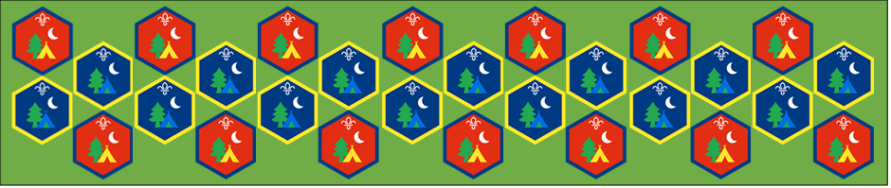
Beaver and Cub
Summer Camp
17th – 30th August 2020
Communication
Session 9
[Document title]
[Document subtitle]

Communication : Activity Sheets
Communication is key to working together and important skill on camp, use the tasks to help you develop your skills
Morse code bracelet: Suitable for: Everyone
Takes: 1hour | Led by: Video and Activity Sheet
https://www.youtube.com/watch?v=ORIDAmGf_yQ
There are lots of communication methods across the world and they are used for many different reasons. Morse code has been used since the 1830’s. It has been used to pass messages to another place or person in a way that not everyone understands. Use the Morse code sheet to work out how to spell your name out, then using straws make a bracelet that shows your name and what you have learnt.
Tracking and treasure hunting: Suitable for: Everyone
Takes: 1hour | Led by: Video and Activity Sheet
https://www.scouts.org.uk/activities/find-me-follow-you/
https://www.youtube.com/watch?v=IYa476qoq0g
When might people use a track to send a message to someone else? People may think about alerting someone to a hazard up ahead, or letting someone know where the camp or base is. When might laying a track be more useful than having a mobile phone? People may think about when you don’t have a signal, if you want to tell people you don’t know – or just that laying a track is fun!
Hack Attack: Suitable for: Cubs
Takes: 1hour | Led by: Activity Sheet
https://www.scouts.org.uk/activities/hack-attack/
When might using a code to communicate be helpful? What did you need to crack the code? Could you crack the code with just the decoder, or do you need a clue?
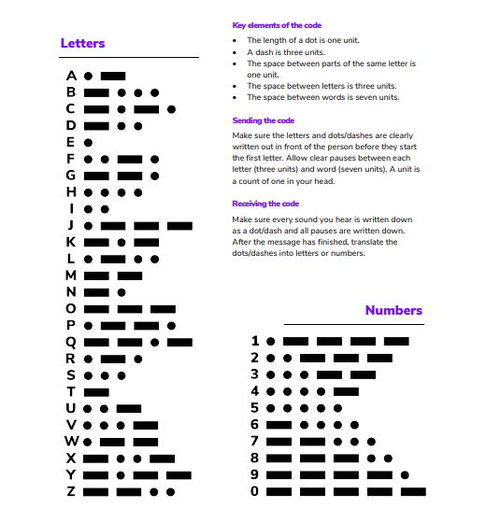
Morse Code

- Use a blue colour straw to make all the dashes, a red one to make the dots and a green one to indicate gaps in the letters.
- Thread them onto some string to spell out your name

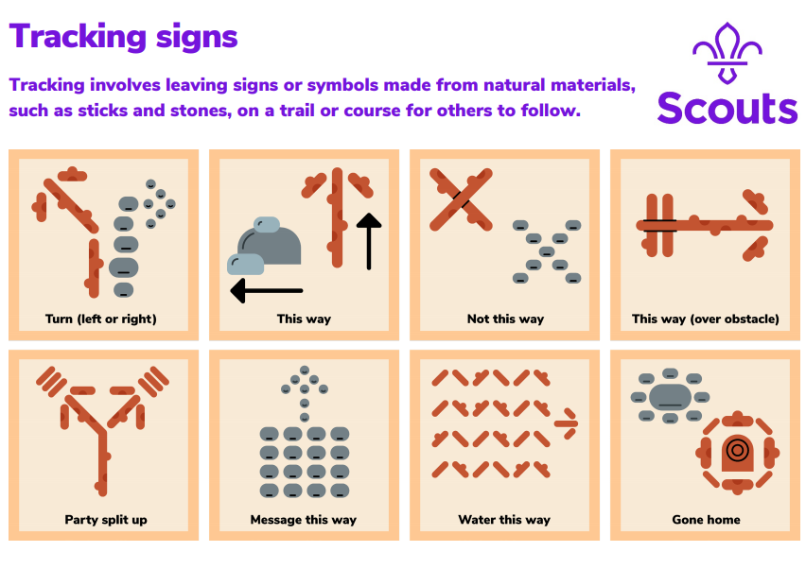

Remember A=A, which may help you if you get stuck
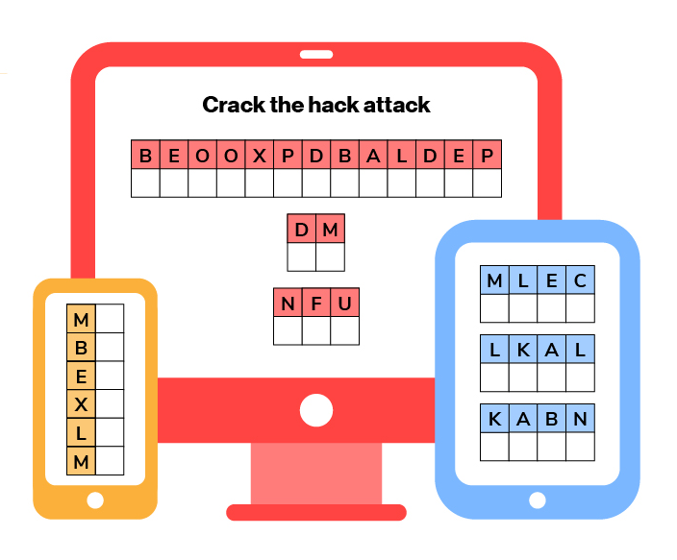

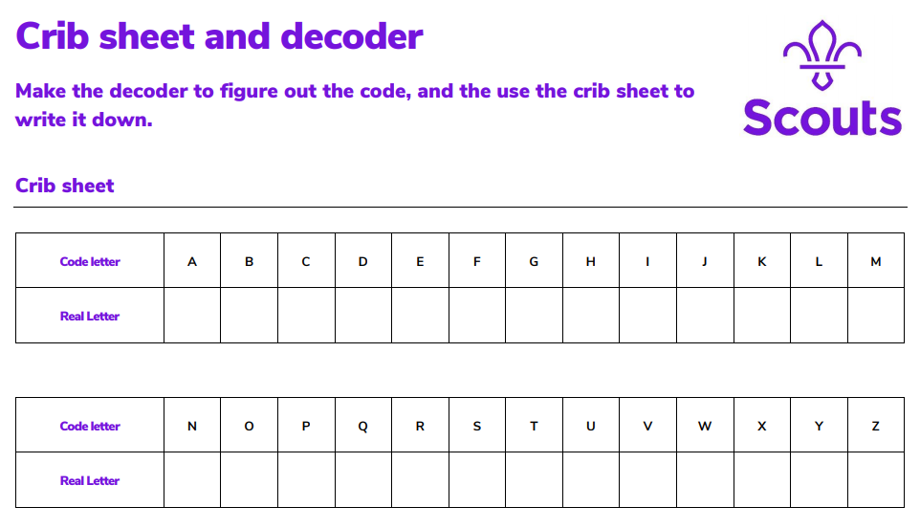

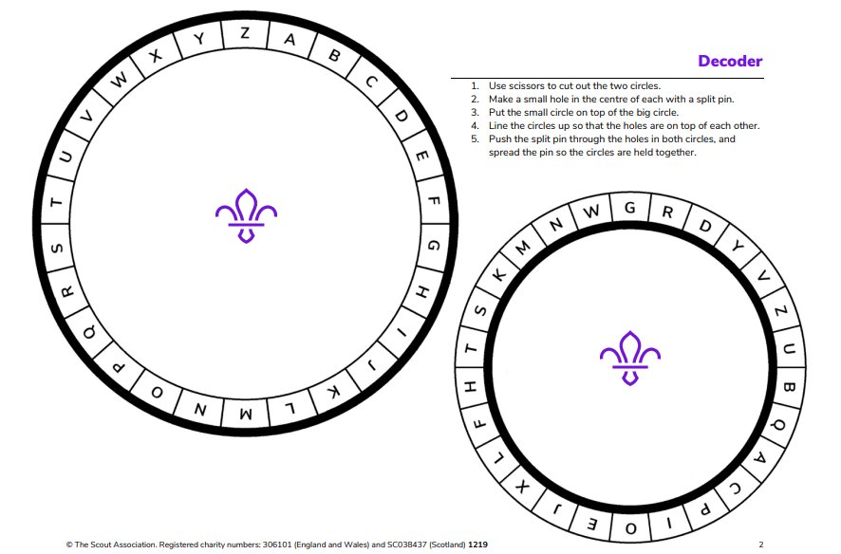

Answer Sheet
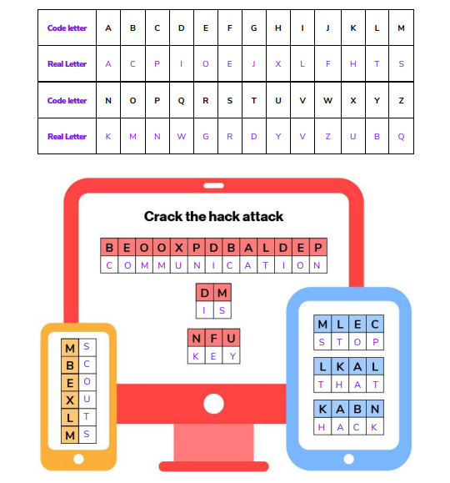

We hope you will all have fun joining in with the activities and sharing in an Event that groups from all over the District will be taking part in.
