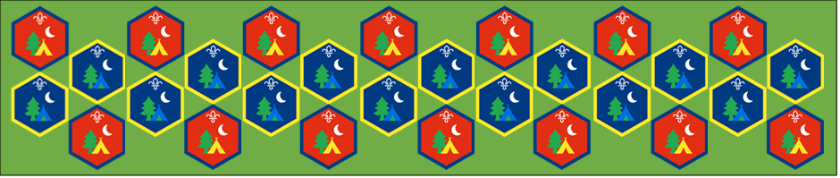
Beaver and Cub
Summer Camp
17th – 30th August 2020
Exploring Nature
Session 8
[Document title]
[Document subtitle]

Exploring Nature : Activity Sheets
Exploring nature is a great way to find out about the area we live or places that we visit during the holidays. Go for a hike or pond dipping and see what you can find in the places you visit.
Nature Hike: Suitable for: Everyone
Takes: 1-3 hours | Led by: Activity Sheet
Get outside and explore, find out about all the different plants and insects that can be found in the area around you
Pond dipping: Suitable for: Everyone
Takes: 1hour | Led by: Activity Sheet
Find a pond or river near your home and see what you can find living there, make a net to help you discover what lives in the pond and use the guide to identify what they are called.
Wildflowers Bingo: Suitable for: Everyone
Takes: 1hour | Led by: Activity Sheet
On your walk see if you can find any wildflowers that match the pictures given. Gain one point for everyone you find and get a bonus point if you can identify what it’s called.

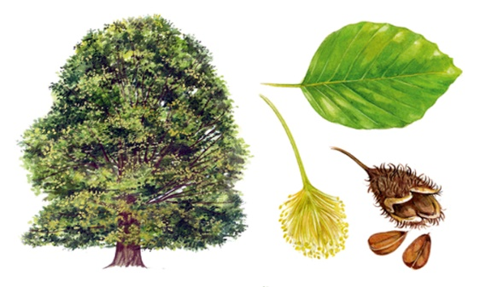
Along the walk look out for some of the common British trees
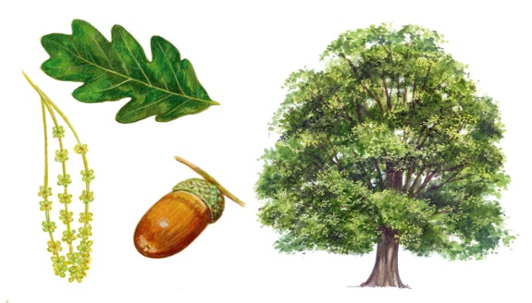
Common Oak |  |  | Common Beach
How many have you seen |  |  | How many have you seen

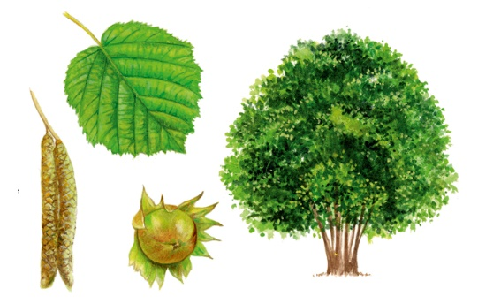
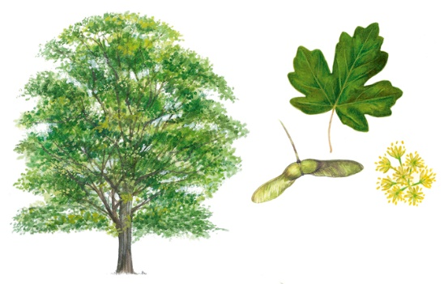
Field Maple |  |  | Common Hazel
How many have you seen |  |  | How many have you seen

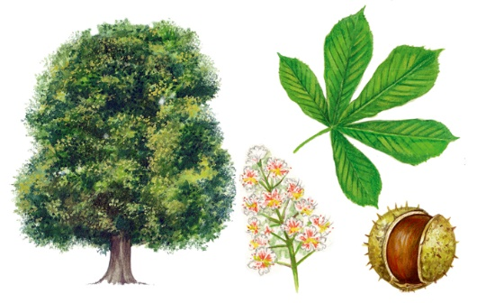
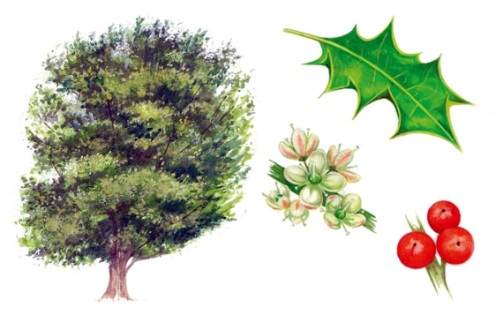
Holly |  |  | Horse Chestnut
How many have you seen |  |  | How many have you seen
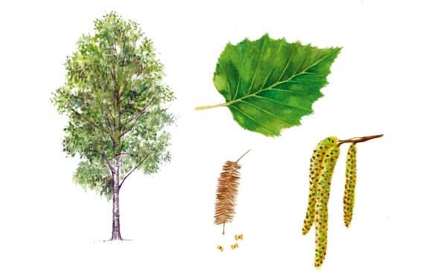
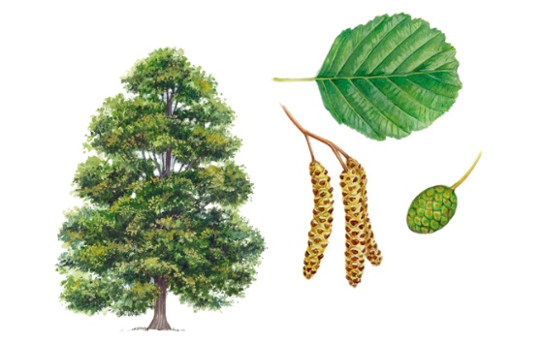
Common alder |  |  | Silver Birch
How many have you seen |  |  | How many have you seen

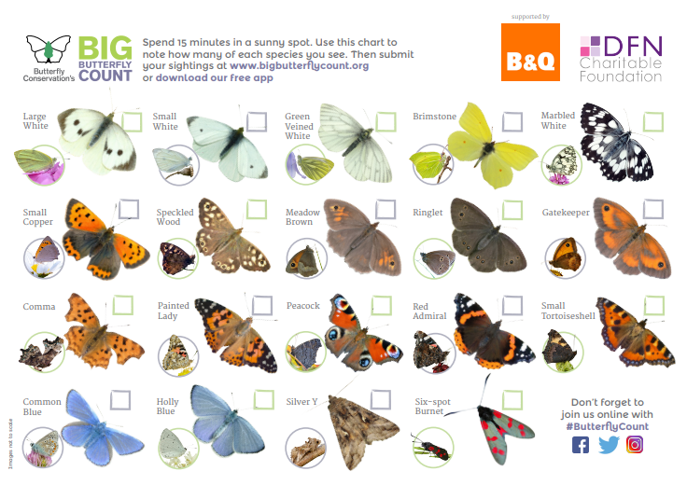

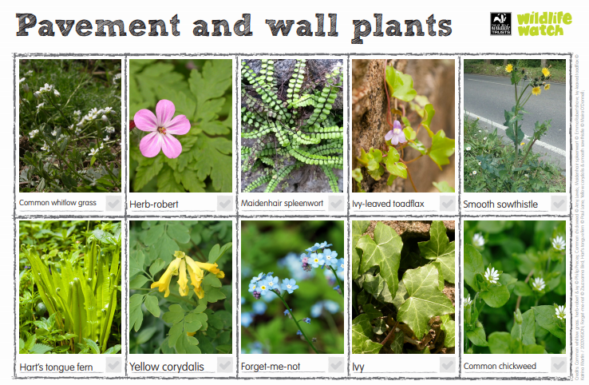

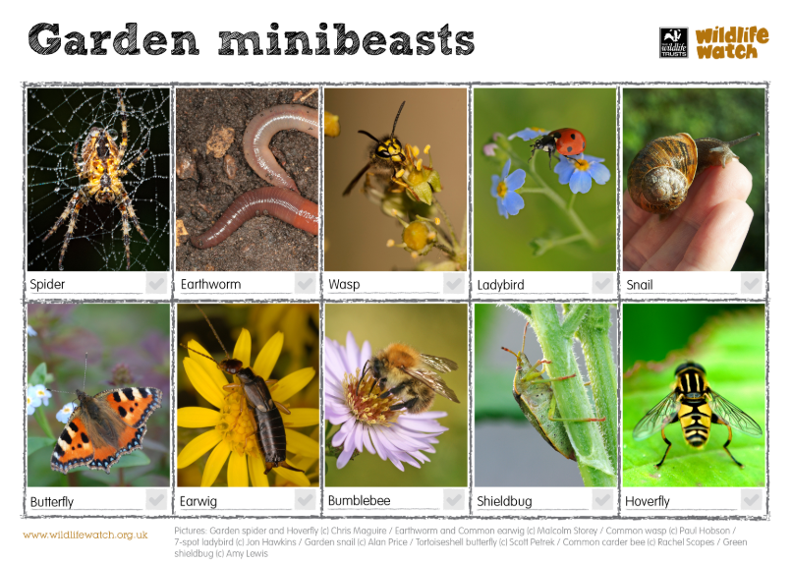

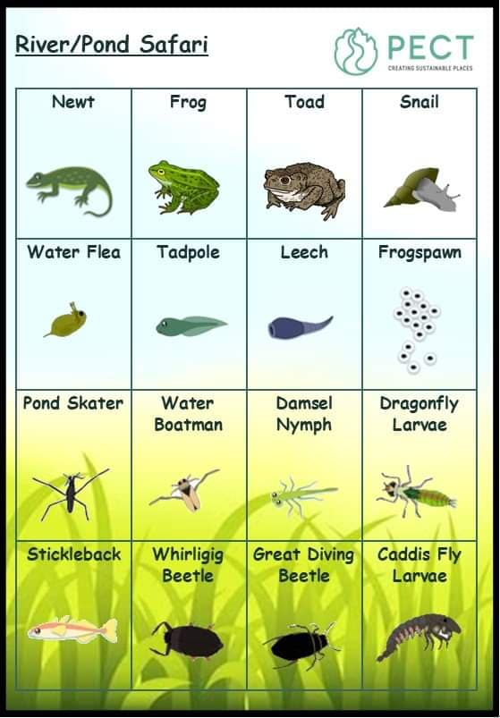

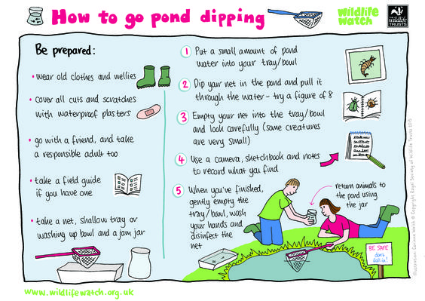

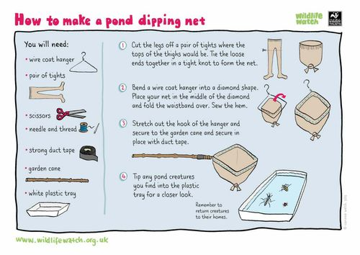
Wildflowers Bingo
On your walk see if you can find any wildflowers that match the pictures given. Gain one point for everyone you find and get a bonus point if you can identify what it’s called.
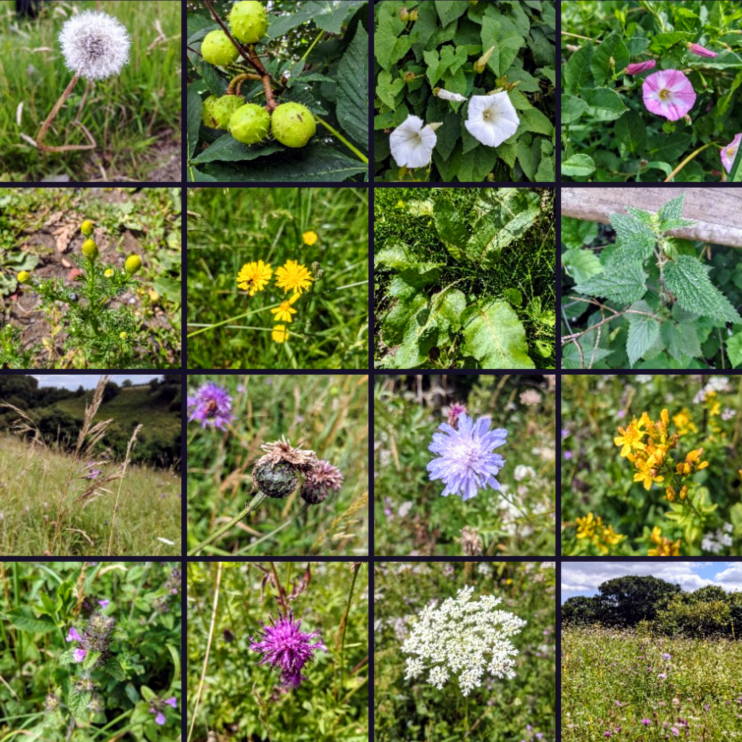

We hope you will all have fun joining in with the activities and sharing in an Event that groups from all over the District will be taking part in.
