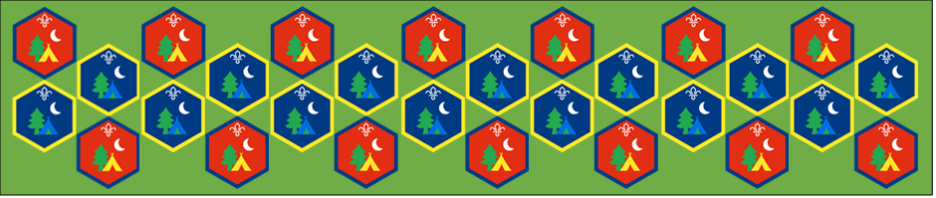
bBui
Beaver and Cub
Summer Camp
17th – 30th August 2020
Stem Challenges
Session 7
[Document title]
[Document subtitle]

Stem Challenge : Activity Sheets
The idea behinds these challenges are to design and build something that helps us connect with nature in the garden.
Build something wind powered | Suitable for: Everyone
Takes: 30 minutes | Led by: Video
https://www.youtube.com/watch?v=lyvWd-TqqLI
https://www.youtube.com/watch?v=qiQ3Zbm1Z2c
https://www.youtube.com/watch?v=eAP3EambmDA
What can you make that is wind powered? Use the videos to give you some ideas of what you could make or come up with something new.

Build a nest or a bird house | Suitable for: Everyone
Takes: 30 minutes | Led by: Video and Activity Sheet
https://www.youtube.com/watch?v=7toh3Zck7gk
https://www.youtube.com/watch?v=c1_uZq5vtcQ
Can you build a nest or a bird house for your garden? Use the videos to help you work out what different materials you could use to build a nest and bird house.
Build a wheelbarrow and shovel | Suitable for: Everyone
Takes: 30 minutes | Led by: Activity Sheet suggested equipment
Try to build using the materials suggested a wheelbarrow and shovel to move something around your garden.
Build a shelter to keep out the rain | Suitable for: Everyone
Takes: 30 minutes | Led by: Activity Sheet suggested equipment
https://www.youtube.com/watch?v=NQH8cCEt6C8
Can you build a shelter to keep out the rain? Or maybe to protect your campfire.

We hope you will all have fun joining in with the activities and sharing in an Event that groups from all over the District will be taking part in.

