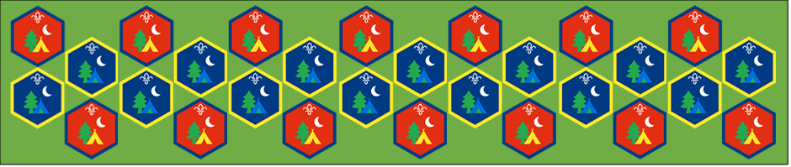
Beaver and Cub
Summer Camp
17th – 30th August 2020
Healthy Living
Session 6
[Document title]
[Document subtitle]

Healthy Living : Activity Sheets
Being Healthy important, in this section we will be looking at how to be healthy and why its important. We can think about healthy choices when it comes to food and the reasons why those have am impact.
What is Healthy Living | Suitable for: Everyone
Takes: 30 minutes | Led by: Video and Activity Sheet
https://www.bbc.co.uk/bitesize/topics/zv4cwmn/resources/1
Find out why its important to eat different types of food in order to have a varied and Healthy Diet.
Food-duko | Suitable for: Cubs
Takes: 40 minutes | Led by: Activity Booklet
https://www.scouts.org.uk/activities/food-doku/
The right foods add up to a healthy diet. Solve the food sudoku puzzles and see who knows their onions (and lettuce)! Work out what foods are Healthy with this puzzle.
Healthy eating Lunch | Suitable for: Beavers
Takes: 30 minutes | Led by: Activity Sheet
Plan for a heathy lunch, what things should you have in your lunch and what things should you limit? Think about what you like to eat and use the images provided and some you have found in magazines and newspapers to make your perfect packed lunch as healthy as possible.
Safety in the Kitchen | Suitable for: Everyone
Takes: 30 minutes | Led by: Activity Sheets
Circle all the dangers that you can see in the family kitchen, what would you do to make it safe?

How does soap work | Suitable for: Everyone
Takes: 30 minutes | Led by: Video and Activity Sheets
https://www.youtube.com/watch?v=TXZ1d70YZJ8
Use the soap pepper experiment to show what happens when bacteria and dirt encounters soap, how does that help us be healthy in the kitchen?
Healthy Teeth | Suitable for: Everyone
Takes: 30 minutes | Led by: Video and Activity Sheets
https://www.youtube.com/watch?v=3Qvo1nIkQnM
Being healthy means looking after our bodies, lets find out why are teeth are so important and why we need to look after them.

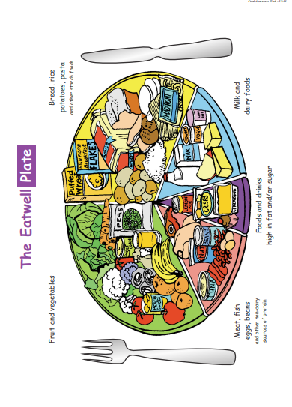

The eatwell plate
Formally the Balance of Good Health, the eatwell plate has been recently updated by the Food Standards Agency. This is the British model of a healthy diet. Other models exist e.g. the Food Pyramid, which is used in America and Ireland. Health Professionals in the NHS prefer the eatwell plate as it does not give undue emphasis to fatty and sugary foods.
Variety and a change towards more vegetables, fruit, bread, breakfast cereals, potatoes, rice and pasta are what matters. Snacks as well as meals count towards a healthy balance. The eatwell plate is a pictorial representation of the recommended balance of foods in a healthy diet. It shows that people don’t have to give up the foods they enjoy for the sake of their health – just eat some in smaller quantities or less frequently
The eatwell plate applies to most people, including vegetarians, people of all ethnic origins and people who are a healthy weight for their height as well as those who are overweight. However, it does not apply to children under two years, as they need full fat milk and dairy products. Between the ages of two and five, children should make a gradual transition to family foods, and the recommended balance shown in the eatwell plate can begin to apply.

Food-doku puzzles and templates
Solve these food Sudoku puzzles to learn which foods add up to a healthy diet. Then get crafty and create some of your own!
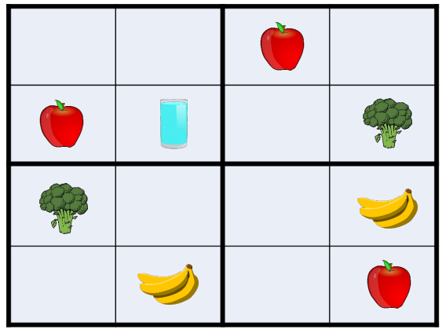

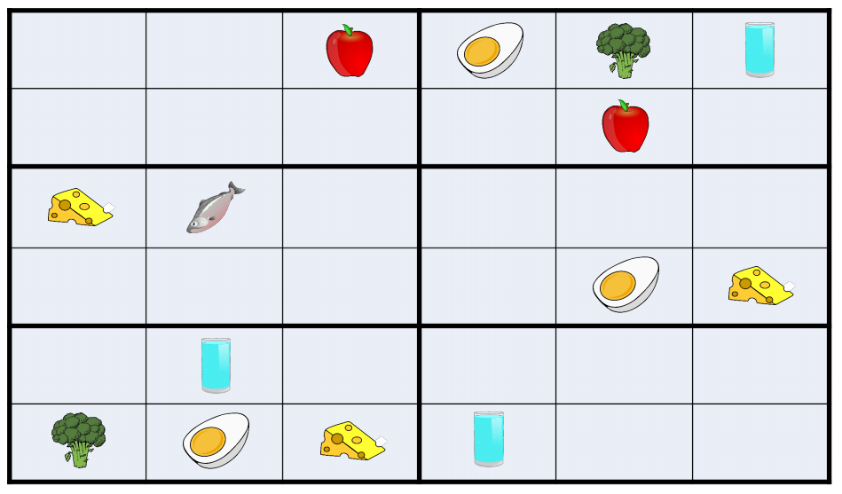
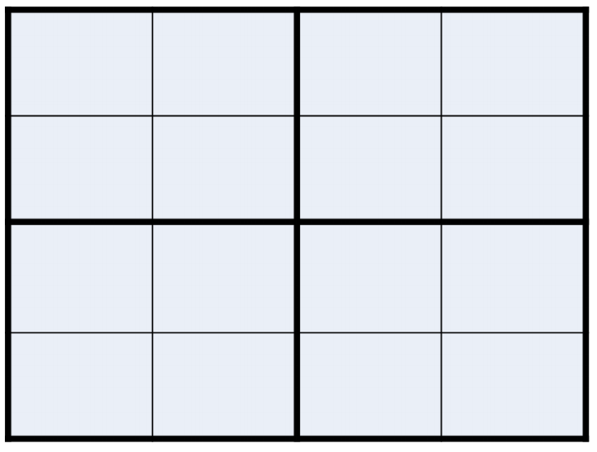

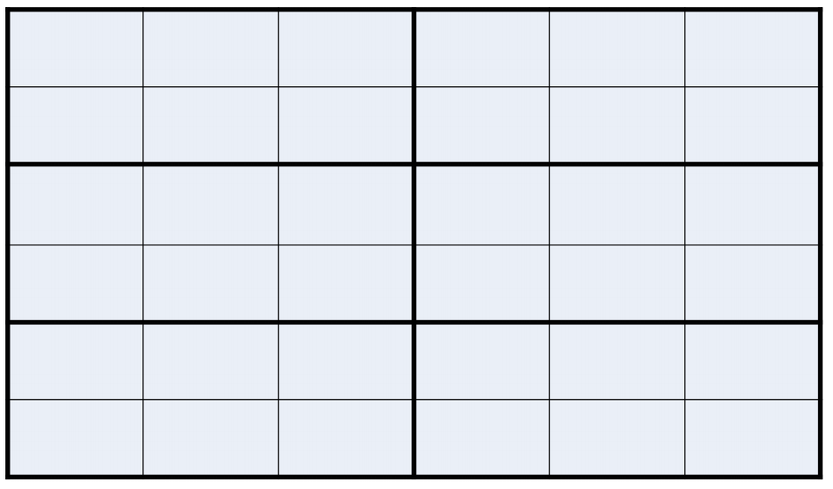

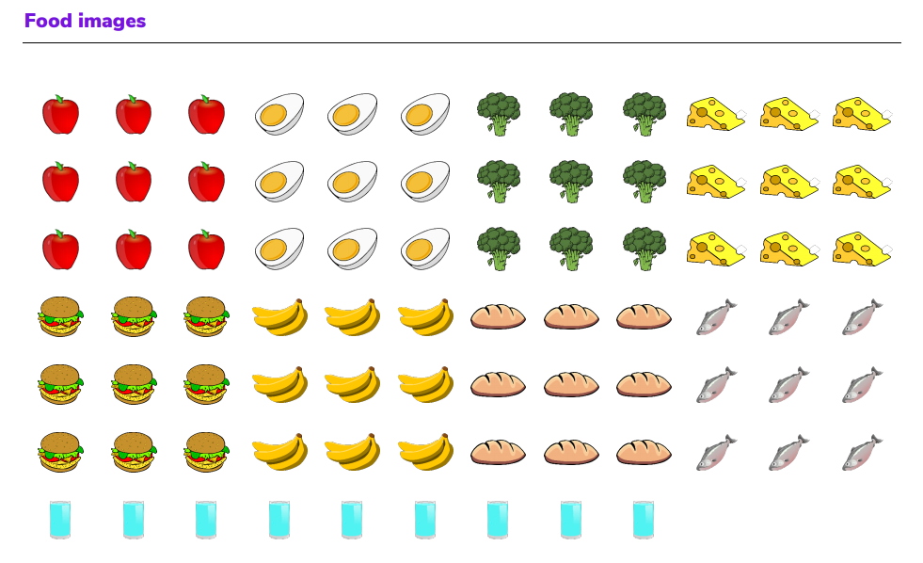
Answers (no peeking!)
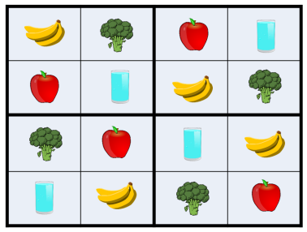

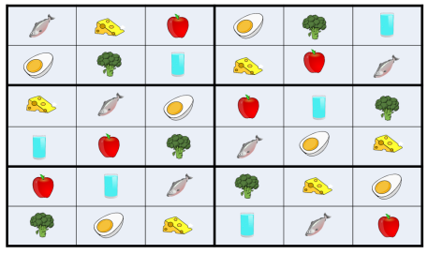

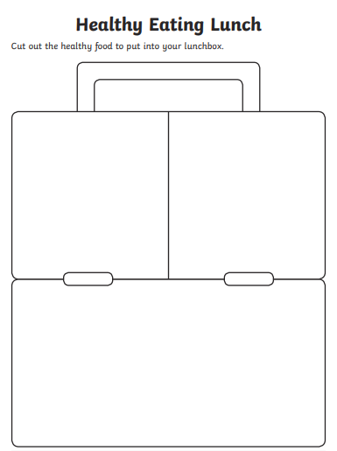

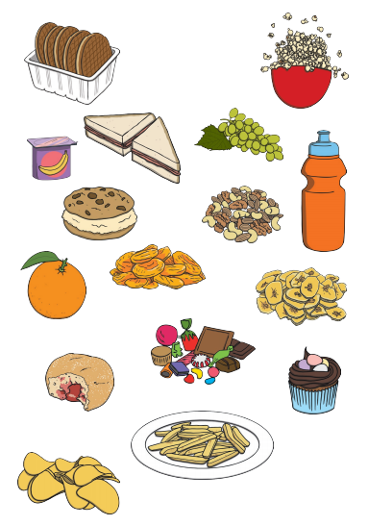

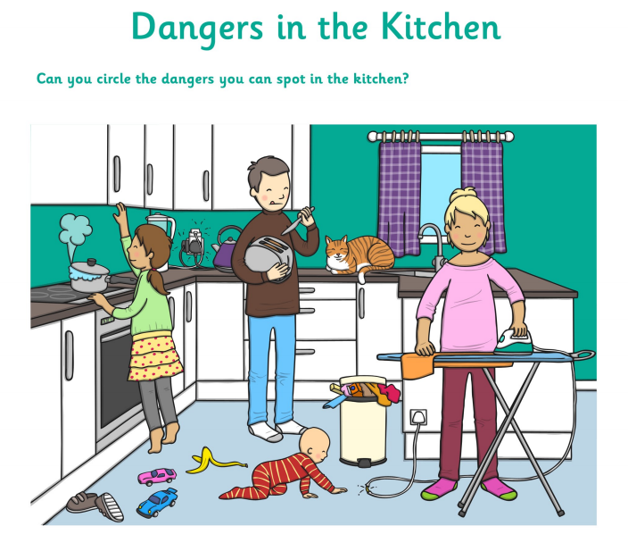

List all the ways you could make the Kitchen safe for the family to use:

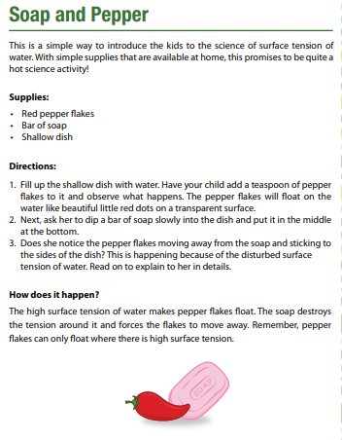

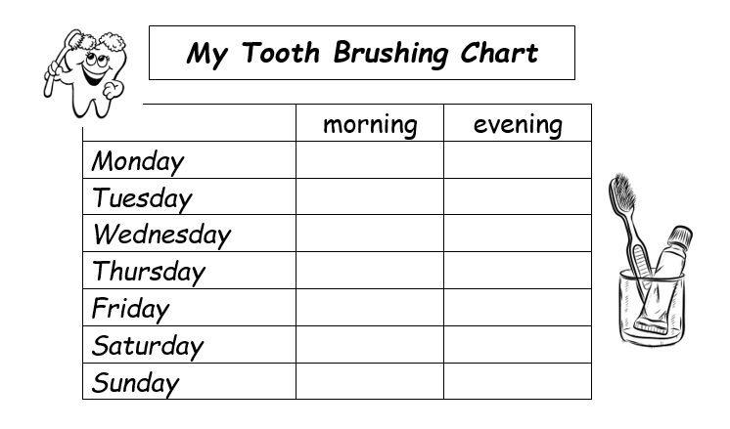
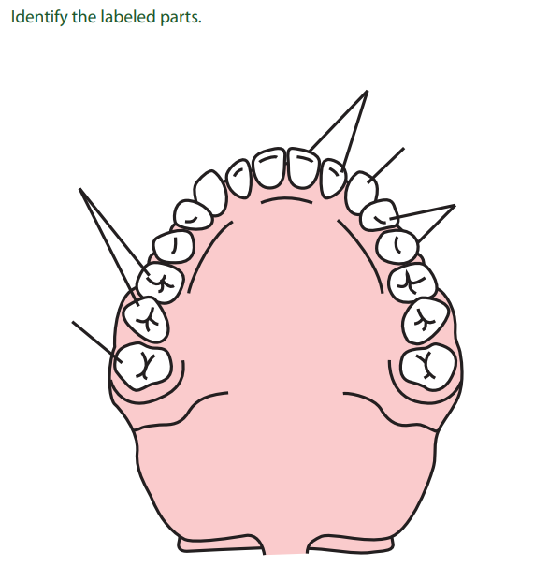

We hope you will all have fun joining in with the activities and sharing in an Event that groups from all over the District will be taking part in.

