

**Beaver and Cub**

**Summer Camp**

**17th – 30th August 2020**

**Health and Fitness**

**Session 5**

[Document title]

[Document subtitle]





**Athletics at Home:**

**The Athletics badge challenges:**



##### Take part in a proper warm up routine, using all the main muscle groups.

##### 

When exercising it is important to make sure your body has warmed up and stretched out so that you do not injure yourself when completing the challenges ahead. You will also notice as you exercise your breathing and heart rate will change. Let’s find out Why and then try it for ourselves during our warmup.

<https://youtu.be/3p6RIv9ZRY4> - Breathing

<https://youtu.be/3p6RIv9ZRY4> - Heart rate

Count how many times you take a breath in 1 minute before completing your warmup then count how many times you take a breath after your warmup. This will show us if we have started to need more oxygen in our bodies as we start to exercise.

You need to start a timer and then place your hand on your chest, each time you breath in you will feel your chest move.

<https://www.youtube.com/watch?v=d3LPrhI0v-w> – Joe Wickes warm up

<https://www.youtube.com/watch?v=vqZ9f_OskUc&t=29s> – Fitness Blender for kids

<https://www.youtube.com/watch?v=dRQf3yFXO1Y> – Healthworks

##### Take part in three of these agility activities:

##### 

**Throw and Clap**

How many times can you clap between throwing a ball into the air and catching it again?

##### 

Can you throw a ball spin around and catch it again?

**Animal laps**

Complete laps of the garden moving like different animals

Hop like a frog, travel sideways like a crab, move on hands and feet like a cat or trot like a horse.

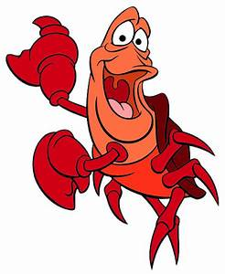

**Nearly an Egg and Spoon Race**

Balance an object on a spoon, it could be an apple, potato, or ball, whatever you are able to find.

How many laps of your garden can you do in 1 minute?

##### 

**Hurdles**

Find something to jump over – it could be tea towels, sticks etc. Lay them out in on the ground around your garden. How many laps of the course can you complete in 2 minutes?

##### 

**Packed Lunch Challenge**

How fast can you make your lunch?

Put 2 plates 10m apart have all the stuff to a packed lunch (6 items) on one plate, now see how fast you can make your lunch on the other plate bringing over one item at a time

##### 

##### 

How fast can you complete the course, what went wrong as you tried to get faster

##### 

**Dress up Challenge**

##### 

**Obstacle course**

You have 10 minutes to make your own obstacle course, it must contain an over, an under, a jump and a balance.

How fast can you complete the course, what went wrong as you tried to get faster

**Ministry of silly jumps**

How many different ways can you think you jump?

Video yourself jumping in the silliest way possible and send it to your leader

How fast can you complete the course, what went wrong as you tried to get faster

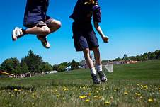

##### Take part in a proper cool down routine, using all the main muscle groups.

##### 

##### When exercising it is important to make sure your body has cooled down properly after exercise so that you do not suffer from cramps or have aches afterwards. Follow the link to a cool down video and finish off your exercise routine.

##### <https://www.youtube.com/watch?v=vqZ9f_OskUc&t=29s> – Joe Wickes

<https://www.youtube.com/watch?v=M-d11QiWdm8> – Healthworks

**Athletics at Home:**

**The Athletics badge challenges:**

##### Take part in a proper warm up routine, using all the main muscle groups.

##### 

When exercising it is important to make sure your body has warmed up and stretched out so that you do not injure yourself when completing the challenges ahead. You will also notice as you exercise your breathing and heart rate will change. Let’s find out Why and then try it for ourselves during our warmup.

<https://youtu.be/3p6RIv9ZRY4> - Breathing

<https://youtu.be/3p6RIv9ZRY4> - Heart rate

Count how many times you take a breath in 1 minute before completing your warmup then count how many times you take a breath after your warmup. This will show us if we have started to need more oxygen in our bodies as we start to exercise.

You need to start a timer and then place your hand on your chest, each time you breath in you will feel your chest move.

<https://www.youtube.com/watch?v=d3LPrhI0v-w> – Joe Wickes warm up

<https://www.youtube.com/watch?v=vqZ9f_OskUc&t=29s> – Fitness Blender for kids

<https://www.youtube.com/watch?v=dRQf3yFXO1Y> – Healthworks

##### Take part in one of these throwing activities:

##### 

**Throw and Clap**

How many times can you clap between throwing a ball into the air and catching it again?

##### 

Can you throw a ball spin around and catch it again?

**Aiming Challenge**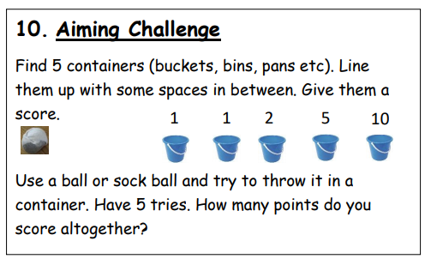

**Blindfold Challenge**

Using your necker as a blindfold how close can you get to a target 3m away?

Now try different types of throw to see which is best, such over arm, under arm, over head or chest push.



**Bowling**

Use some empty water bottles or plastic cups. Find a ball that is big enough, roll it an attempt to knock over as many as possible. Try and beat your score, best of 5.

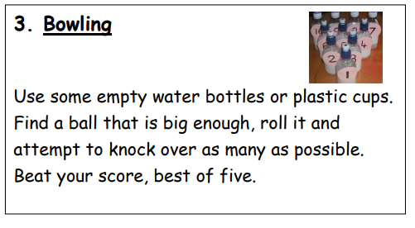

##### Take part in two of these running activities and try your best:

##### 

**Nearly an Egg and Spoon Race**

Balance an object on a spoon, it could be an apple, potato, or ball, whatever you are able to find.

How many laps of your garden can you do in 1 minute?

##### 

**Hurdles**

Find something to jump over – it could be tea towels, sticks etc. Lay them out in on the ground around your garden. How many laps of the course can you complete in 2 minutes?

##### 

##### 

**Backwards Race**

How fast can you run 50m backwards?

Now try completing the challenge on your hands and knees or sideways

**Packed Lunch Challenge**

How fast can you make your lunch?

Put 2 plates 10m apart have all the stuff to a packed lunch (6 items) on one plate, now see how fast you can make your lunch on the other plate bringing over one item at a time

##### 

##### Take part in one of these activities:

##### 

**Dress up Challenge**

##### 

##### 

**Obstacle course**

You have 4 minutes to make your own obstacle course, it must contain an over, an under, a jump and a balance.

How fast can you complete the course, what went wrong as you tried to get faster

##### Do one of these jumps and go as far or as high as you can:

##### 

**Ministry of silly jumps**

How many different ways can you think you jump?

Video yourself jumping in the silliest way possible and send it to your leader

How fast can you complete the course, what went wrong as you tried to get faster

##### 

How fast can you complete the course, what went wrong as you tried to get faster

##### 

**How far can you Jump**

Start with your feet together

Jump forward keeping your feet together, how far did you jump?

##### 

How fast can you complete the course, what went wrong as you tried to get faster

**Star Jump Challenge**

How many star jumps can you do in 1 minute?

##### Take part in a proper cool down routine, using all the main muscle groups.

##### 

##### When exercising it is important to make sure your body has cooled down properly after exercise so that you do not suffer from cramps or have aches afterwards. Follow the link to a cool down video and finish off your exercise routine.

##### <https://www.youtube.com/watch?v=vqZ9f_OskUc&t=29s> – Joe Wickes

<https://www.youtube.com/watch?v=M-d11QiWdm8> – Healthworks

**The Athletics plus badge challenges:**

##### Take part in all six of the activities in the table below.

##### 

Take your best scores for each activity and add it to the table below, if the points you score add up to eight or more, you get your badge.

|  |  |  |  |
| --- | --- | --- | --- |
| **Event:** | **3 points for:** | **2 points for:** | **1 point for:** |
| 50m sprint | 9 seconds | 10 seconds | 11 seconds |
| Throwing a ball | 25 metres | 22 metres | 18 metres |
| Long jump | 3 metres | 2.5 metres | 2 metres |
| Sargent jump | 35cm | 30cm | 25cm |
| Shuttle run 6 x 10 metres | 18 seconds | 19 seconds | 20 seconds |
| 50m skip with a rope | 12 seconds | 13 seconds | 14 seconds |

|  |  |  |  |
| --- | --- | --- | --- |
| **Event:** | **Time recorded:** | **Distance recorded:** | **Points:** |
| 50m sprint (time) |  |  |  |
| Throwing a ball (distance) |  |  |  |
| Long jump (distance) |  |  |  |
| Sargent jump (distance) |  |  |  |
| Shuttle run 6 x 10 metres (time) |  |  |  |
| 50m skip with a rope (time) |  |  |  |



**We hope you will all have fun joining in with the activities and sharing in an Event that groups from all over the District will be taking part in.**



