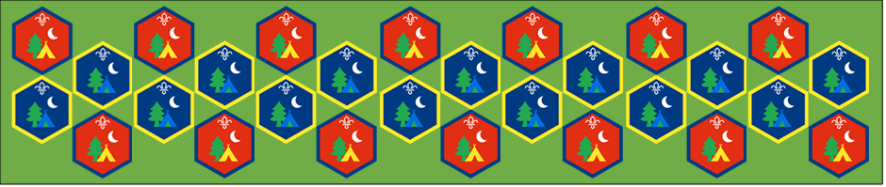
Beaver and Cub
Summer Camp
17th – 30th August 2020
Science in the Garden
Session 4
[Document title]
[Document subtitle]

Science in the Garden : Activity Sheets
Supervise young people, and only do science activities that are advised and age appropriate for your section. Test activities first, to make sure you’re confident you can lead them safely. Use protective clothing where necessary.
Rainbow Flowers | Suitable for: Beavers
Takes: 30 minutes | Led by: Video and Activity Sheet
https://www.youtube.com/watch?v=HeIS-GK0cYI
https://www.scouts.org.uk/activities/fascinating-flowers/
What happened when you put a plant in coloured water? The water travelled up through the stem to the flower. Living things need water to survive – everyone should think of a living thing that needs water and tell a friend how it gets water. It could be a plant, a tree, an animal, or even a human.
Rainbow Celery | Suitable for: Cubs
Takes: 20 minutes | Led by: Video and Activity Sheet
https://www.youtube.com/watch?v=KIug9Foou3s
https://www.scouts.org.uk/activities/rainbow-celery/
Plants need water to survive. Water keeps plants’ roots, stems, leaves, and flowers healthy, and stops them drying up and wilting. Plants make the ‘food’ from sunshine. Plants can get water from rainfall, being put in water, or from us watering them.

Plants draw water up from their roots and stems. This is done by a process called capillary action, drawing liquid upwards through smaller and smaller tubes called capillaries.
Edible Poo! | Suitable for: Everyone
Takes: 1 hour | Led by: Activity Sheet
Who’s ready to make fake poo?? Urghhh, disgusting AND yummy! You should find it looks just like real poo! Tell everyone it's poo... and then eat it! It's poo-a-licious!
Water-wash | Suitable for: Everyone
Takes: 30 minutes | Led by: Activity Sheets
Water, toilets and hygiene
https://www.scouts.org.uk/activities/water-wash/
Millions of people don’t have access to clean water, decent toilets and good hygiene. Learn about the global crisis from WaterAid.
How far do some people travel to get clean water? Imagine having to walk a long way and carrying heavy bottles or buckets home. What activities would you miss out on if you had to walk a long way to collect water? Imagine that the water in your cup is all you have for the whole day. Would it make you more careful with your water?
Spin the Rainbow | Suitable for: Everyone
Takes: 30 minutes | Led by: Video and Activity Sheets
https://www.youtube.com/watch?v=VLdwH6y1l54
When it’s moving really fast, the circle will look white. Does the ink fall off the paper? Do we become colour blind? Is our mind just telling us it’s white?
A scientist called Newton used a coloured circle like this to show that sunlight is made up of all of the colours of the rainbow added together to make white light.
Rain Cloud in a Jar | Suitable for: Everyone
Takes: 30 minutes | Led by: Activity Sheets
Clouds are formed when water vapor rises into the air and condenses onto tiny particles of dust. When billions of these droplets come together, a visible cloud forms. Over time, the droplets and crystals that make up a cloud can attract more water to themselves. When water droplets grow heavy enough, gravity pulls them down as raindrops.
Making a rain cloud in a jar is obviously a simplistic model of how it actually rains, but it gives young children a hands-on visual that is extremely valuable to their learning. Plus, it’s fun!
Build a Rainbow | Suitable for: Everyone
Takes: 30 minutes | Led by: Activity Sheets
When light reflects of water droplets a rainbow is formed, using pens and water and a process called capillary action make a rainbow of your own and watch the colours move up the sheet.

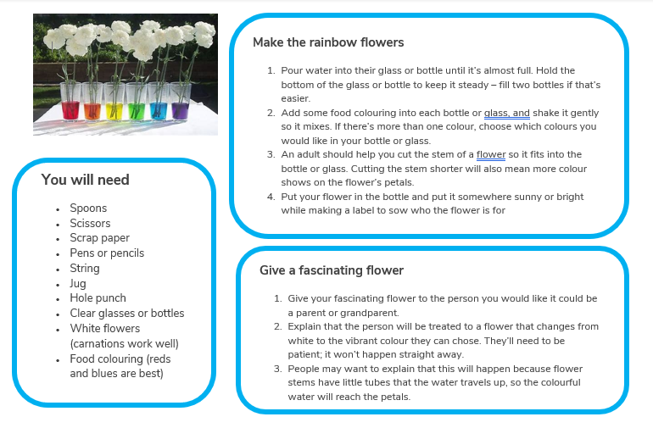

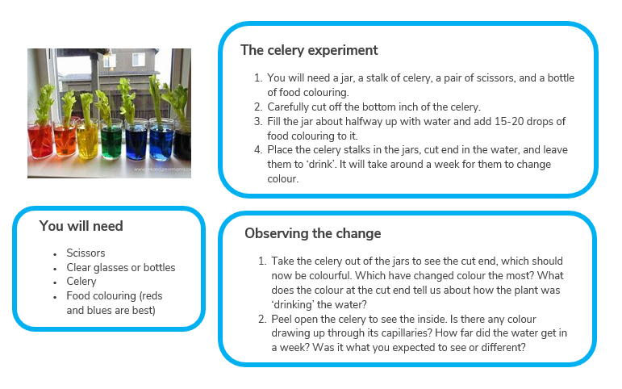
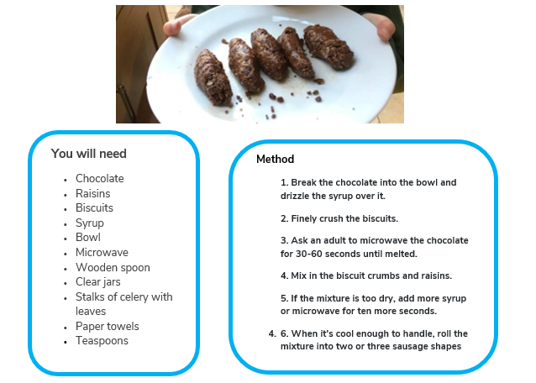

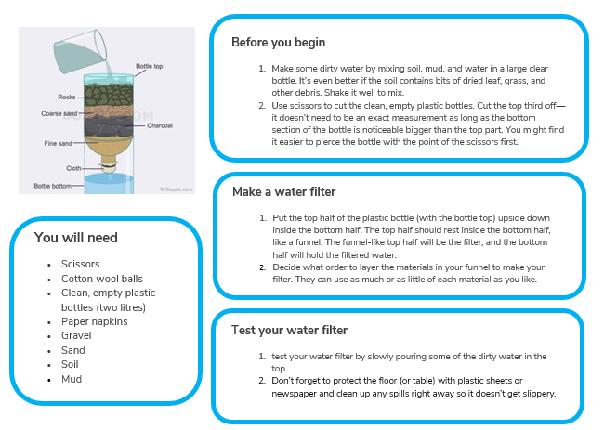

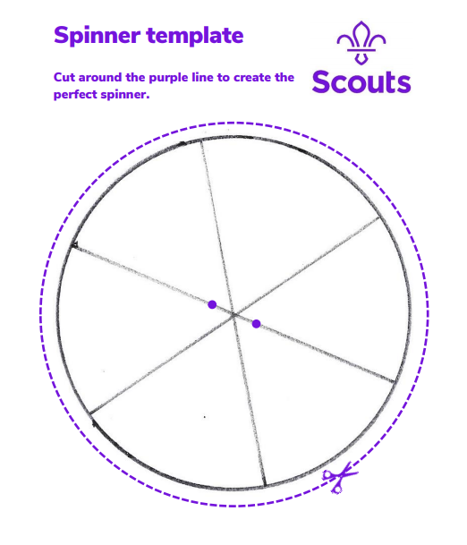
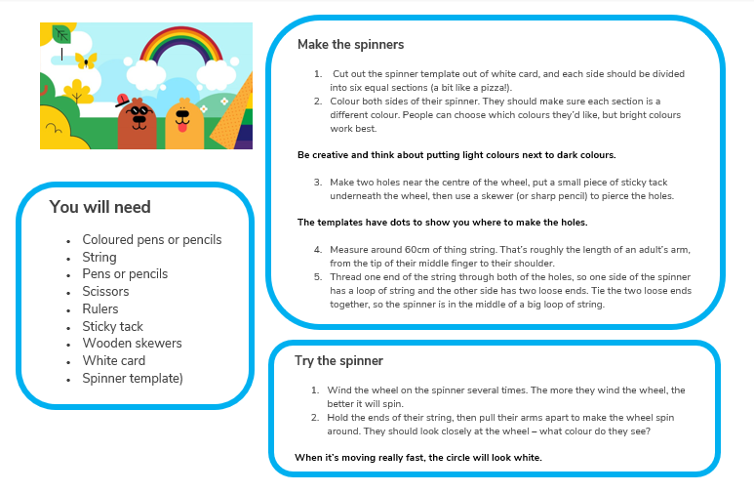

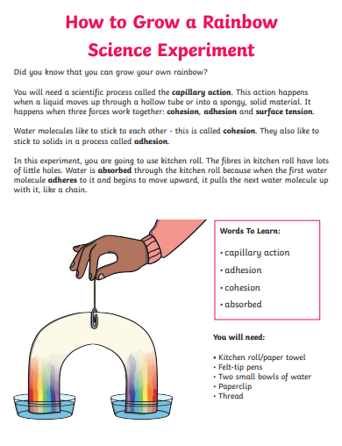

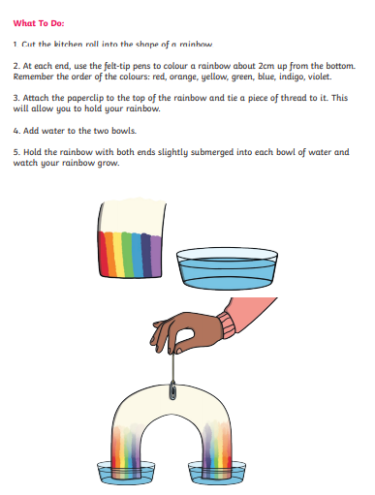

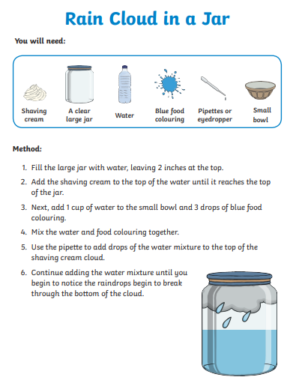

We hope you will all have fun joining in with the activities and sharing in an Event that groups from all over the District will be taking part in.
