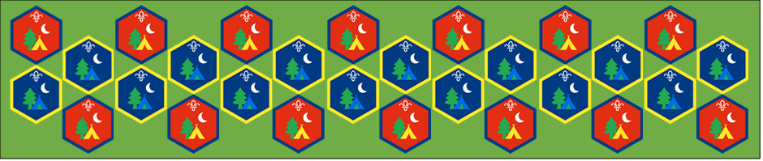
Beaver and Cub
Summer Camp
17th – 30th August 2020
Science in the Home
Session 3
[Document title]
[Document subtitle]

Science in the Home 1: Activity Sheets
Supervise young people, and only do science activities that are advised and age appropriate for your section. Test activities first, to make sure you’re confident you can lead them safely. Use protective clothing where necessary.
Butcher, Baker and Bath Bomb Maker | Suitable for: Cubs
Takes: 1 hour | Led by: Activity Sheet
https://www.scouts.org.uk/activities/butcher-baker-bath-bomb-maker/
The fizzing when the bath bomb hits the water happens because of a chemical reaction taking place between the bicarbonate of soda, citric acid and water. It’s an ‘acid-base’ reaction, where the sodium bicarbonate (from the bicarbonate of soda) is a weak base and the citric acid a weak acid.
The acid-base reaction makes a lot of bubbles – these bubbles are carbon dioxide, like you see in fizzy drinks. The bath water’s not for drinking, though! If anyone’s bomb contained scented oils, they’re released into the air with the carbon dioxide bubbles. Bath bomb recipes usually include corn flour as a dry ‘filler’. This can be used to control the reaction – it can slow down the rate that the sodium bicarbonate and citric acid dissolve, so that the fizzing sensation in your bath lasts longer.
Red Cabbage Indicator | Suitable for: Everyone
Takes: 1 hour | Led by: Video and Activity Sheet
https://www.youtube.com/watch?v=ni3XRxwTvWQ
The cabbage water is a pH indicator – it has one colour when added to an acidic liquid and another when added to an alkaline liquid. The lemon juice is acidic (a low pH number), the water is pH neutral (around pH7) and the bicarbonate of soda mixture is alkaline (a high pH number).
The cabbage indicator should change to a pink or red colour in the lemon juice. It should change to green or yellow in the bicarbonate of soda mixture and remain a purple/blue colour in the water.
Fizzing Fruits | Suitable for: Beavers
Takes: 20 minutes | Led by: Video and Activity Sheet
https://www.scouts.org.uk/activities/fizzing-fruits/
https://www.youtube.com/watch?v=PejM4dA8SPw
Bicarbonate of soda is often used in cooking as a raising agent. Making cinder toffee is a bit like making a volcano – the cinder toffee looks like orange lava. Citrus fruits (such as lemons) usually produce the most fizz because citrus is acidic like vinegar so it reacts with the bicarbonate of soda.
Does anyone know why mixing the bicarbonate of soda with the vinegar made a volcano? A gas called carbon dioxide was released in the chemical reaction – it formed bubbles that looked like lava and escaped the fruit. We make carbon dioxide too. People can’t see or smell it, but if everyone puts their hand near their mouth and breathes out they’ll be able to feel their warm breath which has carbon dioxide in it.
Reaction rockets | Suitable for: Cubs
Takes: 1 hour 30 mins | Led by: Video and Activity Sheet
https://www.scouts.org.uk/activities/reaction-rockets/
https://www.youtube.com/watch?v=jjU1IAgRcQg
The bicarbonate of soda contains sodium bicarbonate and the vinegar contains acetic acid. When they are mixed, they react together and carbon dioxide forms. The carbon dioxide builds up inside the corked bottle and the pressure forces the cork out and causes the rocket to fly!
Float or Sink? | Suitable for: Everyone
Takes: 1 hour | Led by: Video and Activity Sheet
https://www.youtube.com/watch?v=2dyCe1GPagE
Why does a heavy boat float while a small rock sinks? Would a buoy sink if an elephant sat on it? Sometimes objects sink because they’re heavy, but other times it’s because they are buoyant!
Can you find out what things in your home float or sink? Can you make a prediction (guess) if you think the object will float or sink before you place in into the water.

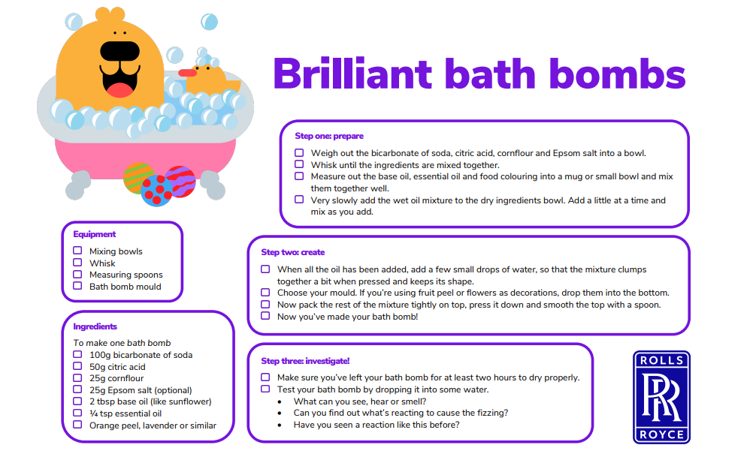
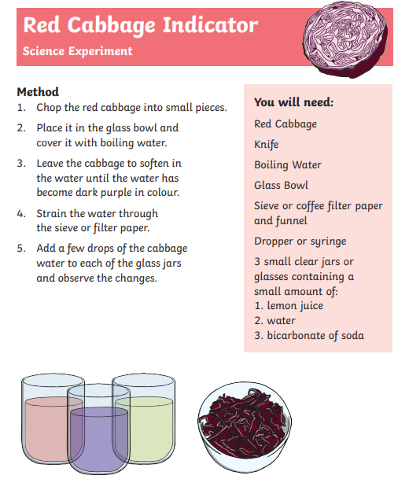
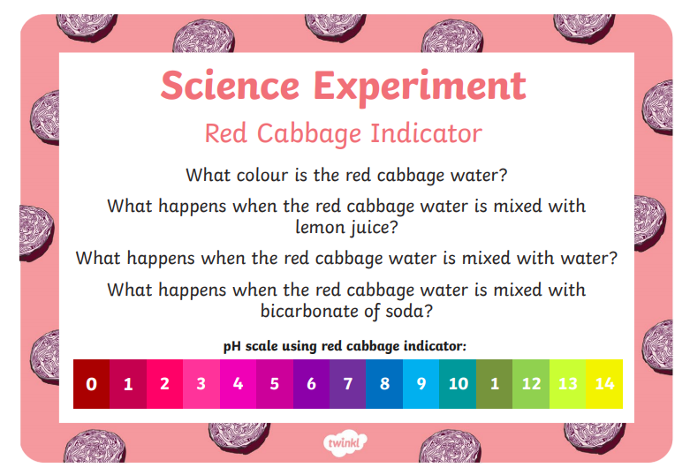
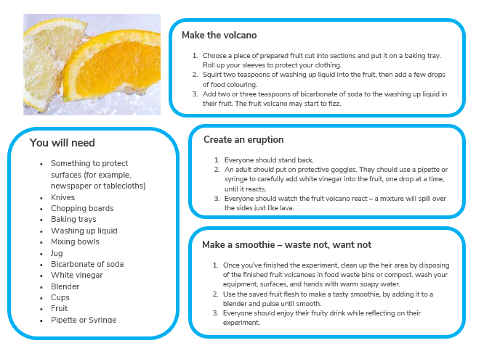

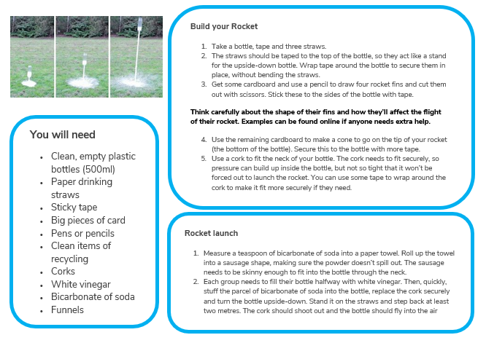

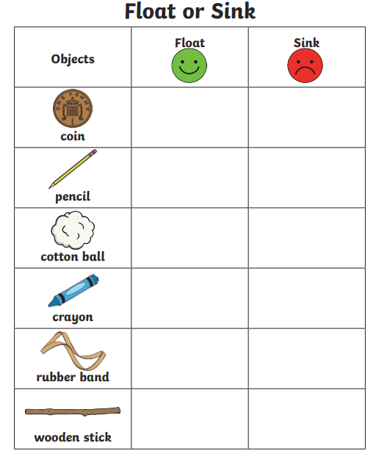
What happens if we change the way that an object looks like to the way it behaves in the water? Lets try with an orange.
- Predict if the mandarin will sink or float
- Drop it in the water. What happens?
- Predict if the peeled mandarin will sink or float.
- Drop it in the water. What happens?
- Describe how the whole mandarin and peeled mandarin are different.

We hope you will all have fun joining in with the activities and sharing in an Event that groups from all over the District will be taking part in.

