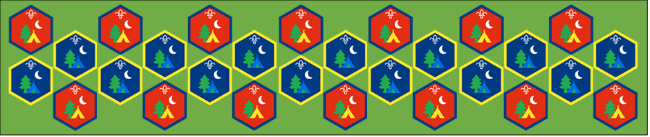
Beaver and Cub
Summer Camp
17th – 30th August 2020
Campfire Cooking
Session 2

[Document subtitle]

Campfire : Activity Sheets
Camp wouldn’t be complete without a campfire, they are used to cook on, provide warmth and to socialise around. What better way to have fun on camp than to build and enjoy a fire
Build a campfire: Suitable for: Everyone
Takes: 1 hour | Led by: Activity Sheet
https://www.youtube.com/watch?v=nPnyBfIM9E4
https://www.scouts.org.uk/activities/construct-a-campfire/
https://prod-cms.scouts.org.uk/media/2711/scout-adventures-fire-lighting-guide.pdf
Follow the videos and the links to find out the best way to light a fire ready for us to use for a range of activities. Make sure you collect enough wood to start and keep the fire going as we will need to cook on it later
Campfire chocolate oranges: Suitable for: Beavers
Takes: 30 minutes | Led by: Activity Sheet
https://www.scouts.org.uk/activities/campfire-chocolate-oranges/
You could plan a whole meal to cook over the campfire – think about a balanced starter and main to go with your chocolate orange dessert, then work together to prepare and cook the banquet.
Campfire crisp: Suitable for: Cubs
Takes: 1hour | Led by: Activity Sheet
https://www.scouts.org.uk/activities/campfire-crisp/
Did they enjoy cooking and eating outside? Did it have any extra challenges? Everyone should think about any changes they’d make to the recipe next time, such as adding different fruits, using smaller or larger chunks of apple, or eating it with custard or ice cream. Part of the fun of campfire cooking is eating outdoors, the group should stop and think about the unique sights, sounds and smells.
Pitta pocket pizzas: Suitable for: Everyone
Takes: 1hour | Led by: Video and Activity Sheet
https://www.scouts.org.uk/activities/pitta-pocket-pizzas/
The good news is that pitta pocket pizzas aren’t just super tasty – they’re healthy, too. How many portions of vegetables do you think were in your meal? Can you remember how many portions of fruit and vegetables we should aim to eat a day? What other ingredients could you add, for example, for more protein?.
Damper bread: Suitable for: Everyone
Takes: 1hour | Led by: Video and Activity Sheet
https://www.scouts.org.uk/activities/damper-snakes/
What other ingredients could you add to you snack, for example to add fruit or protein? Why are carbohydrates an important part of a balanced diet? Why is it especially important to eat enough when you’re active or spending time outdoors?

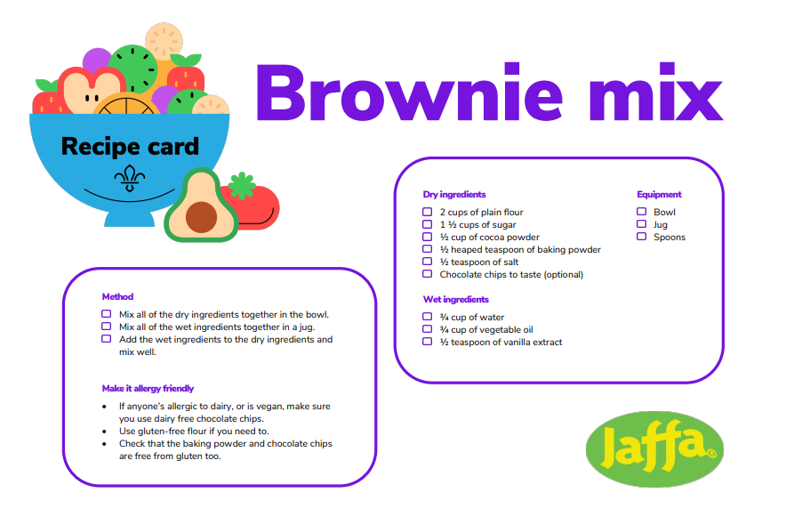

Make the oranges
- Get an orange and get an adult to cut off the top
- Use the dessert spoon to scoop out the inside of the orange. With the orange flesh – people could eat it or strain it over a sieve for juice.
- Fill your empty orange half full of brownie mix. No one should overfill the orange: the mixture expands while it cooks, so overfilled oranges could create a brownie volcano!
- Put the top back on their orange, like a perfectly fitting lid. Wrap your orange in tinfoil.
- An adult should use tongs to put the oranges in the embers of the fire.
- After ten minutes, the adult should use the tongs to turn the oranges over so both sides cook evenly. .
- An adult should check the orange brownies are cooked by holding them with tongs and pushing a cocktail stick or skewer into the centre. If it comes out pretty dry, the oranges are ready! If it’s covered in sticky, sloppy, mixture, leave it in the fire to cook for a few more minutes.

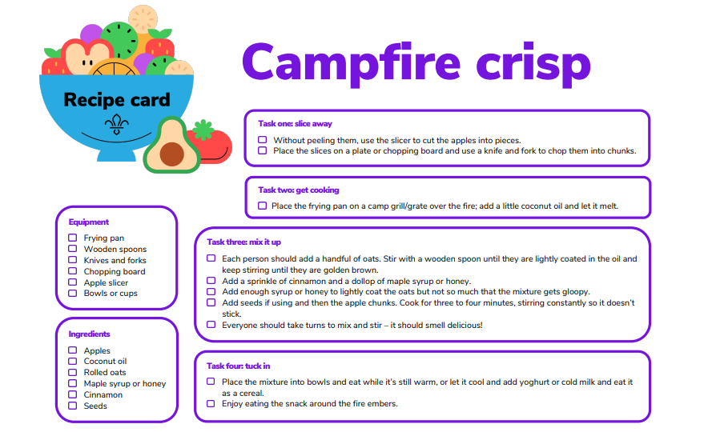

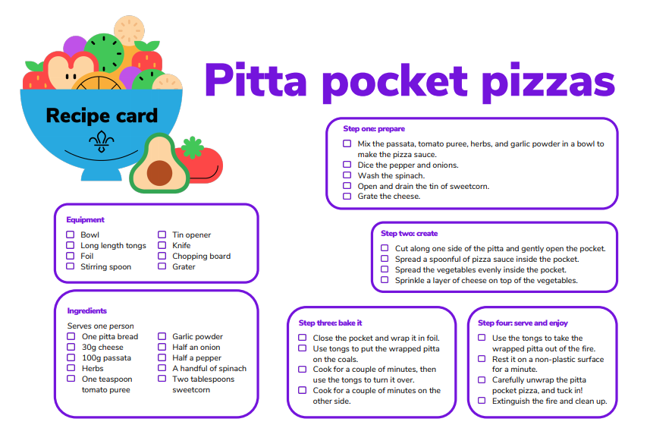

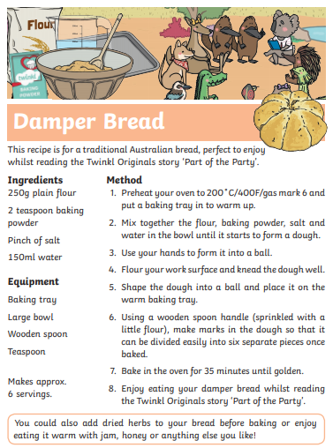

You can either cook this in an oven or twist the dough around a stick to cook on the campfire.

We hope you will all have fun joining in with the activities and sharing in an Event that groups from all over the District will be taking part in.

