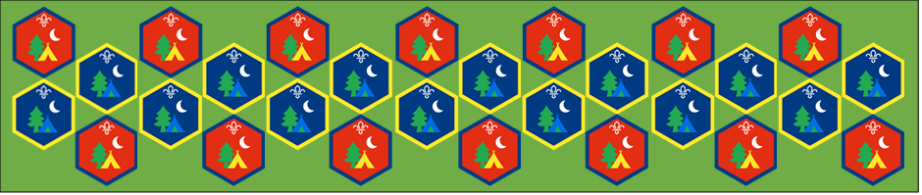
Beaver and Cub
Summer Camp
17th – 30th August 2020
Craft
Session 10
[Document title]
[Document subtitle]

Craft : Activity Sheets
The best thing about creating something is using the natural world to inspire us, these activities will develop these skills. Make something nature inspired and share with others.
Leaf Art: Suitable for: Everyone
Takes: 1hour | Led by: Video and Activity Sheet
https://youtu.be/cYINIyy6_7k
https://www.bbowt.org.uk/blog/jenny-mccallum/family-activity-how-make-salt-dough-leaf-art
While you’re out and about collect leaves and use then in this leaf inspired art project. Learn how to make a tile, hanging decoration and even a bowl using salt dough. Find your leaves and off we go!.
Nature Weaving: Suitable for: Everyone
Takes: 1hour | Led by: Video and Activity Sheet
https://youtu.be/iAGa6xkMpIw
https://www.bbowt.org.uk/blog/jenny-mccallum/family-activity-how-do-natural-loom-weaving
Loom weaving is a great way to display all your nature finds as a beautiful decoration. Long-lasting finds like grasses and sturdy leaves will work best for this. You'll also need some sticks for the frame, and some string - coloured string or wool looks good. Let's get going!
Butterfly Prints: Suitable for: Cubs
Takes: 1hour | Led by: Activity Sheet
https://www.bbowt.org.uk/blog/jenny-mccallum/family-activity-how-make-butterfly-print
https://youtu.be/QY7FFx6-yOQ
There are 59 species of butterfly in the UK, and each one has a different pattern on its wings. Their patterns are symmetrical, which means the pattern on the left wing is the mirror image of the pattern on the right!
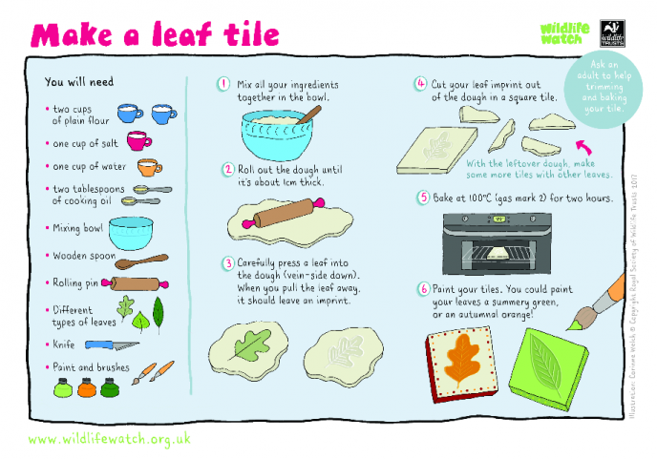

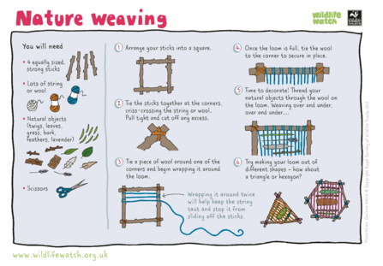

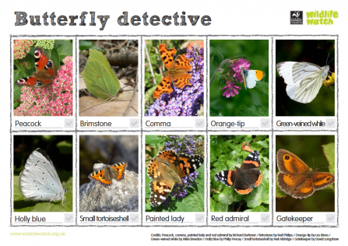

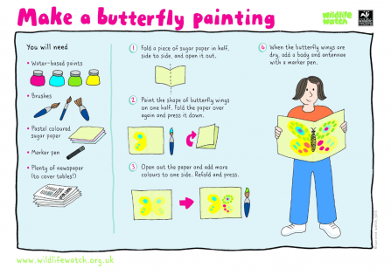

We hope you will all have fun joining in with the activities and sharing in an Event that groups from all over the District will be taking part in.
