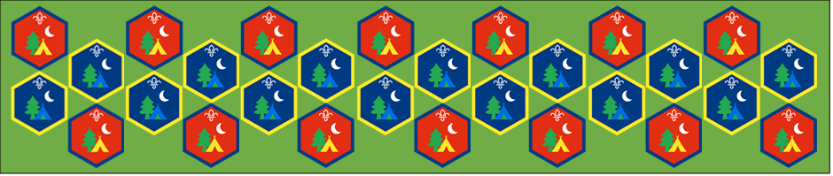
Beaver and Cub
Summer Camp
17th – 30th August 2020
Evening Activities

[Document title]
[Document subtitle]

Evening Activities : Activity Sheets
After a long day on camp there is still time to have fun at the end of the day, there are many different activities that can be done to have fun so let’s settle down and try one of these suggestions to end your day at camp.
Bedtime stories: Suitable for: Everyone
Takes: 1hour | Led by: Video
Bedtime stories can be the perfect way to end a day at camp, settle down and follow the links to find a story to listen to
Can’t you sleep little bear
https://www.youtube.com/watch?v=u1aJimzuzbg&list=PLAOQ3mJUU5n74ctRUDDSE2Ox_7g8oT-VG&index=13
The Gruffalo
https://www.youtube.com/watch?v=s8sUPpPc8Ws&list=PLAOQ3mJUU5n74ctRUDDSE2Ox_7g8oT-VG&index=11
The Very Hungry Catapillar
https://www.youtube.com/watch?v=75NQK-Sm1YY&list=PLAOQ3mJUU5n74ctRUDDSE2Ox_7g8oT-VG&index=32
Tabby McTat
https://www.youtube.com/watch?v=qnYUIz_et-E
Gruffalo song: Suitable for: Everyone
Takes: 1hour | Led by: Video and Song Sheet
https://www.youtube.com/watch?v=qCdVP9Qq6HM
https://www.scouts.org.uk/activities/the-gruffalo-song/
If you enjoyed the Gruffalo story, then have a go at learning the song all about the scary Gruffalo. What a great song to sing around a campfire or just st around with family and friends.
Jackanory: Suitable for: Cubs
Takes: 1hour | Led by: Video
https://www.youtube.com/watch?v=XlkBer1qyJI&list=PLAOQ3mJUU5n74ctRUDDSE2Ox_7g8oT-VG&index=3
https://www.youtube.com/watch?v=qJuBfyHvfqo&list=PLAOQ3mJUU5n74ctRUDDSE2Ox_7g8oT-VG&index=5
https://www.youtube.com/watch?v=noEt7d9LAig&list=PLAOQ3mJUU5n74ctRUDDSE2Ox_7g8oT-VG&index=10
For older kids Jackanory Junior offers a range of stories to listen to as you fall alseep
Campfire: Suitable for: Everyone
Takes: 1hour | Led by: Video
https://www.scouts.org.uk/activities/the-perfect-campfire/
https://www.youtube.com/watch?v=tQf_mVyYSas
No camp is complete without a campfire, follow the links to see a campfire with songs and sketches and if your keen why not have a go at learning some campfire songs yourself.
Eyes to the skies: Suitable for: Everyone
Takes: 45 minutes | Led by: Activity Sheet
https://www.scouts.org.uk/activities/eyes-to-the-skies/
Did anyone spot a constellation in the sky, and follow it with their eyes? Some people may have spotted Ursa Major, Ursa Minor, Orion, or Taurus. Why is stargazing useful? In the past, stars helped people find where they were in the world. Now, we have maps, clocks, and apps to help us – but it can be still useful to know about the stars and phases of the Moon when we’re out camping, for example..

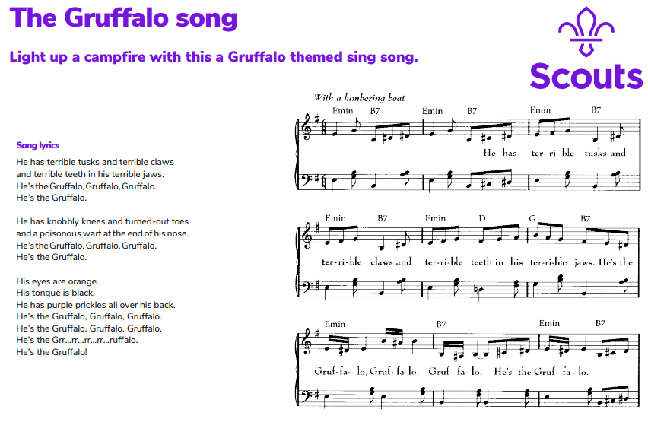
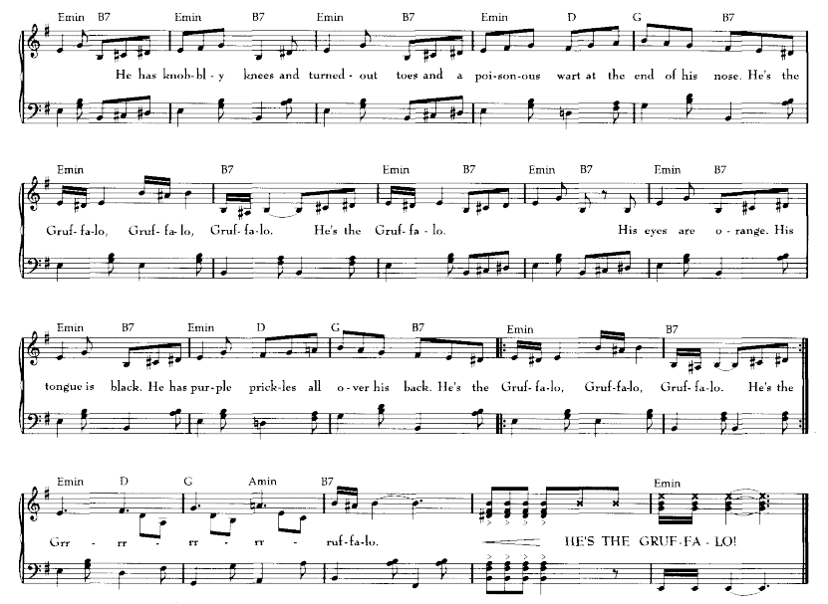

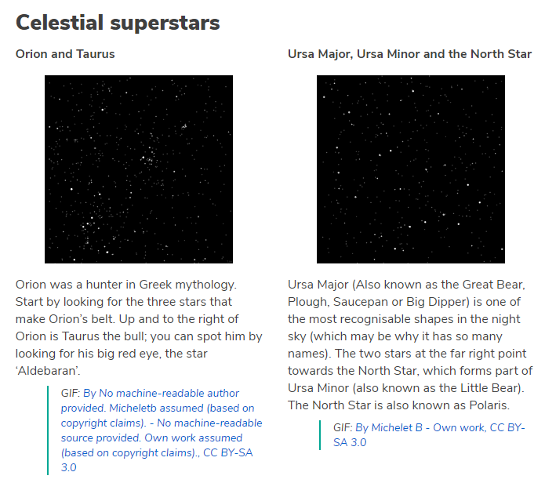
Did you know that of the 12 men who have walked on the Moon, 11 were Scouts?
What is the Moon?
- The Moon is thought to be 4.5 billion years old.
- Most scientists think that the Moon was created when a big object collided with Earth. The collision caused chunks of Earth to be thrown out into space. Over time, the chunks of Earth joined together to form the Moon.
- Unlike the Sun, the Moon doesn’t create any light. Moonlight is just sunlight reflecting on the Moon’s surface.
- Usually the Moon is a greyish-white, but it can change colour. Red Moons are caused by a lunar eclipse (when the Earth moves between the Sun and the Moon, so the sunlight to the Moon). Dust, pollution, or volcanic ash can cause the Moon to appear orange or even blue.
- The Moon controls the tides – the waves in the sea these are caused by the Moon.

What does it look like?
- The surface of the Moon is rough and uneven. It’s covered in craters, lava plains, mountains, and pits, caused by rocks hitting its surface over many years.
- You might be able to see large dark patches on the Moon’s surface. Sometimes these are called the ‘seas of the Moon’. They aren’t full of water, though – they’re actually large pools of frozen lava

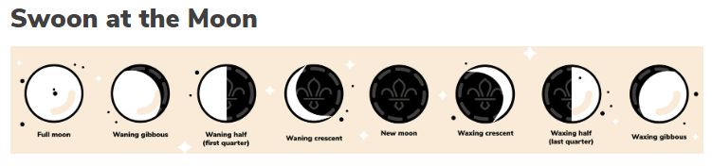
What are the phases of the Moon?
The Moon is always changing; but don't worry, it's just a phase it's going through. As the Moon orbits the Earth, we see a different amount of the Moon reflecting the Sun’s light. This means the Moon looks like it’s changing shapes, even though it’s always a ball shape. The different stages are called phases.
It takes 29.5 days for the moon to go through the eight key stages and complete a lunar cycle. The terms used to describe different phases of the Moon include:
- Waxing (when the Moon appears to be growing in size)
- Waning (when the Moon appears to be shrinking)
- Gibbous (when more than half of the Moon is illuminated)

We hope you will all have fun joining in with the activities and sharing in an Event that groups from all over the District will be taking part in.
