

**Weekly Program**

**Week 5**

**Activity Booklet**

**Exploring Nature**  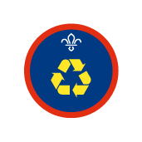 



Dear All,

While we currently are unable to meet each week Thames Ridge will be producing a weekly program pack for you to share with each section offering a range of activities and challenges to keep us all scouting during this difficult time.

We will be using this to support all the young people in their continued efforts to work towards their top awards and to offer comfort to those whom scouting forms a vital part of their weekly routines. We will endeavour in this time to ensure no young person misses out on the values and support scouting provides.

If you have any suggestions of questions relating to what we are offering please send in your thoughts to [ddc-program@thamesridgescouting.org.uk](mailto:ddc-program@thamesridgescouting.org.uk) also please send in any photos of the activities that have been produced by your group for us to share with others in the district group to [photos@thamesridgescouts.org.uk](mailto:photos@thamesridgescouts.org.uk)

Yours in Scouting

The District Team

**Opening Ceremony**

Make a flag out of clothes and take a selfie with it

**Staying Healthy**

Have a go at these animal inspired Yoga moves to relax your body and mind

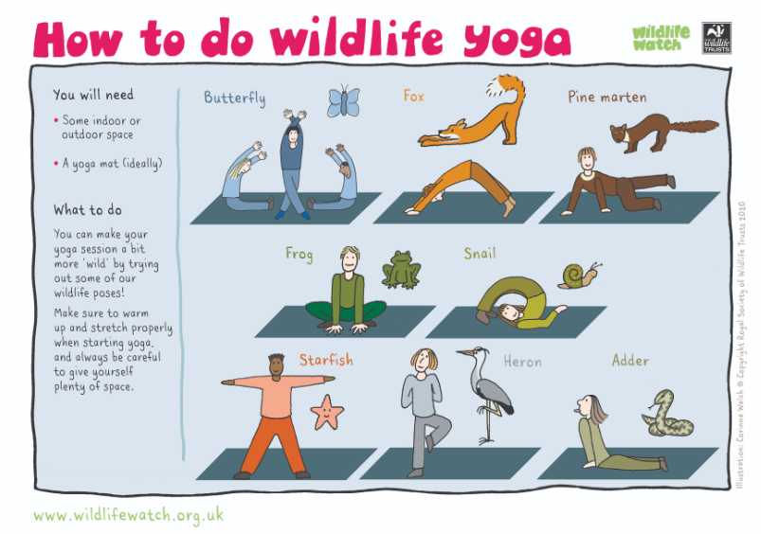

**The world around us**

##### Using the check list given pick an area to research, you will need to think about the plants, animals, or wildlife from your chosen location and how the human activity listed can affect it.

##### Discuss what you found out, giving sources for information from places like museums online, field guides or the internet.

**Arctic Tundra Project**

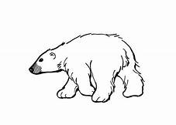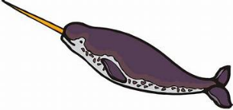In your groups, your task is to produce an Arctic Tundra Project. The checklist below gives you details on what information needs to be included in your project. You are to divide these tasks between everyone in your group equally and each member will be responsible for completing their tasks. You will then bring together all your work and submit one group project for marking, Projects should be completed in class and be handwritten with input from all group members.

**CHECKLIST**

|  |  |  |
| --- | --- | --- |
| Chapter | Information Ideas | Group Member Responsible |
| **Introduction** | **What is your project about? What will you be looking at?** |  |
| **Climate** | **Description of what the climate is like including a climate graph.** |  |
| **Vegetation** | **What types of plant life can you find in the Rainforest** |  |
| **Food** | **What types of food do we get from the arctic? Do any foods we eat contain arctic ingredients?** |  |
| **Resources** | **What different types of resources can we get from arctic?** |  |
| **Animals (1) Mammals** | **What types of Mammals live in the arctic?** |  |
| **Animals (2) Birds** | **What types of Birds live in arctic?** |  |
| **Animals (3) Reptiles** | **What types of Reptiles live in Rainforests?** |  |
| **Animals (4) Insects** | **What types of Insects live in Rainforests?** |  |
| **Animals (5) Fish** | **What types of Fish live in the arctic?** |  |
| **Global Warming** | **What is Global warming? Why is it happening in the arctic?** |  |
| **Impact of Global Warming** | **What is the impact of Global warming? How will it affect people in the future?** |  |
| **Solutions to Global warming** | **How can we solve the problems of Global warming?** |  |
| **Conclusion** | **What have you learned from this project?** |  |

**Tropical Rainforest Project**

In your groups, your task is to produce a Tropical Rainforest Project. The checklist below gives you details on what information needs to be included in your project. You are to divide these tasks between everyone in your group equally and each member will be responsible for completing their tasks. You will then bring together all your work and submit one group project for marking, Projects should be completed in class and be handwritten with input from all group members.

**CHECKLIST**

|  |  |  |
| --- | --- | --- |
| Chapter | Information Ideas | Group Member Responsible |
| **Introduction** | **What is your project about? What will you be looking at?** |  |
| **Climate** | **Description of what the climate is like including a climate graph.** |  |
| **Vegetation** | **What types of plant life can you find in the Rainforest** |  |
| **Food** | **What types of food do we get from the rainforest? Do any foods we eat contain Rainforests ingredients?** |  |
| **Resources** | **What different types of resources can we get from Rainforests?** |  |
| **Animals (1) Mammals** | **What types of Mammals live in Rainforests?** |  |
| **Animals (2) Birds** | **What types of Birds live in Rainforests?** |  |
| **Animals (3) Reptiles** | **What types of Reptiles live in Rainforests?** |  |
| **Animals (4) Insects** | **What types of Insects live in Rainforests?** |  |
| **Animals (5)**  **Fish** | **What types of Fish live in Rainforests?** |  |
| **Deforestation** | **What is Deforestation? Why is it happening in the Rainforests?** |  |
| **Impact of Deforestation** | **What is the impact of Deforestation? How will it affect people in the future?** |  |
| **Solutions to Deforestation** | **How can we solve the problems of Deforestation?** |  |
| **Conclusion** | **What have you learned from this project?** |  |

**Savanna Grassland Project**

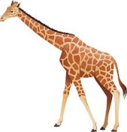In your groups, your task is to produce a Savanna Grassland Project. The checklist below gives you details on what information needs to be included in your project. You are to divide these tasks between everyone in your group equally and each member will be responsible for completing their tasks. You will then bring together all your work and submit one group project for marking, Projects should be completed in class and be handwritten with input from all group members.

**CHECKLIST**

|  |  |  |
| --- | --- | --- |
| Chapter | Information Ideas | Group Member Responsible |
| **Introduction** | **What is your project about? What will you be looking at?** |  |
| **Climate** | **Description of what the climate is like including a climate graph.** |  |
| **Vegetation** | **What types of plant life can you find in grasslands** |  |
| **Food** | **What types of food do we get from grasslands? Do any foods we eat contain grassland ingredients?** |  |
| **Resources** | **What different types of resources can we get from the grasslands?** |  |
| **Animals (1) Mammals** | **What types of Mammals live in grasslands?** |  |
| **Animals (2) Birds** | **What types of Birds live in grasslands?** |  |
| **Animals (3) Reptiles** | **What types of Reptiles live in grasslands?** |  |
| **Animals (4) Insects** | **What types of Insects live in grasslands?** |  |
| **Animals (5) Fish** | **What types of Fish live in grasslands?** |  |
| **Intensive Farming** | **What is Intensive Farming? Why is it happening in the Grasslands?** |  |
| **Impact of Intensive Farming** | **What is the impact of Intensive Farming? How will it affect people in the future?** |  |
| **Solutions to Intensive Farming** | **How can we solve the problems of Intensive Farming?** |  |
| **Conclusion** | **What have you learned from this project?** |  |

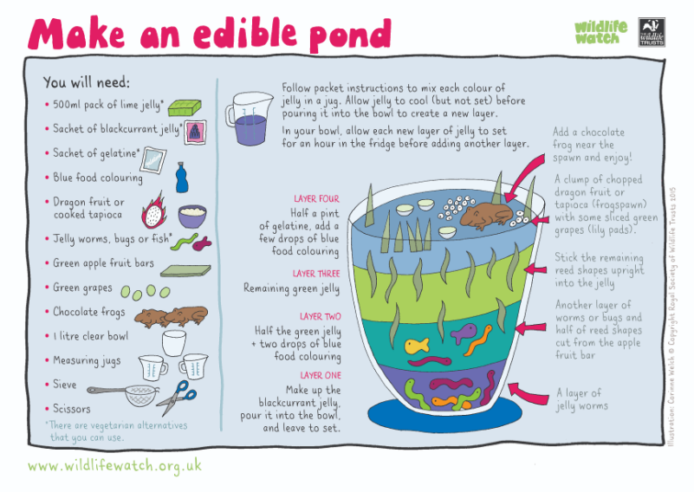**Activity 1**

##### Make an indoor pond that you can share with your family

**Share what you have found out**

Make a poster of the information you have found out about your chosen wildlife area; think about the people you are aiming the poster at.

* What sort of language should you use?
* Should it have data
* Should it include pictures
* Is it being used to inform or educate?

Activity 2

**Nature is all around us**

We are going to be exploring nature, you do not have to go far to see wildlife. Even looking at of your window or standing in your garden can give great opportunities for nature spotting!

Here are some sheets to help you, find out about the wildlife that you can see in your area. Maybe you could look for different things as you go out for your daily exercise or in your own garden

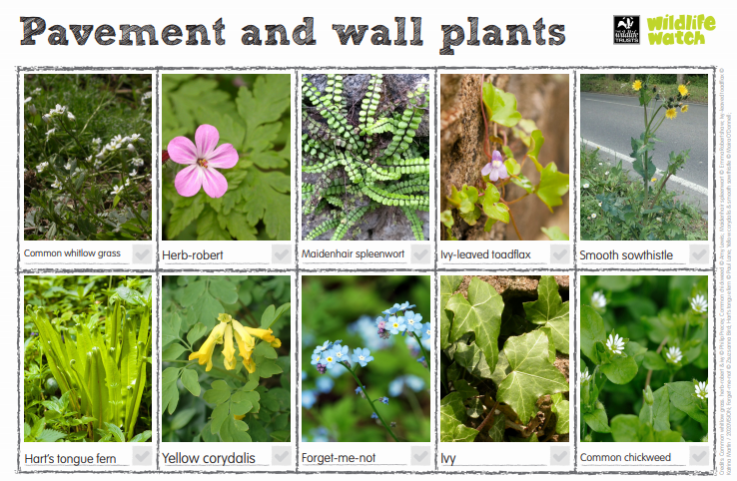

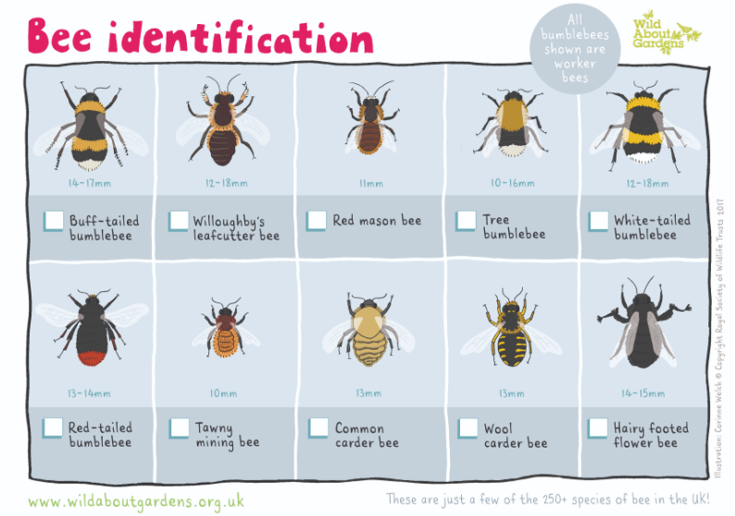

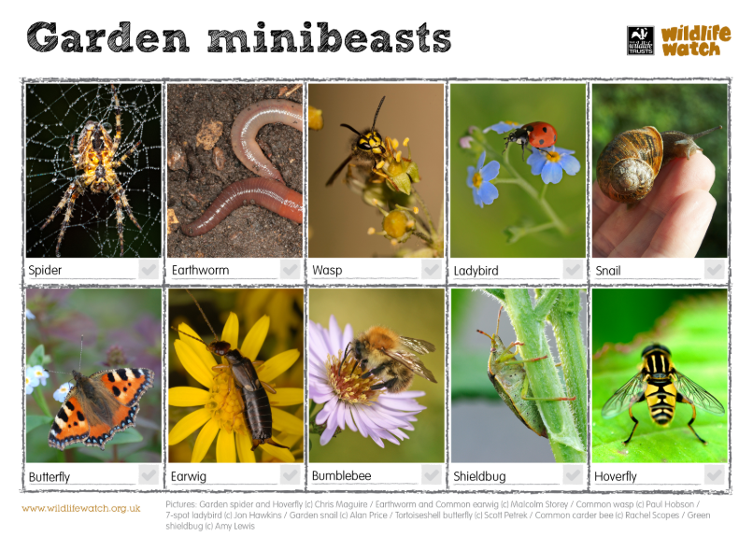

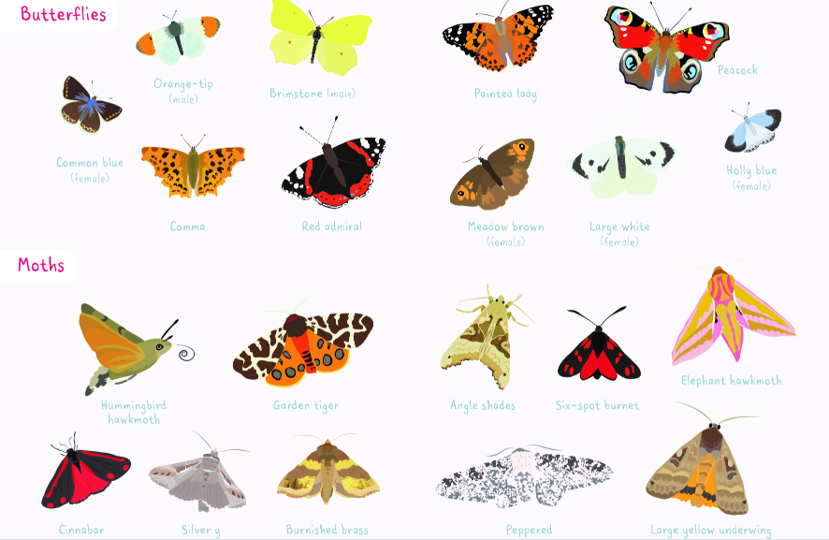

**Where have you been and what have you seen**

You are going to make a poster to show members of a younger section all about the nature you can find in and around the area where you live.

* Draw a map of the places you have walked as part of your daily exercise
* What plants, insects, and birds you have seen along the way.
* What other animals might you find in your area

Activity 3

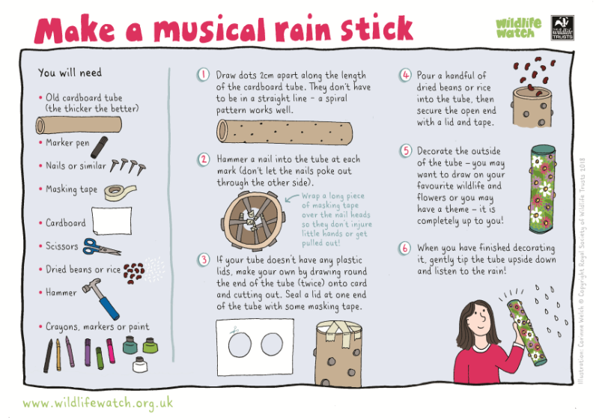

**Closing Ceremony**

Make a nature flag and either film the flag being created to taken apart to share with the group, there are many phone apps that will allow you to use different video techniques.

**Scouting at Home**

What else can I do to link my activities to scouting?

Below is a list of some other activities that we could try to show the different skills we have through scouting, link to the international theme.

|  |  |  |
| --- | --- | --- |
| **Skill** | **Description** | **Achieved** |
| **communicator** | **Make a diary entry about all the things that are different between your day now and before lockdown** |  |
| **International** | **Find out 3 facts about 6 counties you would like to visit** |  |
| **Science** | **Carry out a science experiment** |  |
| **Physical Recreation** | **It’s important to exercise even when you’re stuck at home. Make a video showing how you warm up in order keep fit in your house. Measure your heart rate before and after you do your exercise.** |  |
| **Entertainment** | **Create video of you highlighting the importance of washing your hands** |  |
| **Chef** | Plan, cook, serve and clear away a 2-course meal for your family. |  |
| **Cyclist** | **Make a presentation showing what you need to do to maintain your bike to keep it safe** |  |

**Please keep scouting and send in pictures of all you achieve to the group and district so we can all share in each other’s accomplishments.**

**Yours in Scouting**

**GSL**