Weekly Program
Week 4
Activity Booklet
Prayer and Reflection

Dear All,
While we currently are unable to meet each week Thames Ridge will be producing a weekly program pack for you to share with each section offering a range of activities and challenges to keep us all scouting during this difficult time.
We will be using this to support all the young people in their continued efforts to work towards their top awards and to offer comfort to those whom scouting forms a vital part of their weekly routines. We will endeavour in this time to ensure no young person misses out on the values and support scouting provides.
If you have any suggestions of questions relating to what we are offering please send in your thoughts to ddc-program@thamesridgescouting.org.uk also please send in any photos of the activities that have been produced by your group for us to share with others in the district group to photos@thamesridgescouts.org.uk
Yours in Scouting
The District Team

Opening Ceremony
Build a flagpole out of paper and attach a paper flag to start your opening ceremony, take a picture/video and send it to your leader.
Activity 1

Explore something about the history of your faith at a local, national or international level.
We have recently celebrated Easter and St Georges Day, both Stories teach the value of Bravery in the face of adversary and that we should all strive to do the right thing. Find out about influential figures for your faith.

You could learn about influential people

Prayer and Reflection
Why do you think people pray? What are we thinking about now, that we are thankful for?
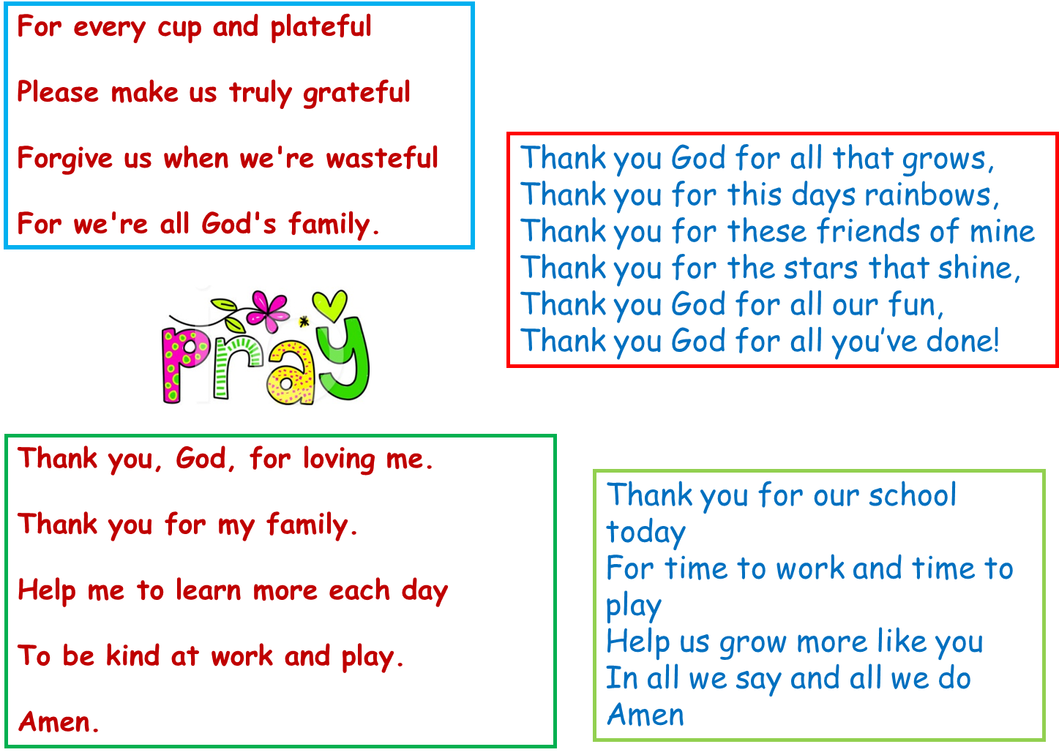

Write a prayer, to reflect on the things that are happening now.
You could write about you are thankful for now, about those working hard to support others or about you family at this time and when you can see them again. It maybe that one of your family is a key worker and you may want to write a prayer for them.

Activity 2
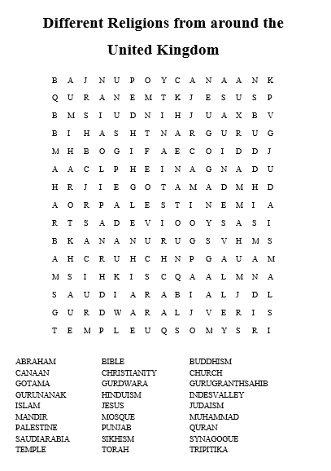

Think about when you have been helpful
St George slayed the Dragon to help the people of the near by village, and Jesus died on the cross to save people from their sins. Both these are stories of helping others, write a story about doing your best and helping others.

Think about how this might link to your promise. What could you do to at the moment to show you are kind and helpful.

Take part in an activity that reflects upon and explores your own beliefs, attitudes and values (this may or may not include religious beliefs).
What values do we share as Scouts? Which Scout value means the most to you? How can we continue to use these values in our current situation?

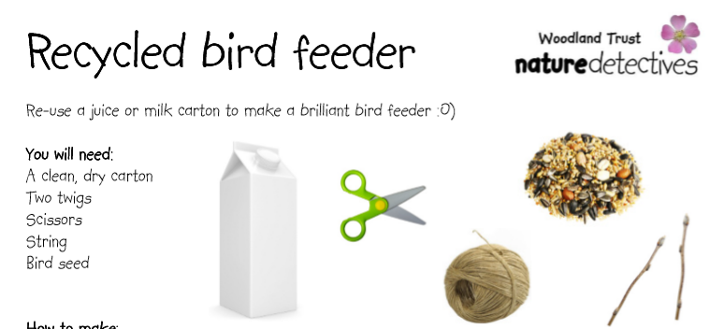
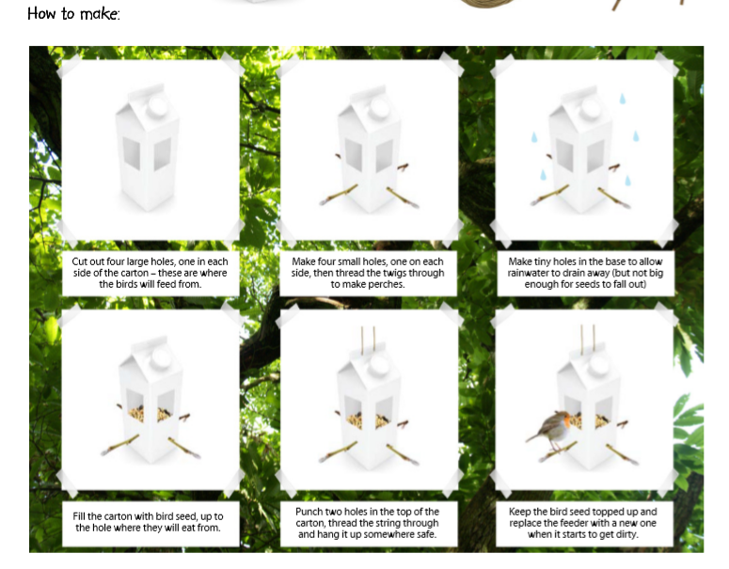When we think of others its not just other people, we should also think of the world around us and the different animals. By making a bird feeder we are helping to encourage birds to come into our gardens.

Community
Find out as much as you can about the different faiths and beliefs in your community area. Where do they meet to worship, what type of festivals do they have?

Closing Ceremony
Lower the flag you have made to signal the end of your scout meeting.
Scouting at Home
What else can I do to link my activities to scouting?
Below is a list of some other activities that we could try to show the different skills we have through scouting, link to the international theme.
Skill | Description | Achieved
communicator | Make a diary entry about all the things that are different between your day now and before lockdown
International | Find out 3 facts about 6 counties you would like to visit
Science | Carry out a science experiment
Physical Recreation | It’s important to exercise even when you’re stuck at home. Make a video showing how you warm up in order keep fit in your house. Measure your heart rate before and after you do your exercise.
Entertainment | Create video of you highlighting the importance of washing your hands
Chef | Plan, cook, serve and clear away a 2-course meal for your family.
Cyclist | Make a presentation showing what you need to do to maintain your bike to keep it safe

Please keep scouting and send in pictures of all you achieve to the group and district so we can all share in each other’s accomplishments.

Yours in Scouting
GSL

