

**Weekly Program**

**Week 6**

**Activity Booklet**

**Dinosaurs**







Dear All,

While we currently are unable to meet each week Thames Ridge will be producing a weekly program pack for you to share with each section offering a range of activities and challenges to keep us all scouting during this difficult time.

We will be using this to support all the young people in their continued efforts to work towards their top awards and to offer comfort to those whom scouting forms a vital part of their weekly routines. We will endeavour in this time to ensure no young person misses out on the values and support scouting provides.

If you have any suggestions of questions relating to what we are offering please send in your thoughts to [ddc-program@thamesridgescouting.org.uk](mailto:ddc-program@thamesridgescouting.org.uk) also please send in any photos of the activities that have been produced by your group for us to share with others in the district group to [photos@thamesridgescouts.org.uk](mailto:photos@thamesridgescouts.org.uk)

Yours in Scouting

The District Team

**Opening Ceremony**

Make a dinosaur out of natural materials, see if you can make one that stands. Maybe you could pioneer a structure and then decorate it to look like the dinosaur of your choice.

**Activity 1**

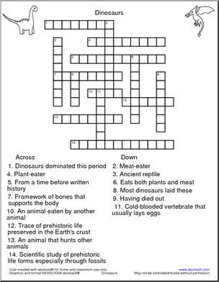

**Dippy the Dinosaur**

Dippy the Diplodocus is 115 years old this month! This majestic cast was unveiled at the Natural History Museum in London in 1905 and became a star, featuring in cartoons, in news reports and even on film and television, he even went on to inspire the Disney film ‘One of Our Dinosaurs is Missing’ He is not at the Museum now but on an adventure across the UK.

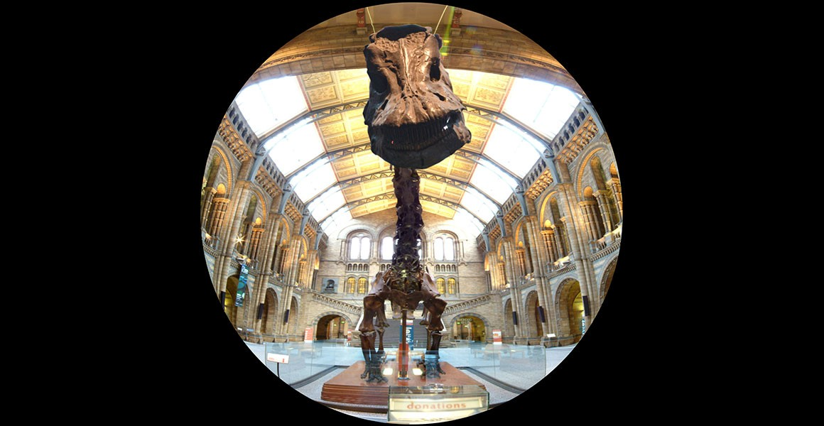

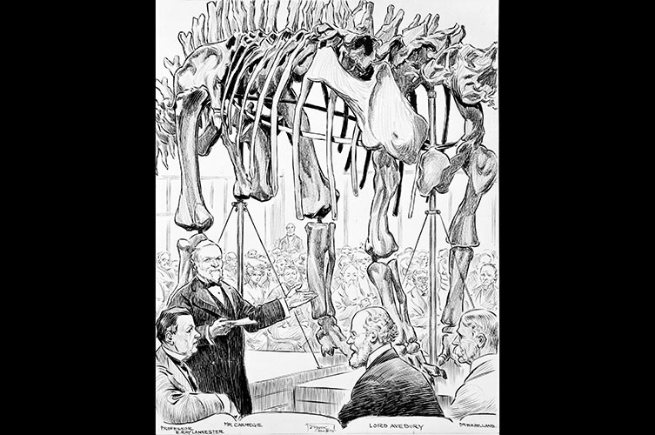

He was presented to Museum by millionaire Andrew Carnegie after King Edward VII said he wanted a *Diplodocus*

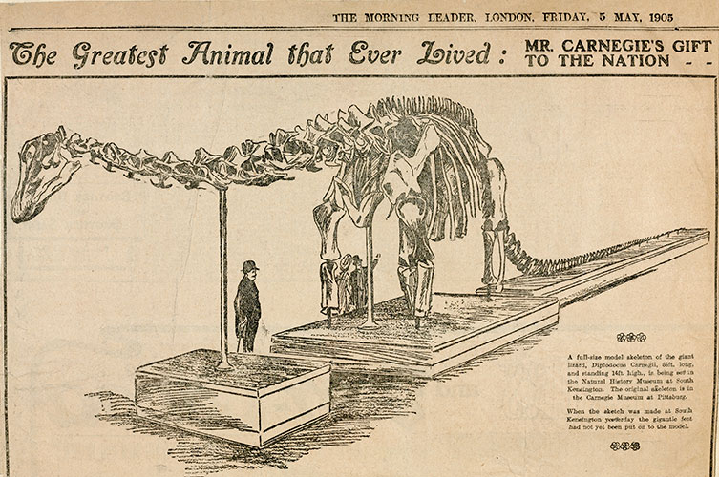

Newspapers referred to the skeleton as coming from the ‘Greatest animal that ever lived’

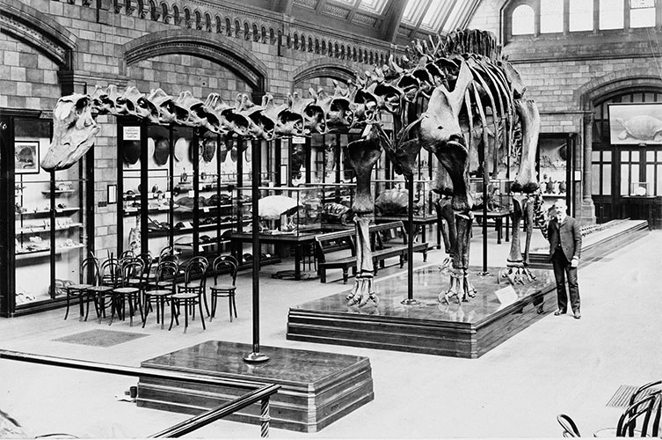

He has been moved around the Museum a lot on the 115 years he has been on display.

His first home was in the reptile gallery.

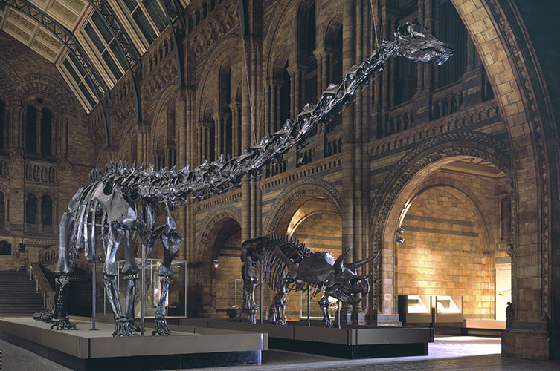

He was moved into the Museum main entrance the Hintze Hall in 1979.

For a short time, he was joined by other dinosaurs such as the triceratops shown.

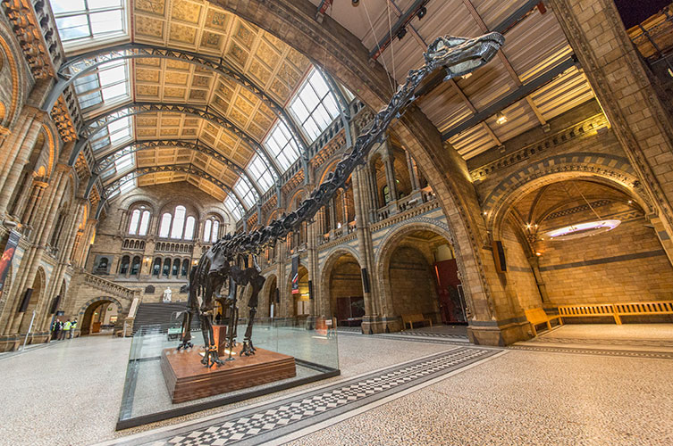

In 2017 Dippy left the Hintze Hall to go on tour around the country.

**Dinosaurs Eggs**

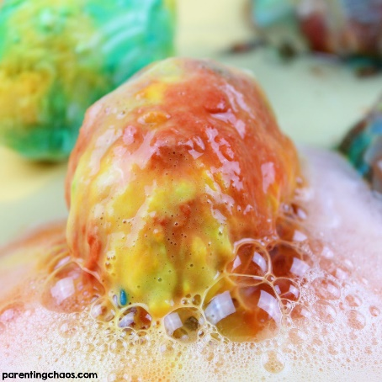Explore chemical reactions with this Hatching Fizzy Dinosaur Egg or adapt them to make bath bombs!

Supplies:

* Baking soda
* Cornstarch
* Food colouring
* Water
* Sandwich bags
* Vinegar

*Note: Turn these into bath bombs by using citric acid to create the chemical reaction instead of vinegar! To create bath bombs you will use 1 Tablespoon of citric acid per 3 Tablespoons of baking soda when making your dinosaur eggs*

Directions:

1. Add 3 heaping tablespoons of baking soda and 1 heaping teaspoon of corn starch to a sandwich bag. If making bath bombs, add your citric acid in this step.

2. Add a few tablespoons of water and a couple drops of food colouring to the bag.

3. Close the bag. On a covered surface, gently knead the bag to mix the ingredients. You will want your mixture to be a mould-able consistency. Add in more baking soda or water as needed.

4. Repeat the steps above until you have a couple different colours.

5. Wear gloves for this next step, otherwise you’ll have coloucrful hands for days!

6. Remove the mixture from the bags onto a cookie sheet or activity tray.

7. Pat together and gently shape the baking soda mixture into an egg shape.

8. Add the shaped eggs into a small container that you can place into your freezer. Allow the eggs to harden for 2-3 hours.

*Squeeze vinegar onto the dinosaur eggs and watch the chemical reaction! The eggs will fizz and bubble. If you’d like the mixture to foam even more, add a bit of dish soap to the pan before you place the eggs into it.*

**Activity 2**

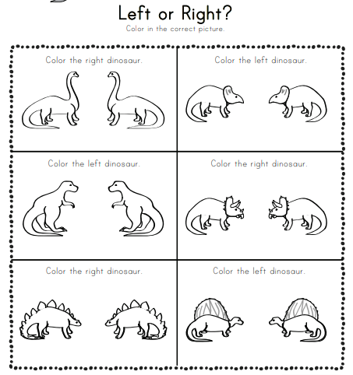

**What killed the dinosaurs?**

To write an article to show how the dinosaurs became extinct. Remember the criteria for selecting a good argument.

* Is it reliable?- who is saying it?
* Is it a known source?
* Is it unbiased? (not just someone’s opinion)
* Is it factual? (not fiction a story)
* Has it been reviewed by peers?
* If yes to some or all these questions then it is a good piece of evidence

Read all the theories before you begin and plan out what you are going to say, will you might want to use diagrams to explain your reasoning

**The impact theory**  
The impact theory was beautifully simple and appealing. Much of its evidence was drawn from a thin layer of rock known as the 'KT boundary'. This layer is 65 million years old (which is around the time when the dinosaurs disappeared) and is found around the world exposed in cliffs and mines.

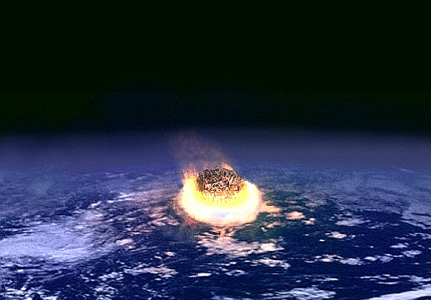For supporters of the impact theory, the KT boundary layers contained two crucial clues. In 1979 scientists discovered that there were high concentrations of a rare element called iridium, which they thought could only have come from an asteroid. Right underneath the iridium was a layer of 'spherules', tiny balls of rock which seemed to have been condensed from rock which had been vapourised by a massive impact.

On the basis of the spherules and a range of other evidence, Dr Alan Hildebrand of the University of Calgary deduced that the impact must have happened in the Yucatan peninsula, at the site of a crater known as Chicxulub. Chemical analysis later confirmed that the spherules had indeed come from rocks within the crater.

The impact theory seemed to provide the complete answer. In many locations around the world, the iridium layer (evidence of an asteroid impact) sits right on top of the spherule layer (evidence that the impact was at Chicxulub). So Hildebrand and other supporters of the impact theory argued that there was one massive impact 65 million years ago, and that it was at Chicxulub. This, they concluded, must have finished off the dinosaurs by a variety of mechanisms**. From a BBC news item march 2009**

**Super Volcanoes**

The super volcano theory argues that the asteroid impact was merely a prelude to a number of volcanic eruptions that occurred in an area in India named the Deccan Traps.

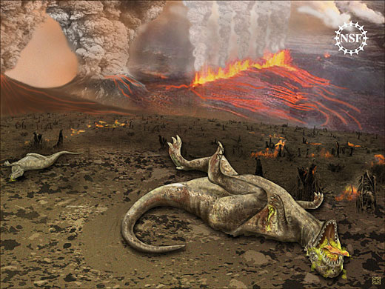Researchers have discovered four separate waves of eruptions that released huge clouds of sulfur dioxide into the air, bringing showers of acid rain in turn. These waves are estimated to have occurred between 67.5 and 65 million years ago.

Geophysicists argue that the asteroid impact could not have kicked up enough dust or sulfur dioxide to cause global climate change. The super volcanoes may have dispersed between 10 and 150 billion tonnes of sulfur dioxide with each 'pulse'.

Geologist Gerta Keller states that after the initial pulse “the species disappear; we have essentially very few left,” and “by the fourth flow, the extinction is complete,”

The super volcano theory is the biggest challenger to the classic impact theory, though Rick Fireston of Lawrence Berkeley National Laboratory isn't swayed by the argument "There was volcanism at the time. There's always volcanism, but that impact is so significant that you can't ignore it." **From Metro newspaper may 2010**

**Combined Theory**

Keller, proponent of the Super Volcano theory, stresses that her findings do not deny that an impact occurred, and noted that a combination of the two theories could provide the ultimate answer:

"The dinosaurs might have faced an unfortunate coincidence of a one-two punch - of Deccan volcanism and then a hit from space,

"We just show the Deccan eruptions might have had a significant impact - no pun intended."

**From Newspaper Metro may 2010**

**Ice Age**

A team from Holland and Italy discovered fossilised cold water plankton that dates back 65 million years in an area that had previously been warm see in Tunisia.

Dinoflagellates and Benthic Formanifera plankton were found in the first time-dated fossils that provide clear evidence of climate swings.

Matthew Huber of Indiana's Purdue University said: "The fossils indicate that something suddenly made the water cold enough to support these tiny critters."

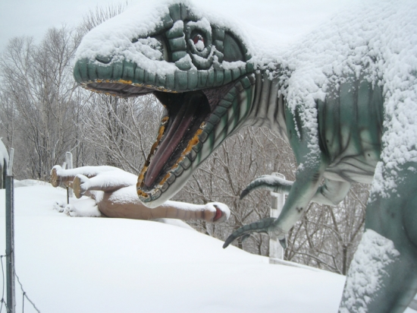"We theorise that the meteor strike produced huge quantities of sulfate particles, such as are often blown high into the atmosphere during a volcanic eruption, and these particles shielded the Earth's surface from sunlight. The decrease in solar energy ultimately caused a long cold spell, called an 'impact winter,' that persisted for years."

The hypothesised ice age would have killed off many of the planet's living species into extinction, including dinosaurs.

The find does not however reveal the catalyst for the sudden climate change, so while the ice age may have been the method of extinction, the event that preceded it (widely regarded to be the asteroid impact) would be the cause. **From Newspaper Metro may 2010**

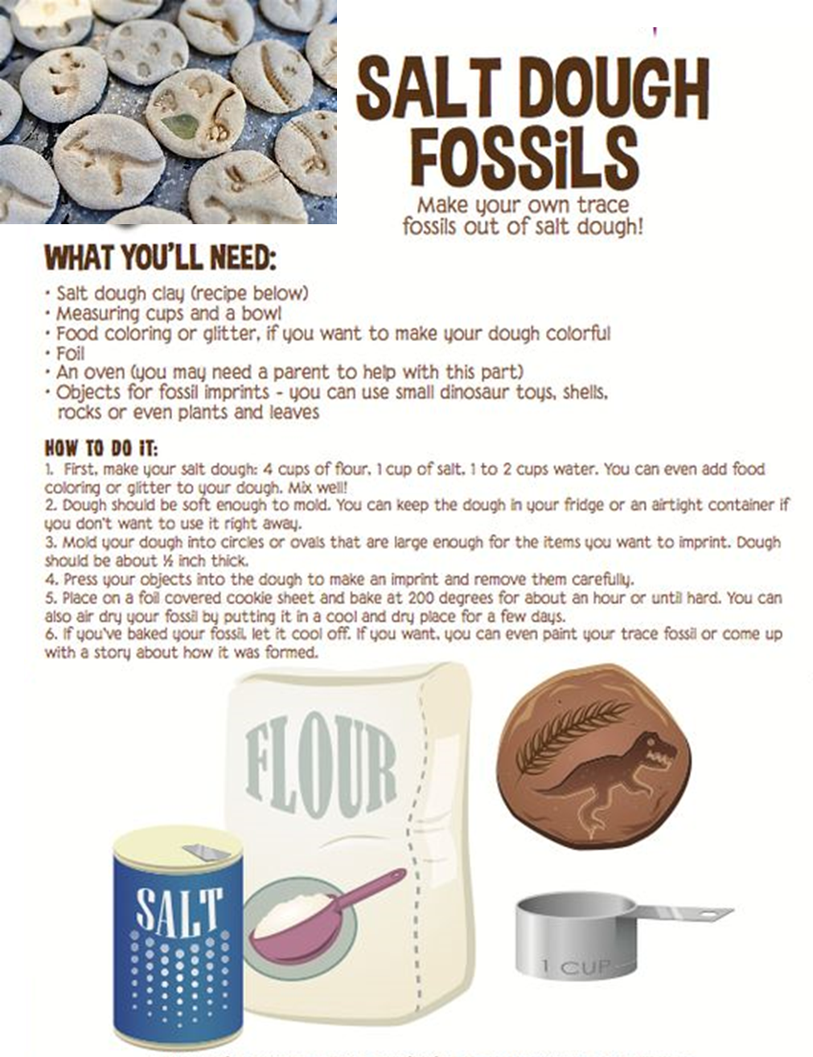

### **Brachiosaurus bone snacks.**

Straightforward to make. Just by buying or making some pizza dough, cut it into strips, then place small bone-shaped chunks on the ends. Sprinkle with cocoa powder and sugar for a sweet taste, or you could add grated cheese before cooking for a savoury snack – what a unique treat!

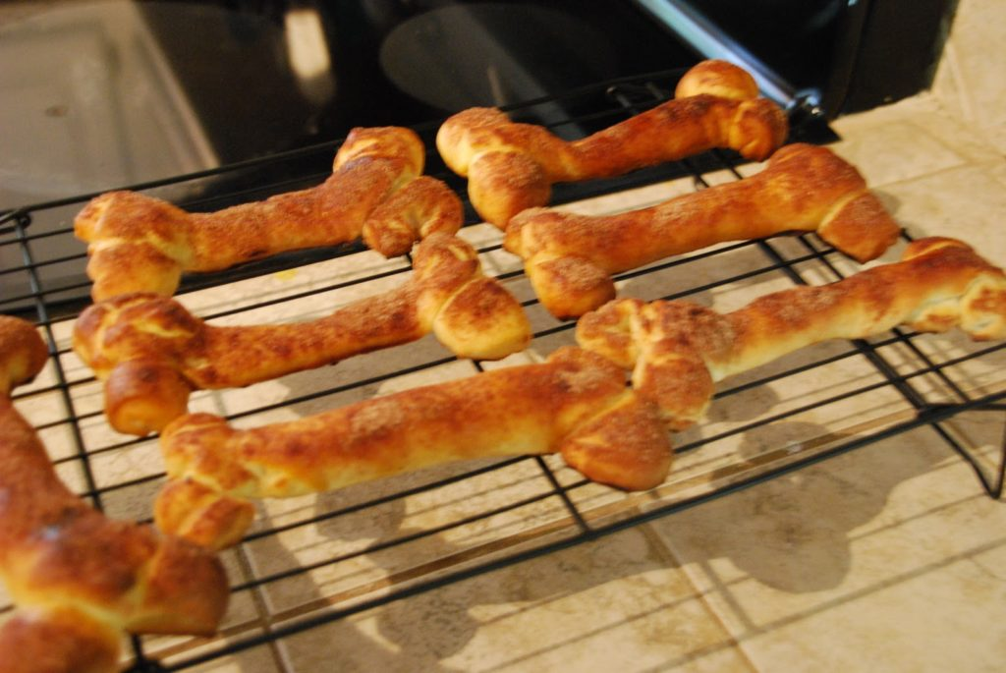

**Pizza Dough Recipe**

* 1-1/4 cups warm water (110° to 115°)
* 2 teaspoons sugar, divided
* 1 package (1/4 ounce) active dry yeast
* 3-1/2 to 4 cups all-purpose or 00 flour
* 1 teaspoon sea salt
* 1 teaspoon each dried basil, oregano and marjoram, optional
* 1/3 cup vegetable or olive oil

## **Directions**

* In a small bowl, mix warm water and 1 teaspoon sugar; add yeast and whisk until dissolved. Let stand until bubbles form on surface. In a large bowl, whisk 3 cups flour, salt, remaining 1 teaspoon sugar and if desired, dried herbs. Make a well in center; add yeast mixture and oil. Stir until smooth. Add enough remaining flour to form a soft dough.
* Turn onto a floured surface; knead, adding more flour to surface as needed until no longer sticky and dough is smooth and elastic, 6-8 minutes. Place in a large greased bowl; turn once to grease top. Cover and let rise in a warm place for 30 minutes; transfer bowl to refrigerator and chill overnight. Allow dough to come to room temperature before rolling, about 30 minutes.

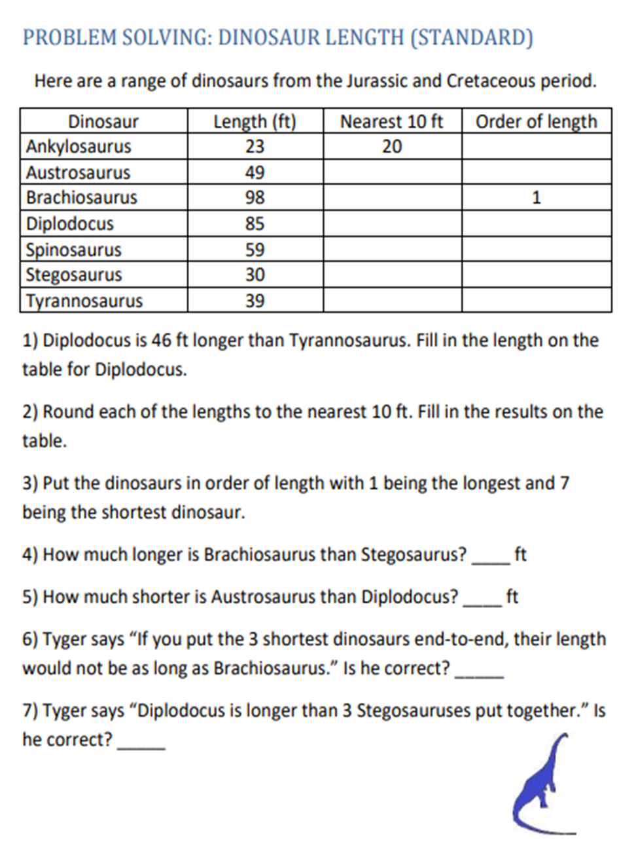**Activity** **3**

**Closing Ceremony**

Spell your name using a dinosaur for each letter

**Scouting at Home**

What else can I do to link my activities to scouting?

Below is a list of some other activities that we could try to show the different skills we have through scouting, link to the international theme.

|  |  |  |
| --- | --- | --- |
| **Skill** | **Description** | **Achieved** |
| **communicator** | **Make a diary entry about all the things that are different between your day now and before lockdown** |  |
| **International** | **Find out 3 facts about 6 counties you would like to visit, and 3 places you would visit and why when you got there** |  |
| **Physical Recreation** | **It’s an important to exercise even when you’re stuck at home. Make a video showing how you warm up in order keep fit in your house. Measure your heart rate before and after you do your exercise.** |  |
| **Performing Arts** | **Create video of you highlighting the importance of washing your hands** |  |
| **Chef** | Plan, cook serve and clean up after a full, balanced menu for a for your family covering all meals for at least four days. |  |
| **Global issues** | **Spend three days living on food that costs no more than £2 a day. Share with others about how it went including a top tip for cooking meals with so little money. This could be a discussion, blog, video diary** |  |

**Please keep scouting and send in pictures of all you achieve to the group and district so we can all share in each other’s accomplishments.**

**Yours in Scouting**

**GSL**