Weekly Program
Week 4
Activity Booklet
Prayer and Reflection

Dear All,
While we currently are unable to meet each week Thames Ridge will be producing a weekly program pack for you to share with each section offering a range of activities and challenges to keep us all scouting during this difficult time.
We will be using this to support all the young people in their continued efforts to work towards their top awards and to offer comfort to those whom scouting forms a vital part of their weekly routines. We will endeavour in this time to ensure no young person misses out on the values and support scouting provides.
If you have any suggestions of questions relating to what we are offering please send in your thoughts to ddc-program@thamesridgescouting.org.uk also please send in any photos of the activities that have been produced by your group for us to share with others in the district group to photos@thamesridgescouts.org.uk
Yours in Scouting
The District Team

Opening Ceremony
Build a flagpole out of paper and attach a paper flag to start your opening ceremony, take a picture/video and send it to your leader.

Prayer and Reflection
Why do you think people pray? What are we thinking about now, that we are thankful for?
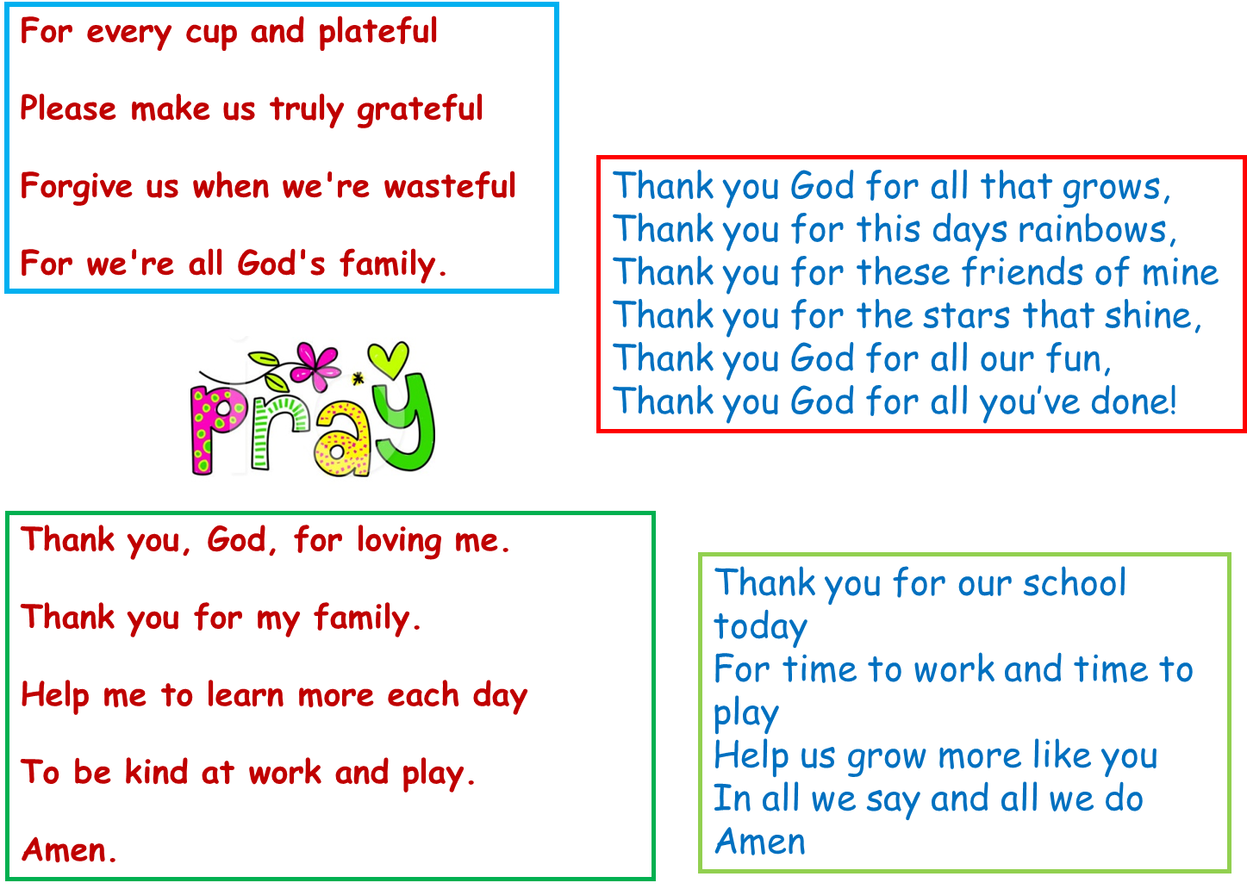

Write a prayer, to reflect on the things that are happening now.
You could write about you are thankful for now, about those working hard to support others or about you family at this time and when you can see them again. It maybe that one of your family is a key worker and you may want to write a prayer for them.

Activity 2
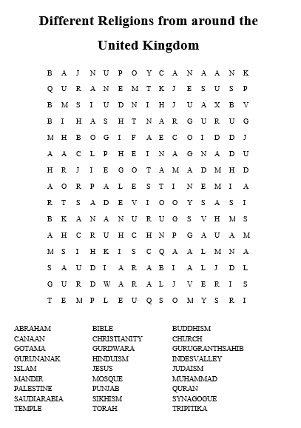

Think about when you have been helpful
We have recently celebrated Easter and St Georges Day, both Stories teach the value of Bravery in the face of adversary and that we should all strive to do the right thing.
St George slayed the Dragon to help the people of the nearby village, and Jesus died on the cross to save people from their sins. Write a story to explain doing your best to the younger sections it can either be factual or fictional.

Reflects upon and explore your own beliefs, attitudes and values (this may or may not include religious beliefs).
What values do we share as Scouts? Which Scout value means the most to you? How can we continue to use these values in our current situation?

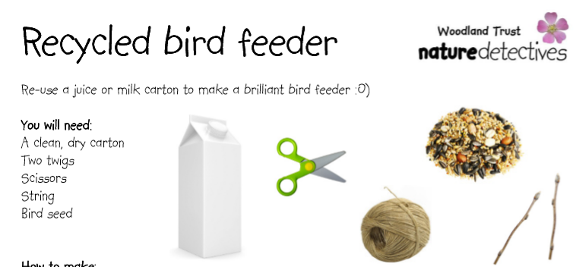
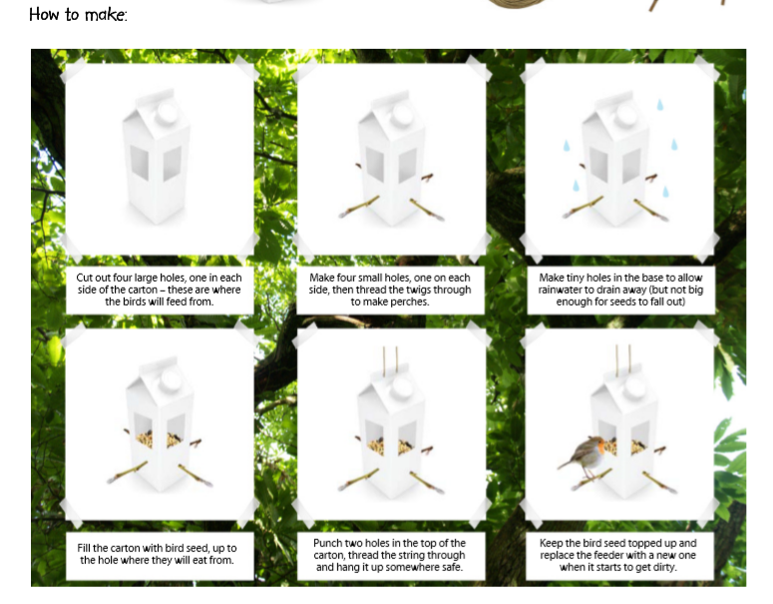When we think of others its not just other people, we should also think of the world around us and the different animals. By making a bird feeder we are helping to encourage birds to come into our gardens.

Dingbats
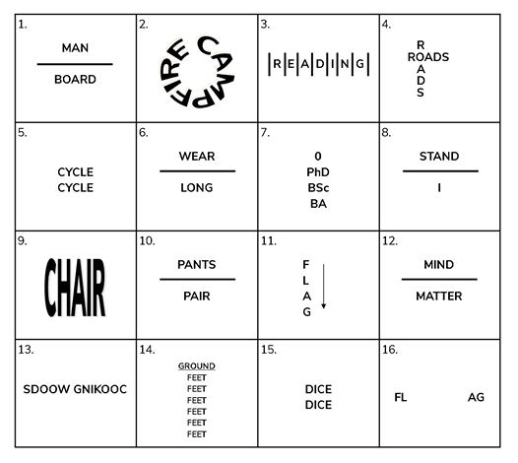

Closing Ceremony
Lower the flag you have made to signal the end of your explorer scout meeting.

Scouting at Home
What else can I do to link my activities to scouting?
Below is a list of some other activities that we could try to show the different skills we have through scouting, link to the international theme.
Skill | Description | Achieved
communicator | Make a diary entry about all the things that are different between your day now and before lockdown
International | Find out 3 facts about 6 counties you would like to visit, and 3 places you would visit and why when you got there
Physical Recreation | It’s an important to exercise even when you’re stuck at home. Make a video showing how you warm up in order keep fit in your house. Measure your heart rate before and after you do your exercise.
Performing Arts | Create video of you highlighting the importance of washing your hands
Chef | Plan, cook serve and clean up after a full, balanced menu for a for your family covering all meals for at least four days.
Global issues | Spend three days living on food that costs no more than £2 a day. Share with others about how it went including a top tip for cooking meals with so little money. This could be a discussion, blog, video diary

Please keep scouting and send in pictures of all you achieve to the group and district so we can all share in each other’s accomplishments.

Yours in Scouting
GSL

