VE Day Weekend
9th May
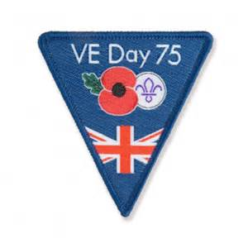

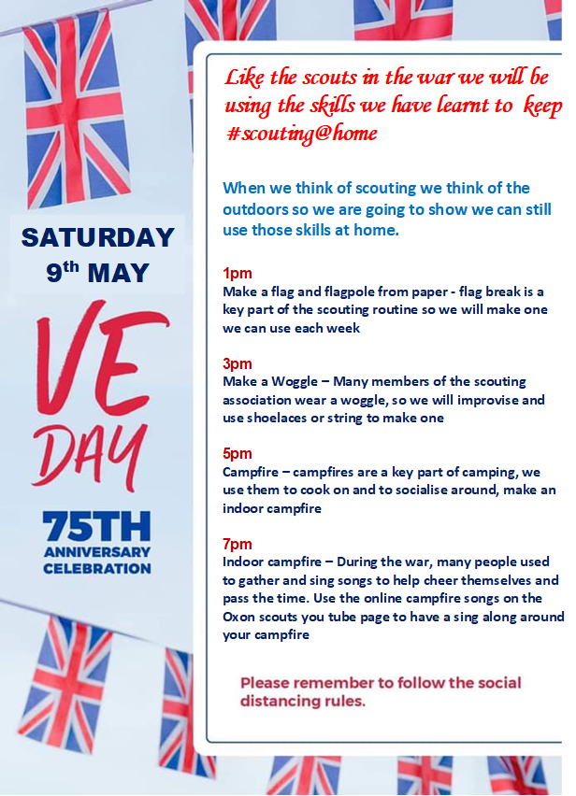

SCOUTING IN THE WAR
As Scouts we are guided by these values:
Integrity - We act with integrity; we are honest, trustworthy and loyal.
Respect - We have self-respect and respect for others.
Care - We support others and take care of the world in which we live.
Belief - We explore our faiths, beliefs and attitudes.
Co-operation - We make a positive difference; we co-operate with others and make friends.
And during the war the scouts did all they could to follow these core principles and help with the war effort. There have only be three times since scouting began when meetings have been suspended, this current period while we keep apart to stay safe during the current pandemic and during the two world wars. Like we are doing now the scouts used their initiative to keep scouting active and to follow the core values that scouting represents, and so we follow their example and just because we cannot carry on with our meeting in a tradition sense we can still use the skills and values that scouting teaches us.

THE BOY SCOUTS ARE CARRYING ON
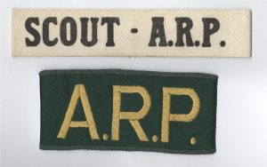
This was the slogan of the Scout Movement during the Second World War (1939 – 1945). By the end of 1940 over 53,000 Scouts had trained to undertake over hundred and seventy National War Service jobs. The Scouts were proud of its record and commissioned a booklet entitled They Were Prepared and a film Men of Tomorrow in 1941 to tell the story of their efforts.
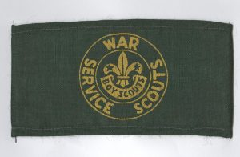

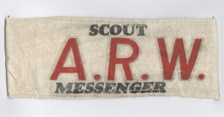

These badges and armbands were issued to Scouts undertaking official war work

EVACUATION
On the 1 September 1939 Operation Pied Piper began. This was the code name of a mass evacuation of civilians, particularly children, from areas thought to be at risk from air raids. During the War over 3.5 million people in the UK were relocated. The Government had been planning the evacuation scheme and had approached civilian organisations to assist with the programme. Older Scouts were used to help organise groups of children, carry luggage and offer comfort were necessary.
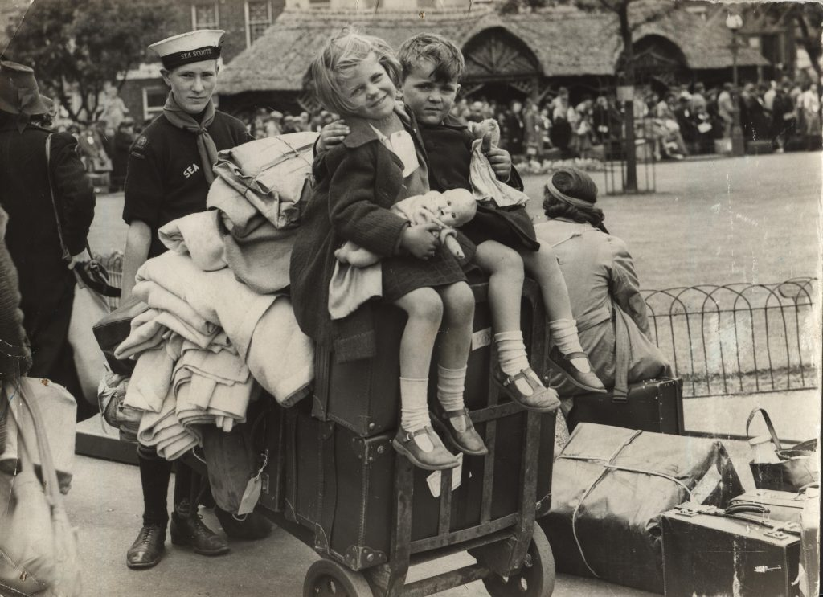
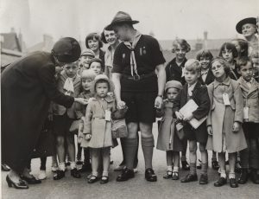

AIR RAID PRECAUTIONS
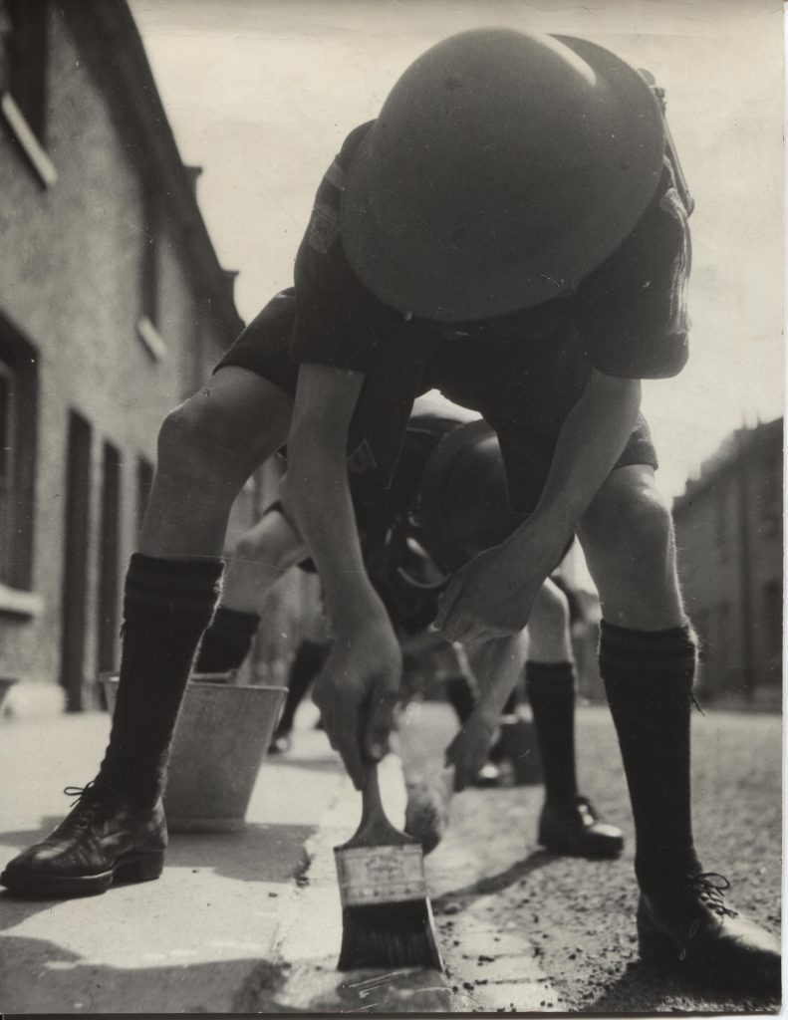
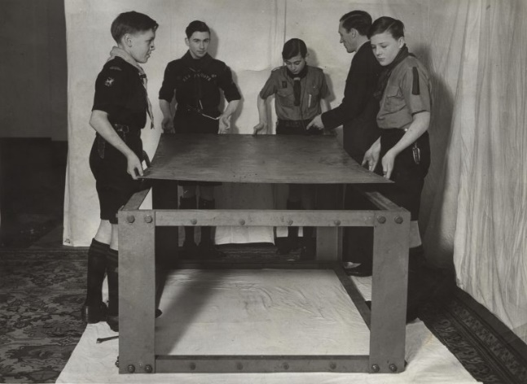
Scouts were asked to help prepare the country for air raids, this included preparing for the government imposed blackout. Teams of Scouts helped by painting white lines on the edge of roads making them more visible in the dark. Teams of Scouts could be booked to help put up air raid shelters. There were two main types of shelters, Anderson shelters which could be dug and built in the garden and Morrison shelters erected inside the house.

THE BLITZ
During the Blitz Scouts supported civilian organisations included the Air Raid Warden’s Service, fire and ambulance services. Scouts worked in very dangerous conditions as fire watchers, stretcher bearers, carrying messages, supporting evacuation of hospitals during air raids and carrying out first aid. These were all tasks which Scout training would support.
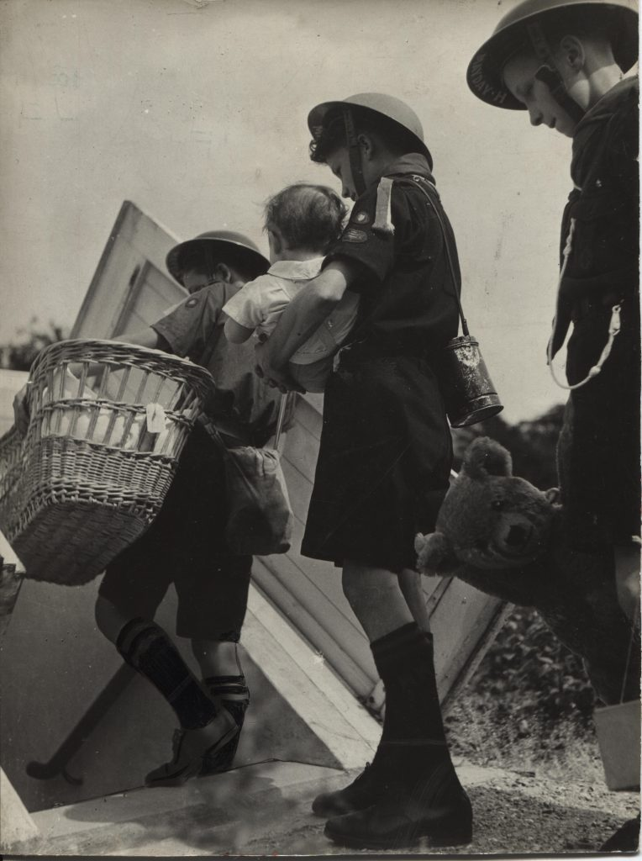
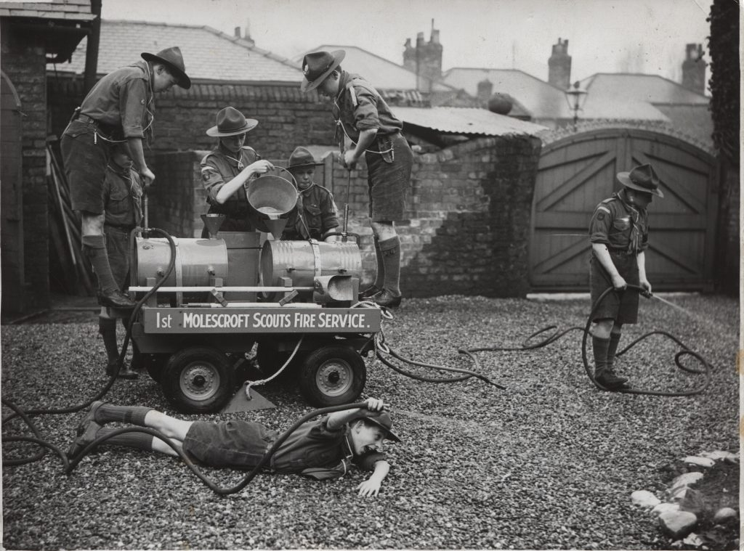

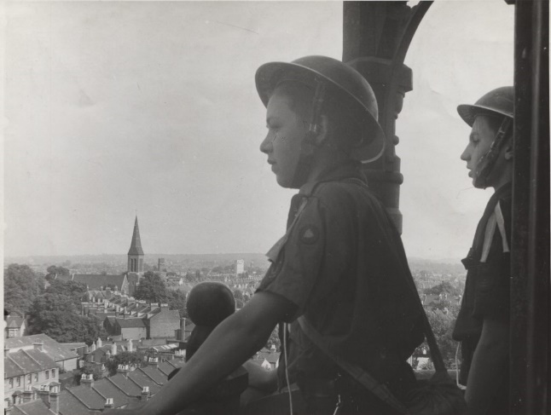
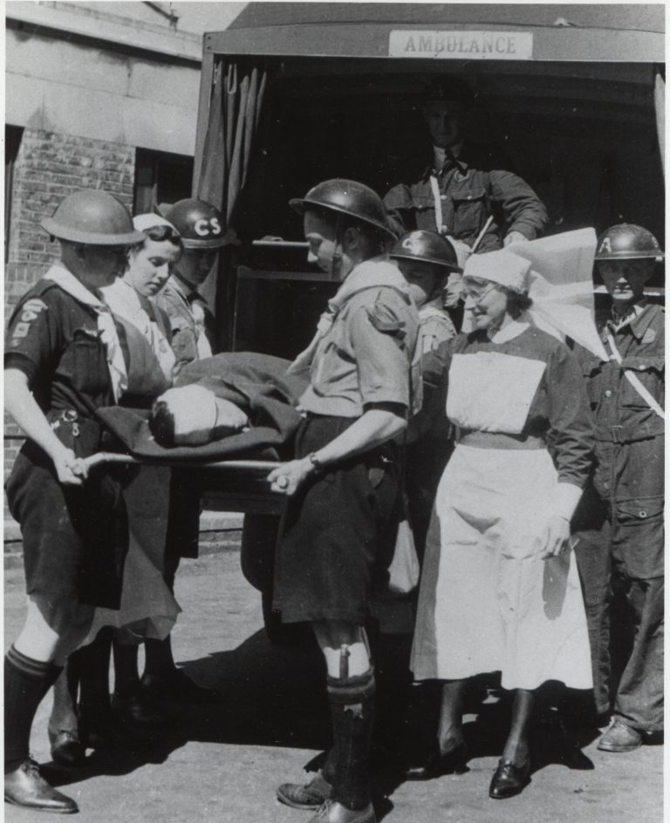

HOME GUARD
In 1940 the Home Guard was formed from volunteers who weren’t eligible for active service due to age, health or their occupation. Their role was to slow down the enemy advance in case of invasion. Scouts helped teach skills such as tracking, first aid and bushcraft to this newly formed force.
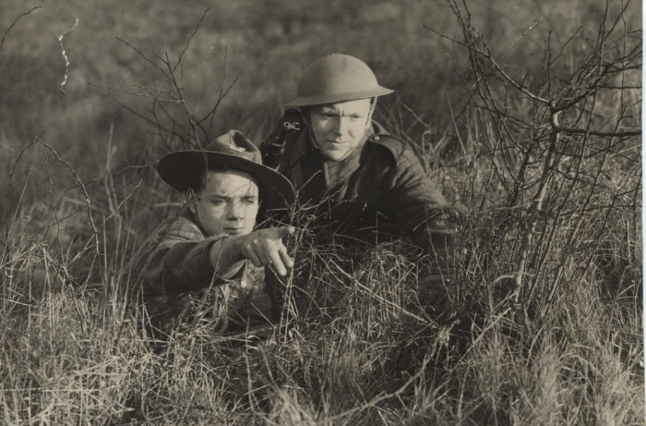

WORKING THE LAND
The Dig for Victory campaign was introduced to encourage people to convert land for food production to help increase the amount of home produced food limiting the reliance on imported goods. Scouts helped maintain plots of land including this war garden set up in the grounds of a hospital.
Scouts also carried out other tasks such as working with the Women’s Timber Corp to fell wood for the war effort. They also helped collect plants which could be used for medical purposes including sphagnum moss which has antiseptic properties and could be used in wound dressings.
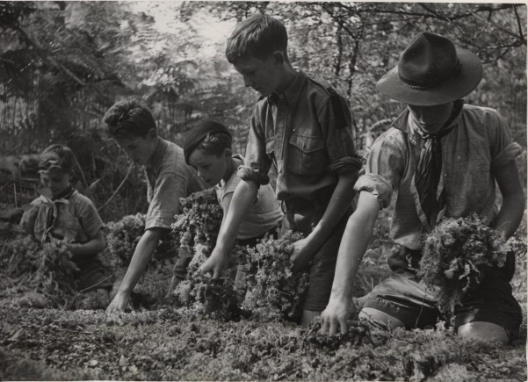
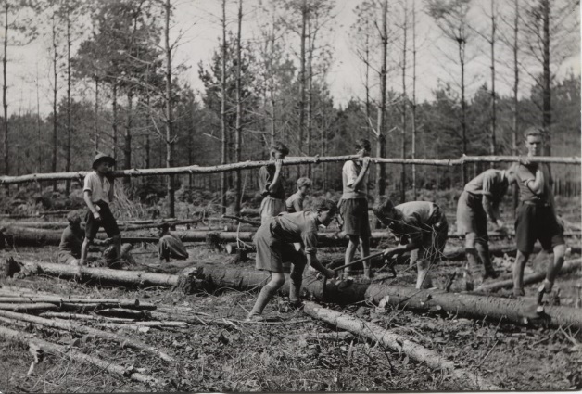
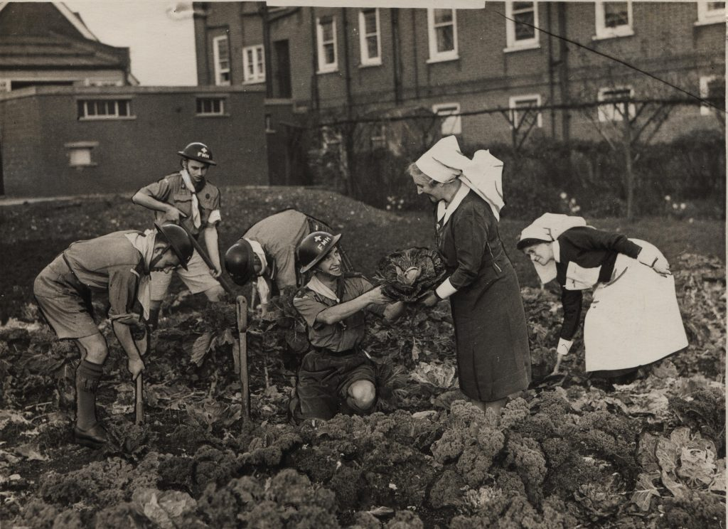

COMMUNITY SUPPORT
Scouts also carried out a range of other jobs including supporting other civilian services with provision like service cafes for those in the armed forces. Fulham District Scouts worked with the YMCA to serve refreshments from this van.
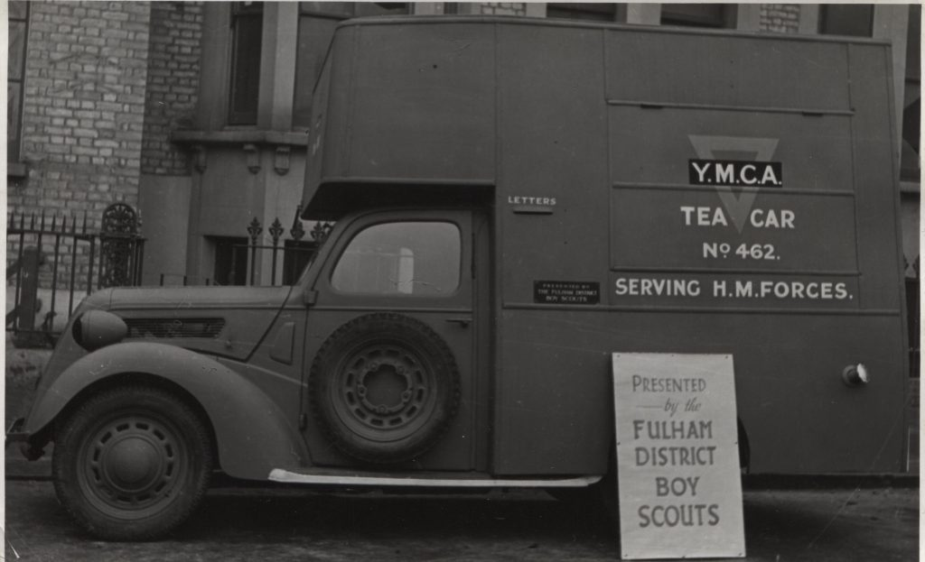
With so many adults called up to do war service many Patrol Leaders stepped into their leaders role to ensure Scouting carried on. A special certificate was issued to those who took on this responsibility. Campaigns such as the collection of waste paper and scrap metal to raise funds to support the war effort were also attractive to Scouts wanting to do their bit.
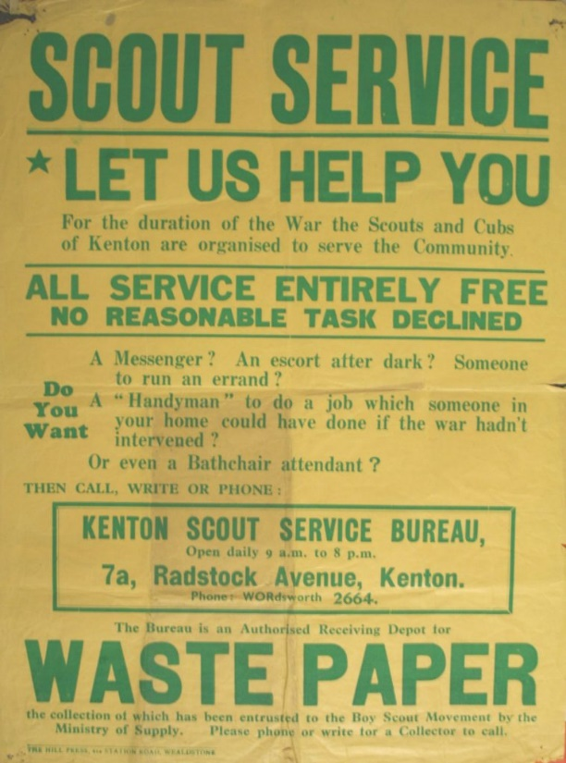

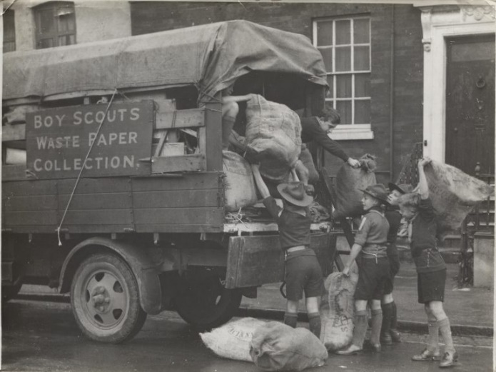

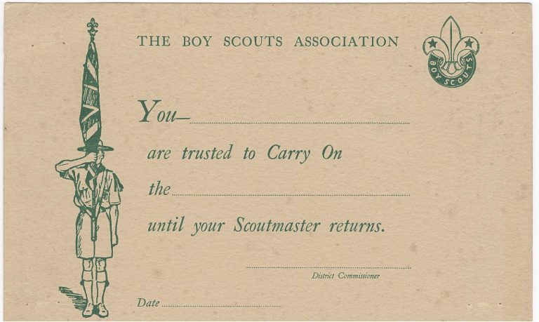

Bravery
The bravery of many Scouts was recognised through the Scouts gallantry award scheme. These included John Flinn of Sheffield, a local newspaper wrote up a report of his actions

In a hail of shrapnel, Flinn took charge of a woman who had been rescued from a demolished house, and wheeled her on a grocer’s barrow to a first-aid post. Flinn wore a saucepan on his head to protect himself during the air raid.

John was awarded the Gilt Cross, the fourth highest gallantry award for facing ‘moderate risk’ in the course of his duties. He was a Patrol Leader with 36th Sheffield (St John’s Ranmoor) Scout Group, when he won the award.
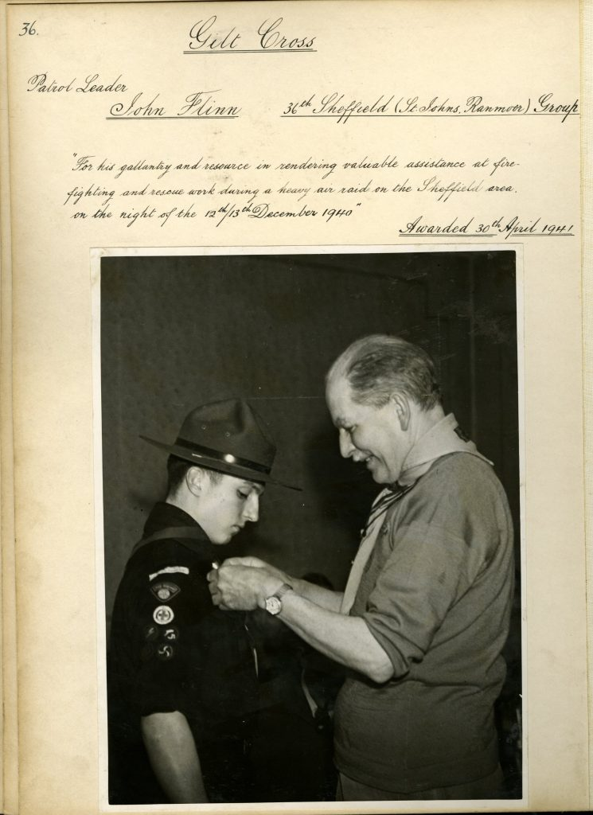

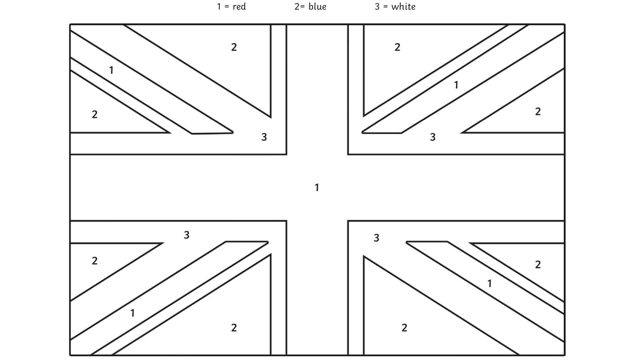

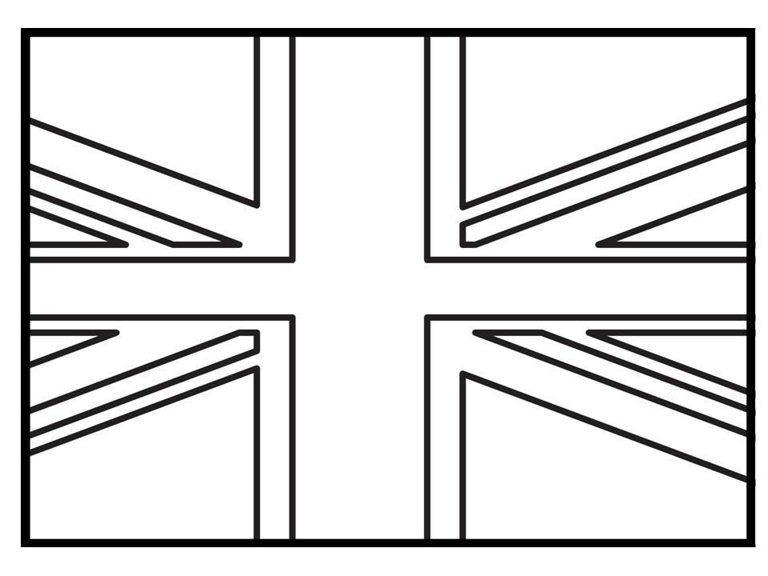

INDOOR CAMPFIRE
To prepare the ‘wood’ for your campfire, cut a square shape from a pizza box. Gather toilet roll tubes and cut kitchen towel tubes in half to use as ‘logs’. Cut brown paper bags into strips to twist into pretend kindling. Glue the tubes to the cardboard. Tear strips of bright red, orange and yellow paper to look like flames and tape them to the cardboard, placing battery-powered tea lights among them to light the ‘flames’.
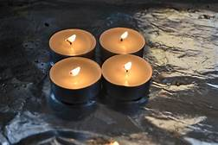
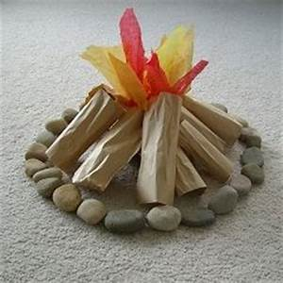

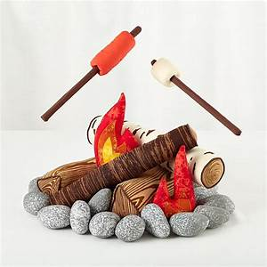

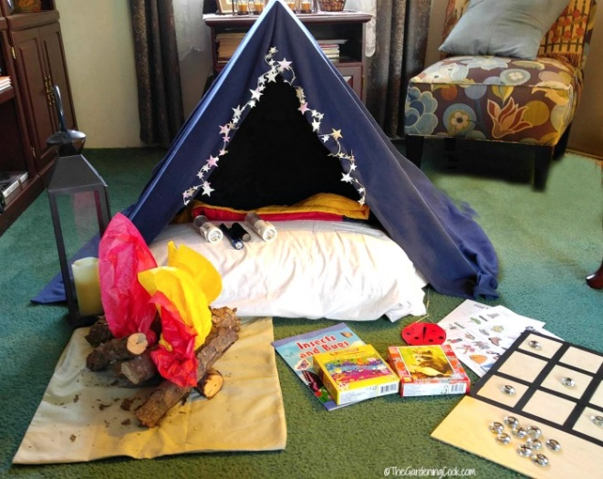

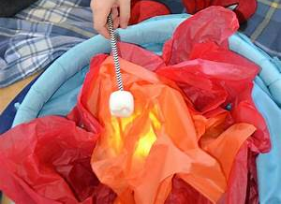

MAKE A WOGGLE
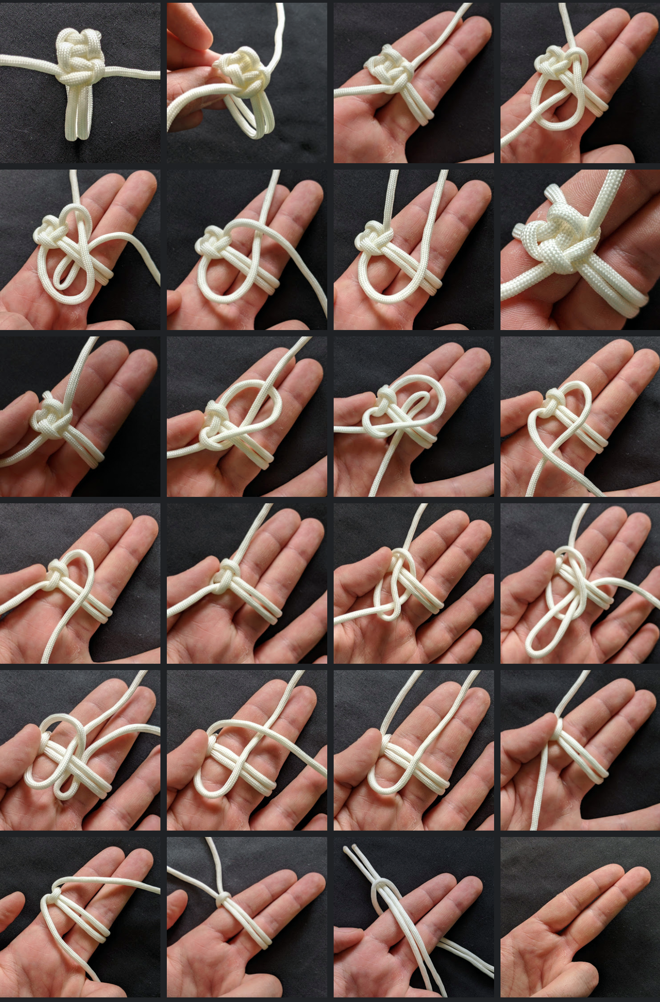
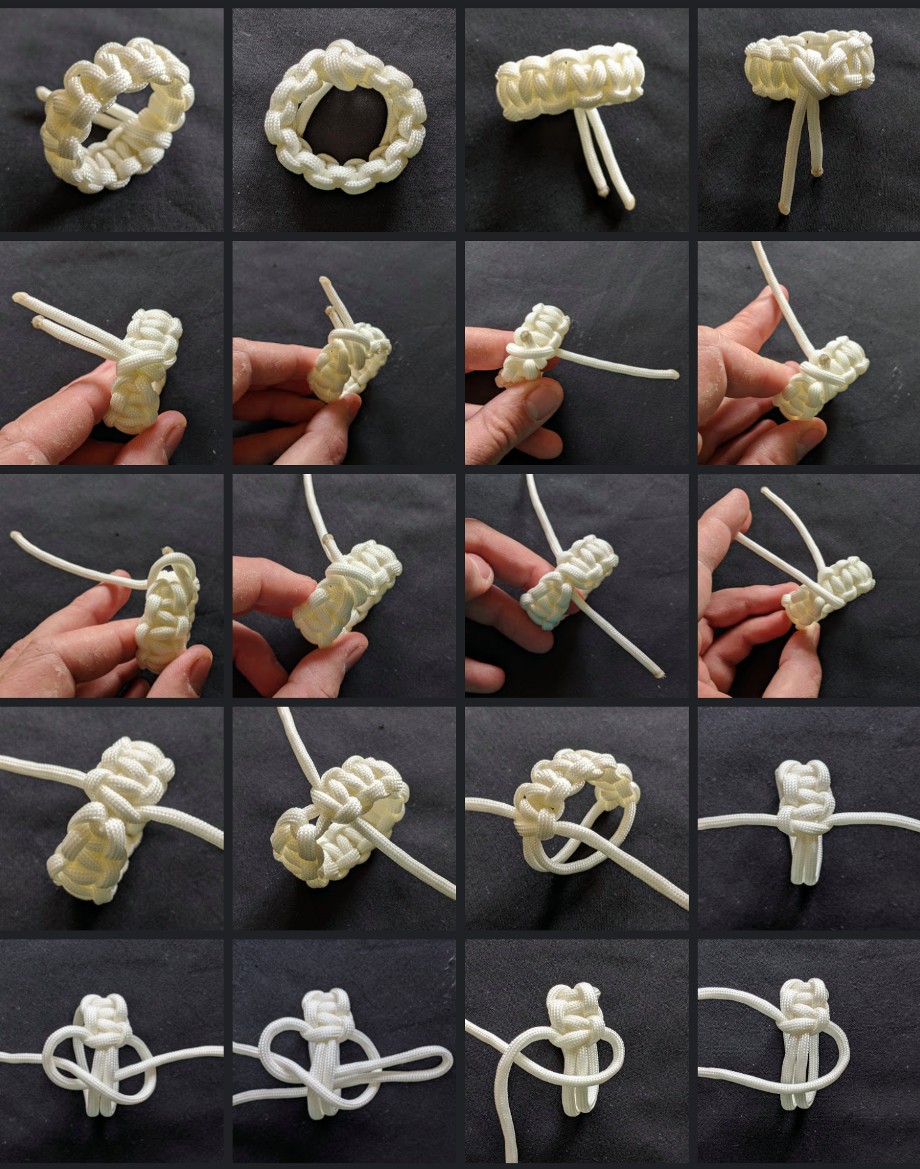

CAMPFIRE LINK
https://www.youtube.com/channel/UCcTwkvEljON_9MA2J6IJj0Q

