VE Day Weekend
10th May
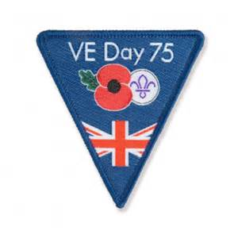

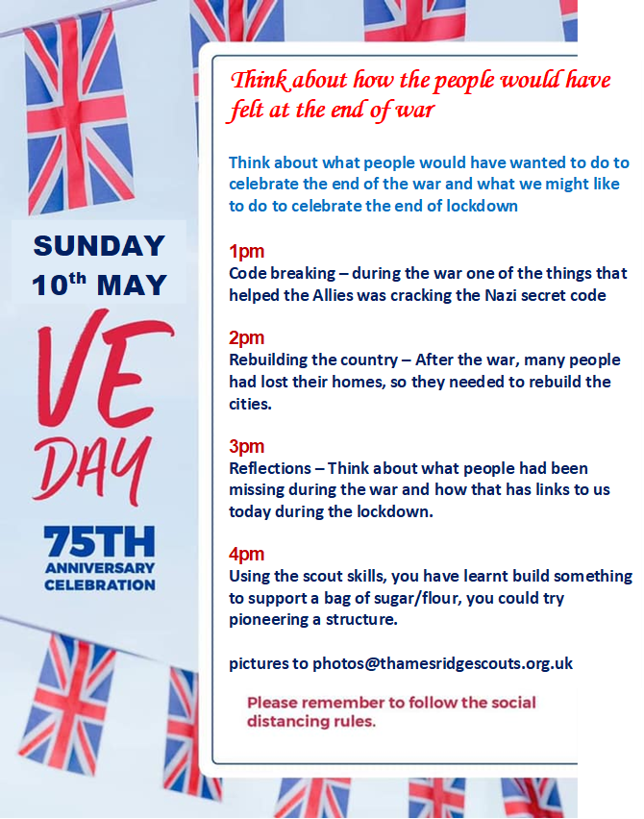

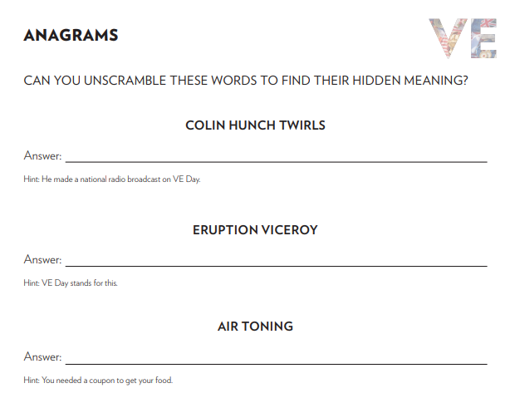

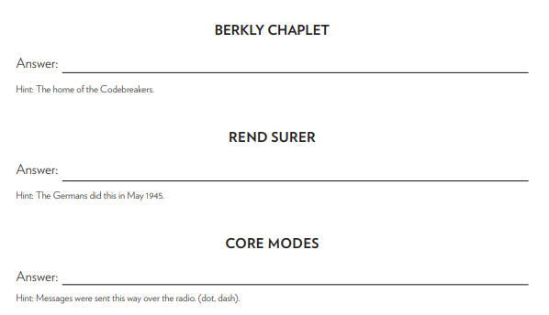

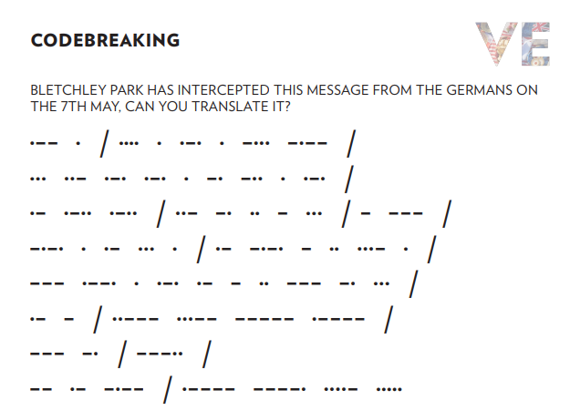

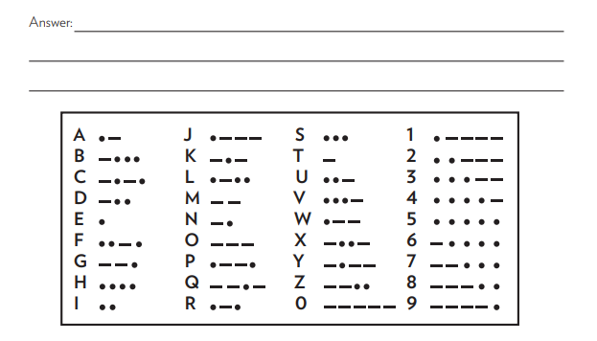

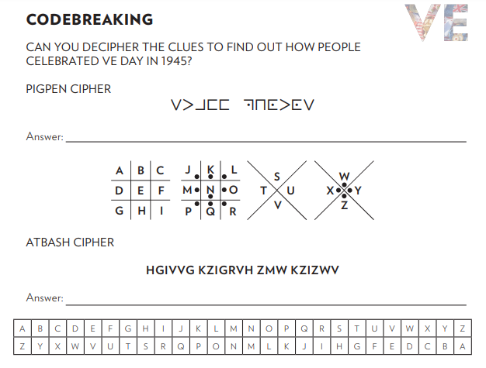

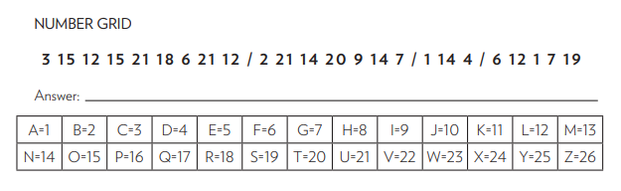

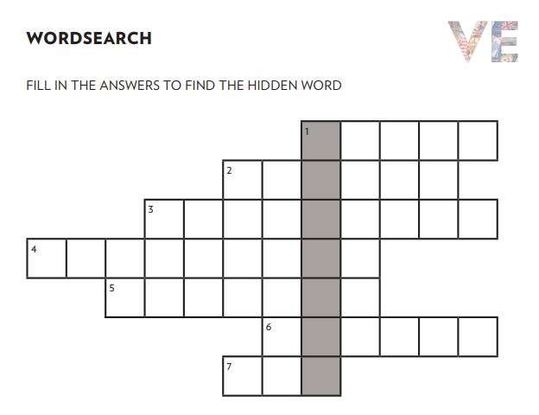
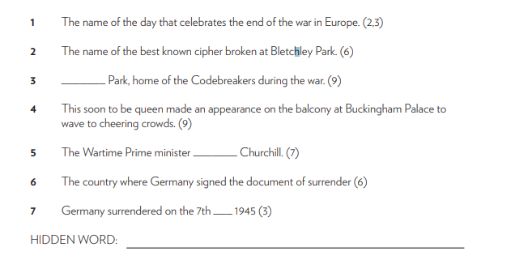

REBUILDING THE CITIES
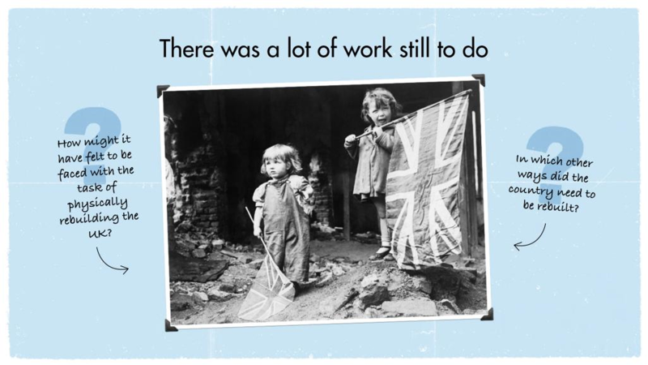

There was also an air of anti-climax. The hardships of the war years had taken their toll on many people and left them with little energy for rejoicing. In Britain, the strain of air raids, the strictures of wartime life and the impact of rationing all left their mark on a weary population who knew there were more difficulties yet to endure.
Think about the task that the country faced having to rebuild, and the opportunity it gave to redesign the way that people lived.
- Using materials such as Lego or recycling build a house of the future

- Design on paper or digitally what your dream house would look like

- Describe what you think houses in the future may look like and why

REFLECTIONS ON THEN AND NOW
In his VE Day speech, Winston Churchill said,

“Do not despair, do not yield to violence and tyranny, march straight forward.”

How can you keep going when you face difficult or worrying times?

It’s important to remember important historical events, and the people who made sacrifices, but also to remember the impact the war had on people at home and how they worked together to help out.

Right now we are facing our own challenge as a country by staying at home to help keep others safe from the covid-19 outbreak, but there are still plenty of people and causes that need help.

Like during the war we are still supporting many brave people who are risking their own lives to help others, many people are still going out to work each day to support their communities during time, like the scouts did in the war.

Write an account of why celebrating the end of the war helped bring the communities together and then think about how you will celebrate the end of lockdown and what you are most looking forward to.

