Weekly Program
Week 6
Activity Booklet
Dinosaurs

Dear All,
While we currently are unable to meet each week Thames Ridge will be producing a weekly program pack for you to share with each section offering a range of activities and challenges to keep us all scouting during this difficult time.
We will be using this to support all the young people in their continued efforts to work towards their top awards and to offer comfort to those whom scouting forms a vital part of their weekly routines. We will endeavour in this time to ensure no young person misses out on the values and support scouting provides.
If you have any suggestions of questions relating to what we are offering please send in your thoughts to ddc-program@thamesridgescouting.org.uk also please send in any photos of the activities that have been produced by your group for us to share with others in the district group to photos@thamesridgescouting.org.uk
Yours in Scouting
The District Team

Grand Howl
Make an Dinosaur from clothes or materials in your home to start your meeting and take a selfie with it.

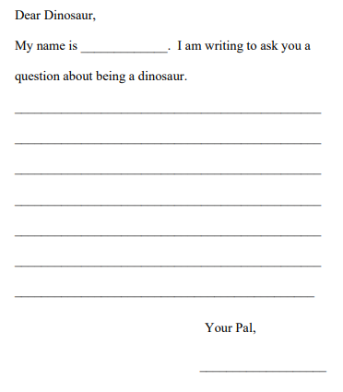
Activity 1
Imagine you could write a letter to a Dinosaur, which one would you write to and what would you ask
Dippy the Dinosaur
Dippy the Diplodocus is 115 years old this month! This majestic cast was unveiled at the Natural History Museum in London in 1905 and became a star, featuring in cartoons, in news reports and even on film and television. He is not at the Museum at the moment but on an adventure across the UK.
To celebrate Dippy this week we will be looking at Dinosaurs.
Dinosaurs
Dinosaurs are a group of reptiles that dominated the land for over 140 million years (more than 160 million years in some parts of the world). They evolved diverse shapes and sizes, from the fearsome giant Spinosaurus to the chicken-sized Microraptor, and were able to survive in a variety of ecosystems.
One of the reasons for dinosaurs' success is that they had straight back legs, perpendicular to their bodies. This allowed them to use less energy to move than other reptiles that had a sprawling stance like today's lizards and crocodiles.
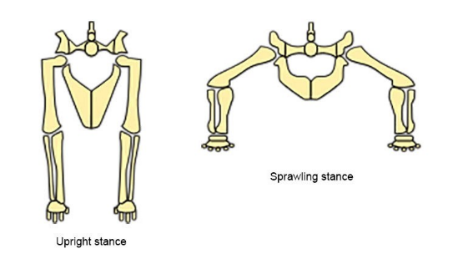
With their legs positioned under their bodies rather than sticking out to the side, dinosaurs' weight was also better supported.
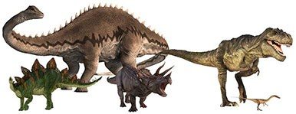

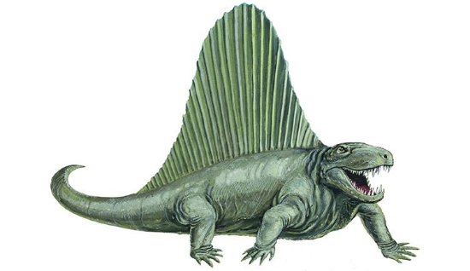

Despite its prehistoric appearance, Dimetrodon was not a dinosaur

Many dinosaur species became extinct around 66 million years ago, but a group of living dinosaurs are still with us today: birds.

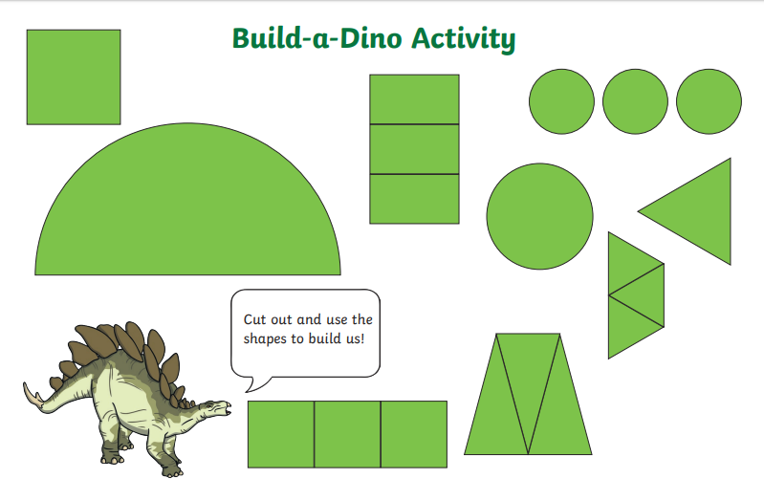

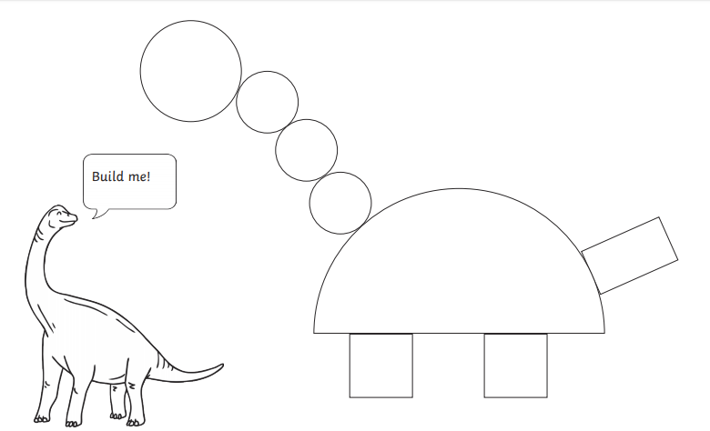

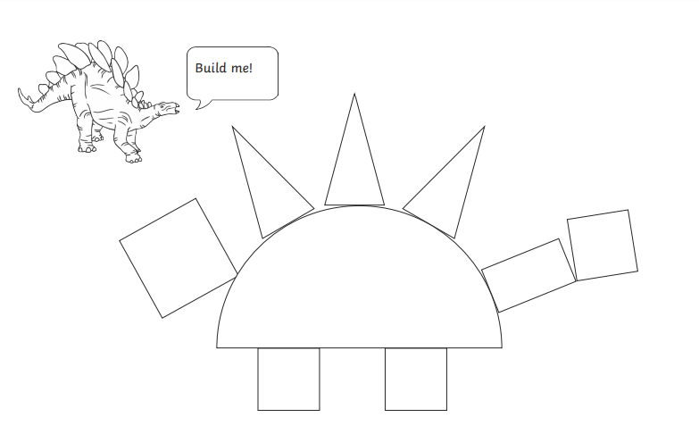

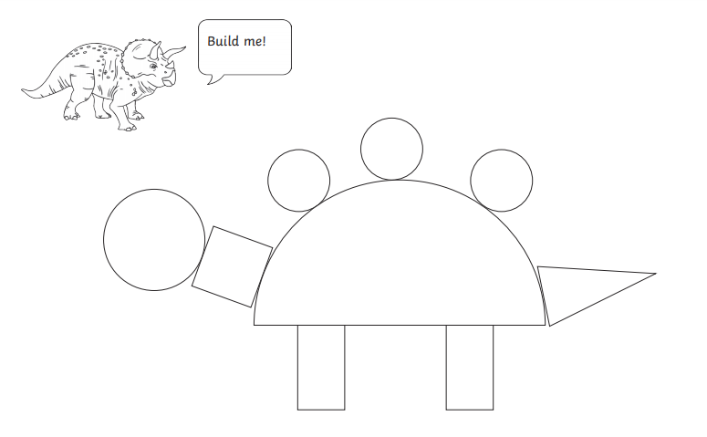

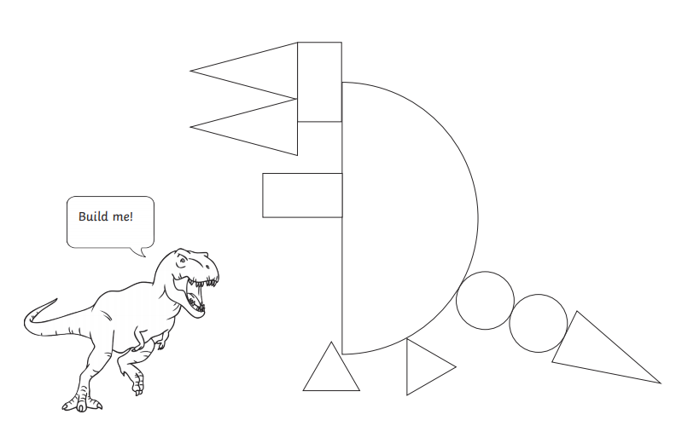

Activity 2

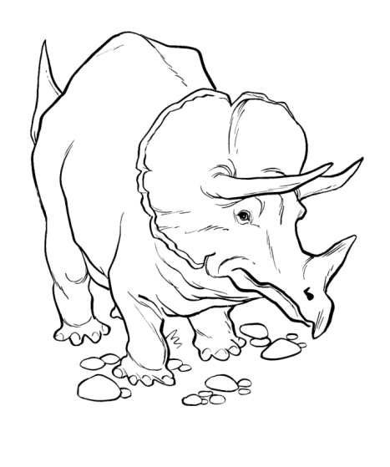

Exploding Dinosaur Mud
These dinosaurs are stuck in the mud! They need a magic potion to set them free from their lava rocks!
Supplies:
- Baking Soda
- Coffee Grounds (optional)
- Sand
- Green Food Colouring
- Vinegar
- Water

How to Make Exploding Dinosaur Rocks:
Add an entire box of baking soda (16 oz), two cups of coffee grounds, sand to desired texture, and a couple drops of green food dye for fun.
Mix all the items together in a bowl and create balls of dirt adding a small dinosaur toy if you have them to the middle as they are rolled together.
Rocks will need to dry for a couple of hours, normally about 3-4 hours in full sunlight to harden fully.
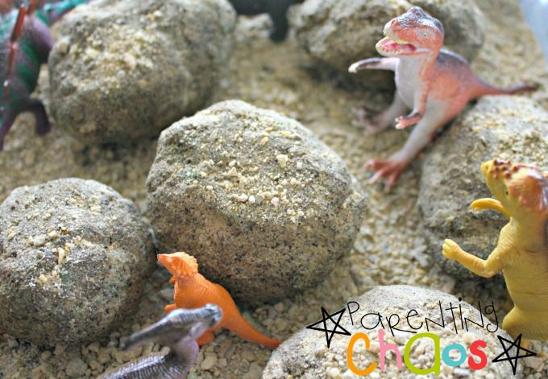

Tyrannosaurus Rex Info Hunt
Read through the information on the T-Rex and then answer the questions about it.
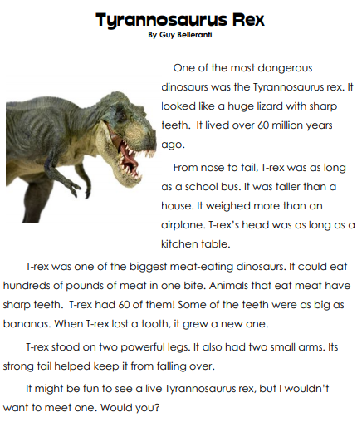

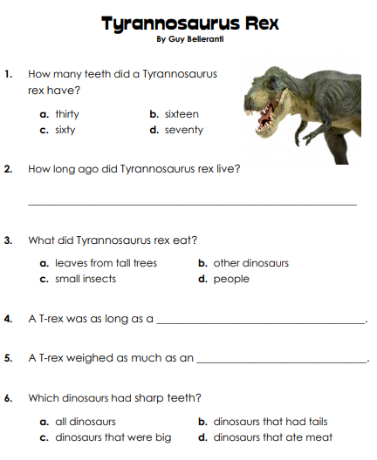

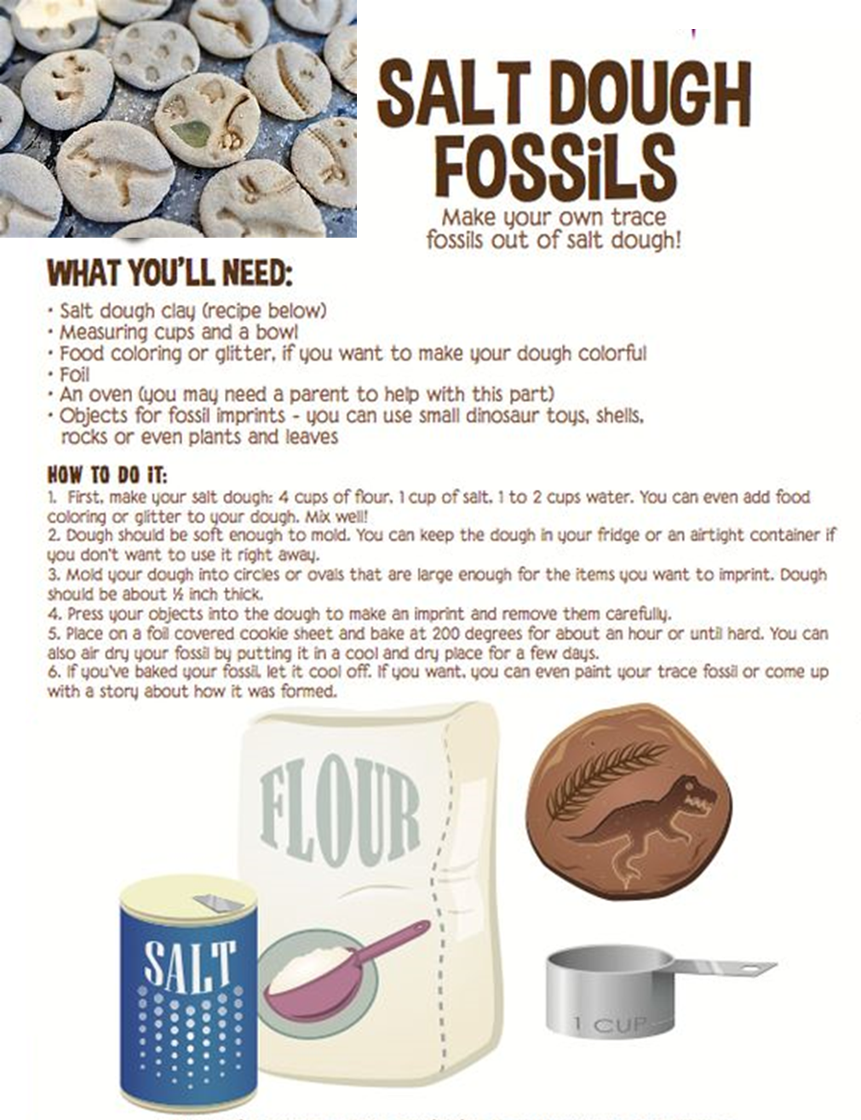

Problem solving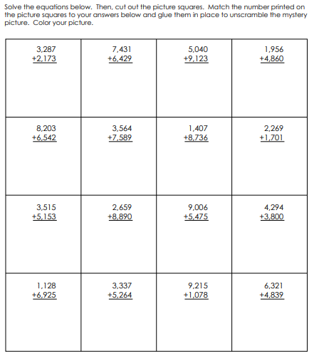

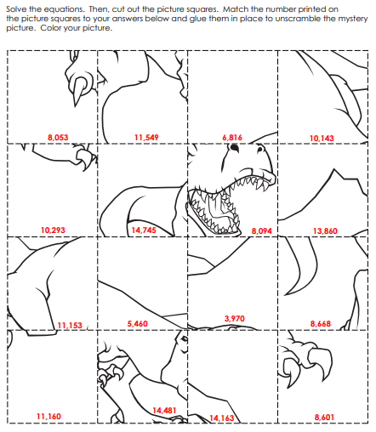

Closing Ceremony
Practice grand howl to end your meeting

Scouting at Home
What else can I do to link my activities to scouting?
Below is a list of some other activities that we could try to show the different skills we have through scouting, link to the international theme.
Skill | Description | Achieved
communicator | Make a entry about all the things that are different between your day now and before lockdown
International | Find out 3 facts about 6 counties you would like to visit
Science | Carry out a science experiment
Athletics | It’s an important to exercise even when you’re stuck at home. Make a video showing how you warm up in order keep fit in your house. Measure your heart rate before and after you do your exercise.
Book reader | Create poster showing how you would look after a book and about libraries
Chefs | Plan, cook and serve a balanced 2 course meal for your family
Cyclist | Make a presentation showing what you need to do to maintain your bike to keep it safe

Please keep scouting and send in pictures of all you achieve to the group and district so we can all share in each other’s accomplishments.

Yours in Scouting
GSL

