Weekly Program
Week 5
Activity Booklet
Exploring Nature
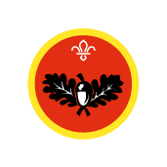

Dear All,
While we currently are unable to meet each week Thames Ridge will be producing a weekly program pack for you to share with each section offering a range of activities and challenges to keep us all scouting during this difficult time.
We will be using this to support all the young people in their continued efforts to work towards their top awards and to offer comfort to those whom scouting forms a vital part of their weekly routines. We will endeavour in this time to ensure no young person misses out on the values and support scouting provides.
If you have any suggestions of questions relating to what we are offering please send in your thoughts to ddc-program@thamesridgescouting.org.uk also please send in any photos of the activities that have been produced by your group for us to share with others in the district group to photos@thamesridgescouting.org.uk
Yours in Scouting
The District Team

Grand Howl
Make an England Flag from clothes or materials in your home to start your meeting and take a selfie with it.

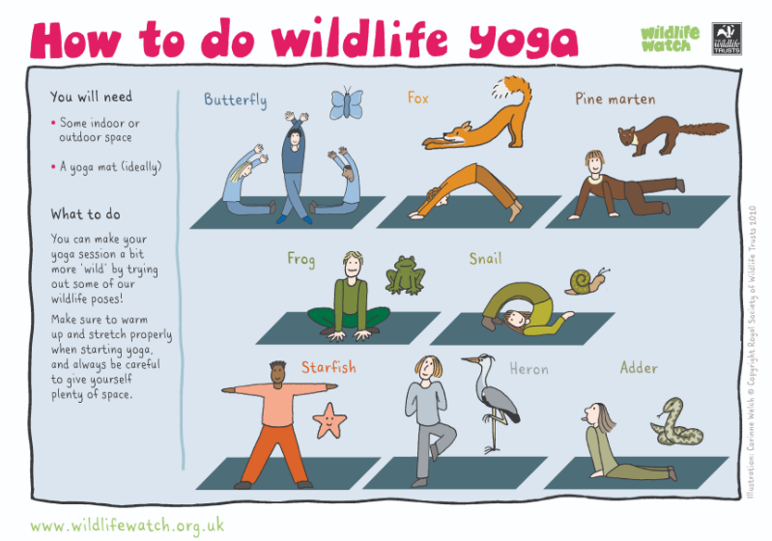
Activity 1
Have a go at doing some wildlife yoga to help keep healthy

Nature is all around us
We are going to be exploring nature, you do not have to go far to see wildlife. Even looking at of your window or standing in your garden can give great opportunities for nature spotting!
Here are some sheets to help you, find out about the wildlife that you can see in your area. Maybe you could look for different things as you go out for your daily exercise or in your own garden
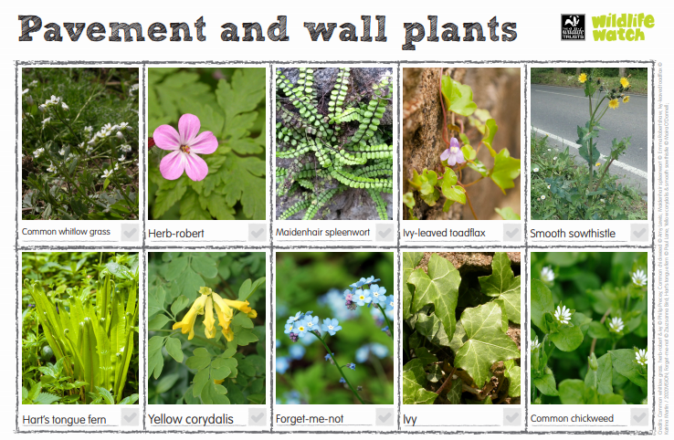

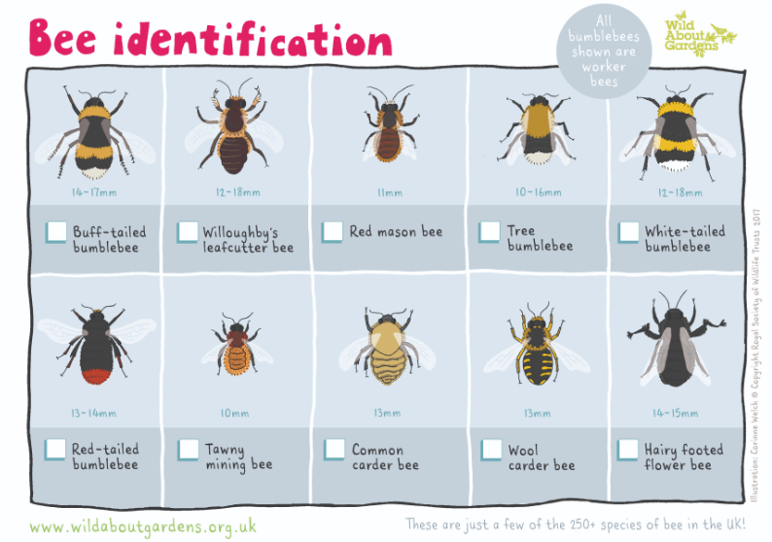

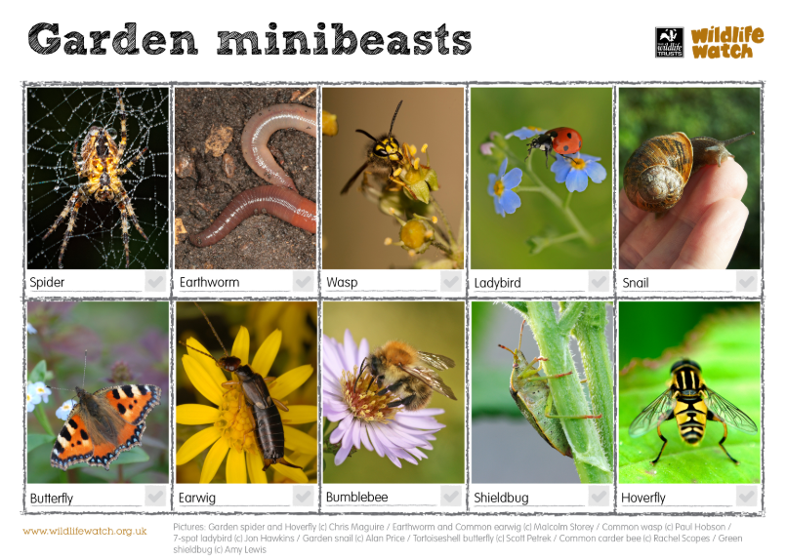

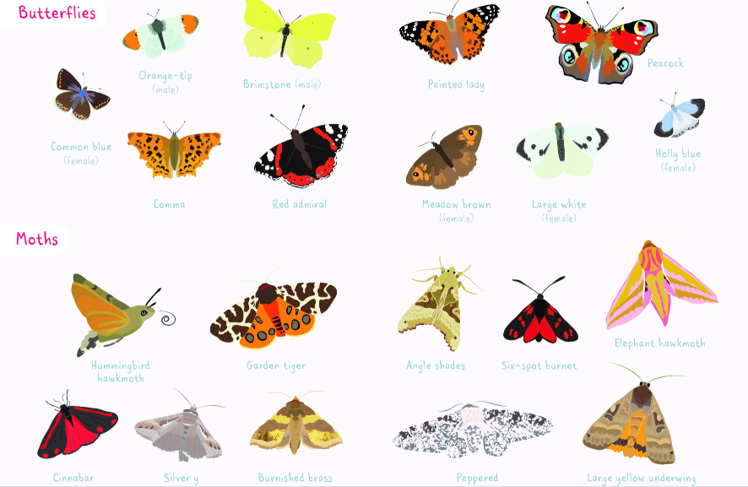

Activity 2
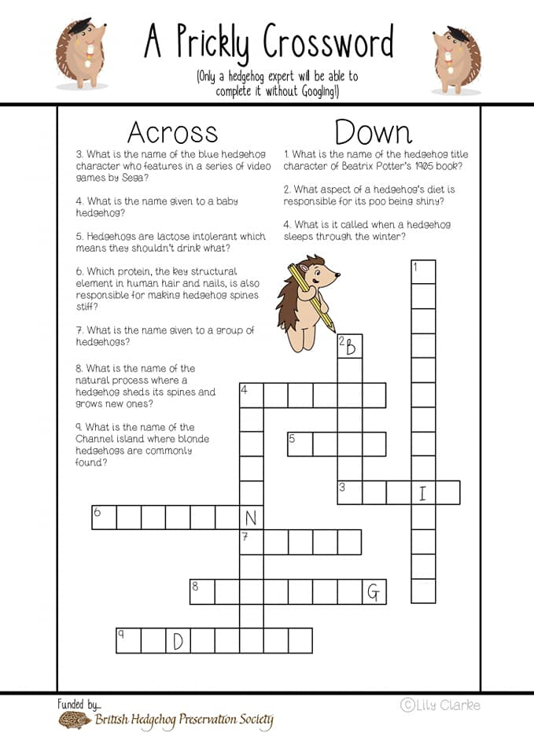

Helping Nature
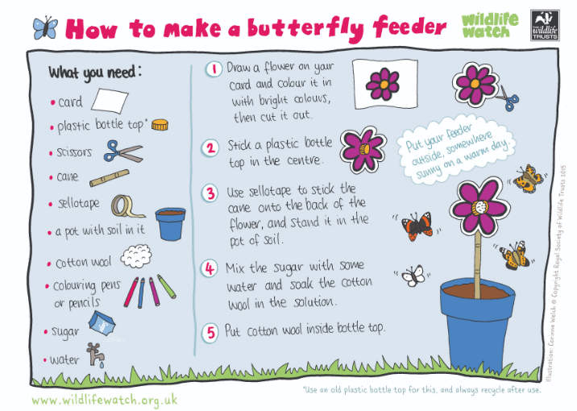
When we think of helping others it is not just other people, we should also think of the world around us and the different animals. By helping insects and other wildlife we are ensuring out areas have biodiversity.

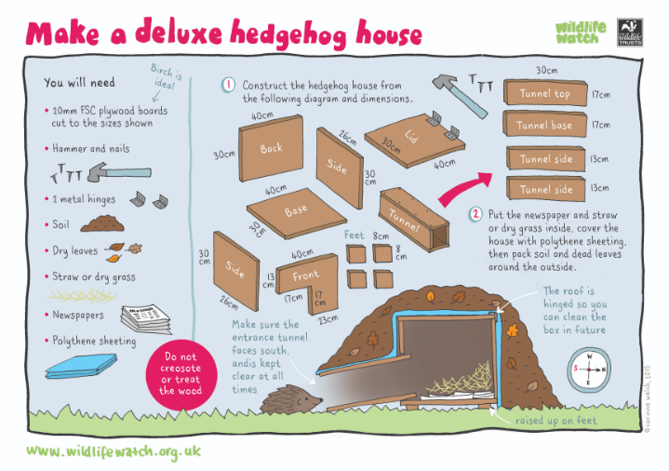

Activity 3
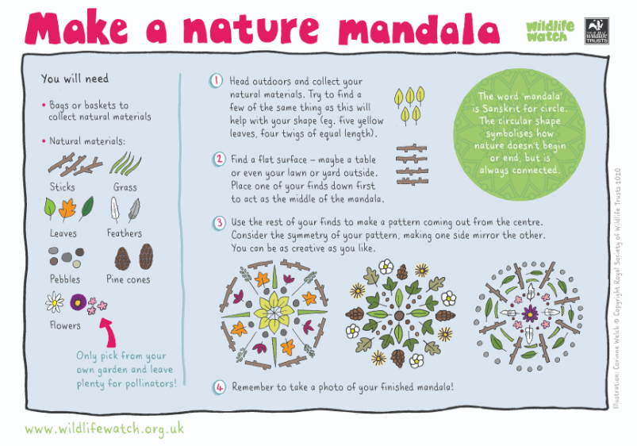

Where have you been and what have you seen
You are going to make a poster to show others where you have been and what you have seen when exploring nature.
- Draw a map of the places you have walked as part of your daily exercise
- What plants, insects, and birds you have seen along the way.
- What other animals might you find in your area

Closing Ceremony
Practice grand howl to end your meeting

Scouting at Home
What else can I do to link my activities to scouting?
Below is a list of some other activities that we could try to show the different skills we have through scouting, link to the international theme.
Skill | Description | Achieved
communicator | Make a entry about all the things that are different between your day now and before lockdown
International | Find out 3 facts about 6 counties you would like to visit
Science | Carry out a science experiment
Athletics | It’s an important to exercise even when you’re stuck at home. Make a video showing how you warm up in order keep fit in your house. Measure your heart rate before and after you do your exercise.
Book reader | Create poster showing how you would look after a book and about libraries
Chefs | Plan, cook and serve a balanced 2 course meal for your family
Cyclist | Make a presentation showing what you need to do to maintain your bike to keep it safe

Please keep scouting and send in pictures of all you achieve to the group and district so we can all share in each other’s accomplishments.

Yours in Scouting
GSL

