Weekly Program
Week 6
Activity Booklet
Dinosaurs

Dear All,
While we currently are unable to meet each week Thames Ridge will be producing a weekly program pack for you to share with each section offering a range of activities and challenges to keep us all scouting during this difficult time.
We will be using this to support all the young people in their continued efforts to work towards their top awards and to offer comfort to those whom scouting forms a vital part of their weekly routines. We will endeavour in this time to ensure no young person misses out on the values and support scouting provides.
If you have any suggestions of questions relating to what we are offering please send in your thoughts to ddc-program@thamesridgescouting.org.uk also please send in any photos of the activities that have been produced by your group for us to share with others in the district group to photos@thamesridgescouts.org.uk
Yours in Scouting
The District Team

Welcome
Make a dinosaur from natural materials in your home to start your meeting and take a selfie with it.

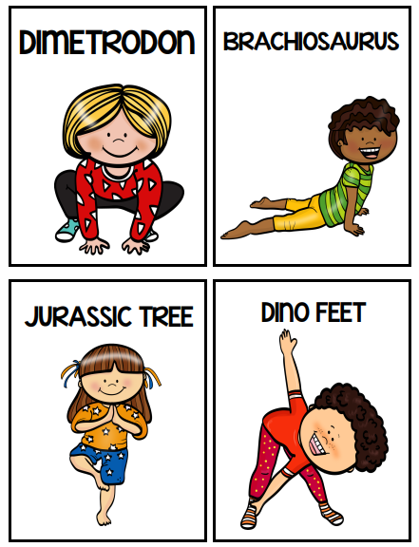
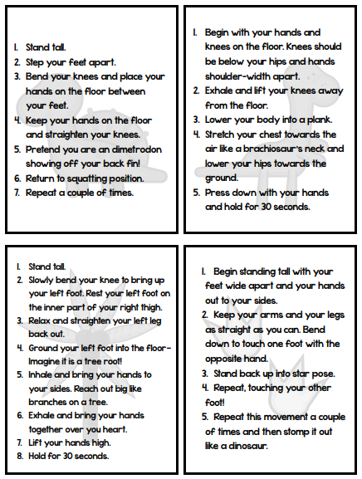
Activity 1
Have a go at doing some dinosaur yoga to help keep healthy

Dippy the Dinosaur
Dippy the Diplodocus is 115 years old this month! This majestic cast was unveiled at the Natural History Museum in London in 1905 and became a star, featuring in cartoons, in news reports and even on film and television. He is not at the Museum at the moment but on an adventure across the UK.
To celebrate Dippy this week we will be looking at Dinosaurs.
Dinosaurs
Dinosaurs are a group of reptiles that dominated the land for over 140 million years (more than 160 million years in some parts of the world). They evolved diverse shapes and sizes, from the fearsome giant Spinosaurus to the chicken-sized Microraptor, and were able to survive in a variety of ecosystems.
One of the reasons for dinosaurs' success is that they had straight back legs, perpendicular to their bodies. This allowed them to use less energy to move than other reptiles that had a sprawling stance like today's lizards and crocodiles.
With their legs positioned under their bodies rather than sticking out to the side, dinosaurs' weight was also better supported.
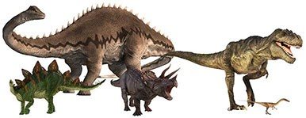
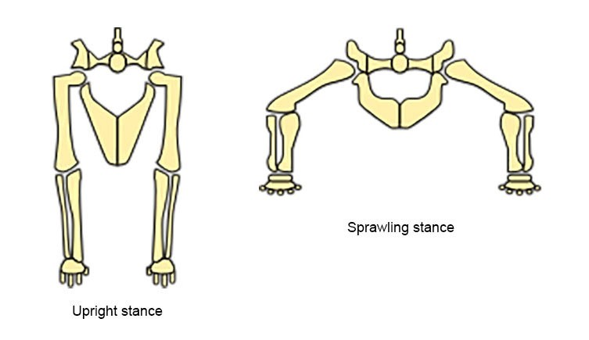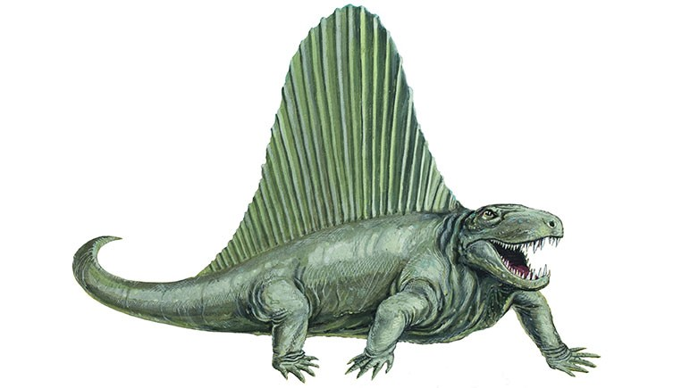
Despite its prehistoric appearance, Dimetrodon was not a dinosaur

Many dinosaur species became extinct around 66 million years ago, but a group of living dinosaurs are still with us today: birds.
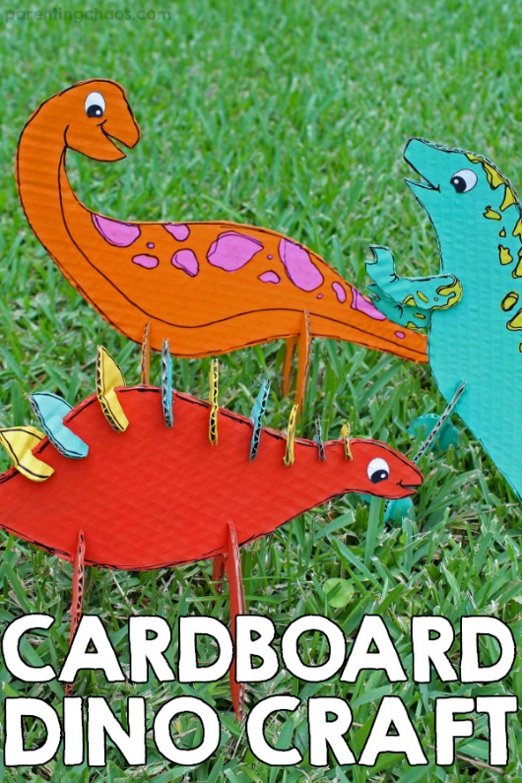
Cardboard Dinosaurs
Supplies:
- Card
- Paint
- Glue
- Scissors
- Paint Brush

Directions
- Download and print out the dinosaur templates
- Cut the templates out and trace them onto cardboard
- Cut the cardboard out
- Paint the dinosaurs with bright paint, allow the paint to dry completely
- Add spots and detail with black paint, allow the paint to dry completely
- Cut slits into the legs and spikes
- Assemble the dinosaurs and secure them with a dab of glue
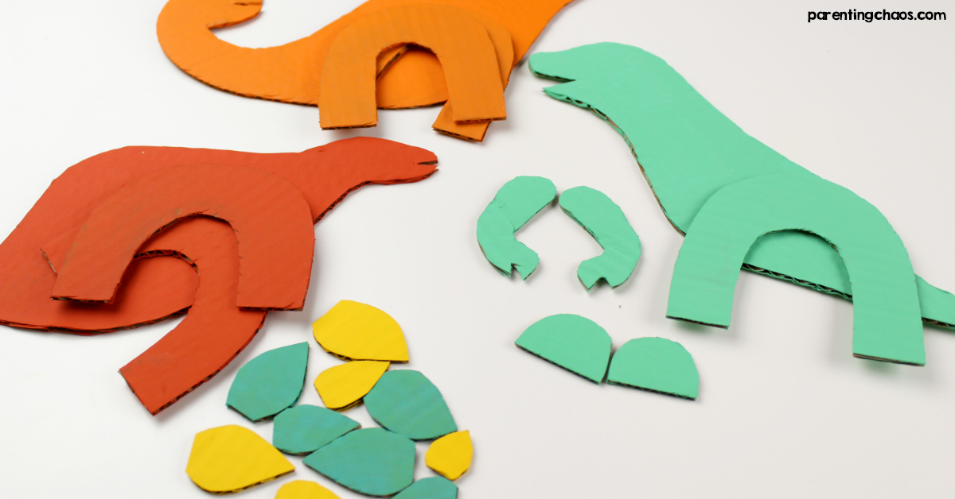

Your Dinosaurs are now ready for display, play or both!

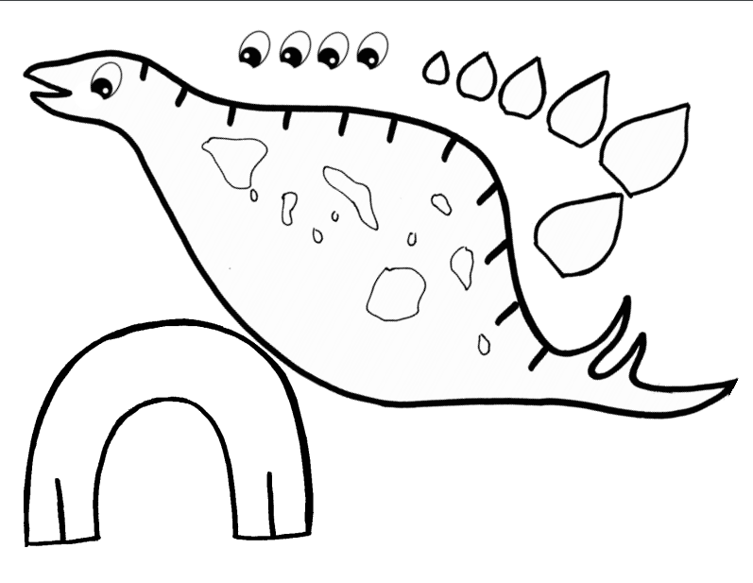

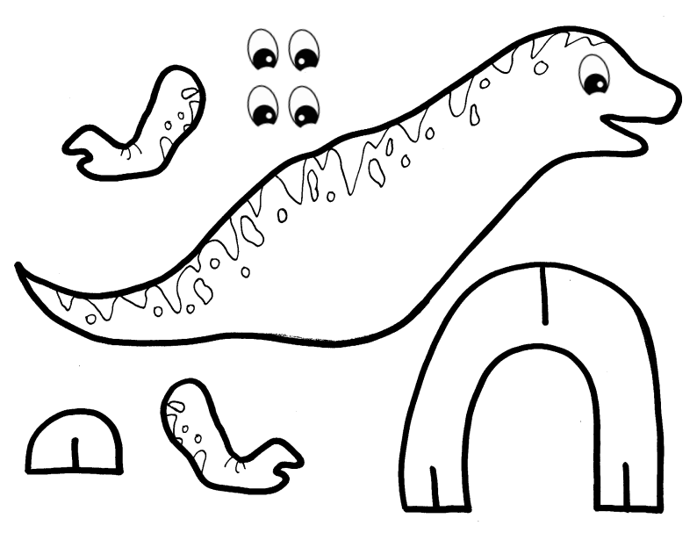

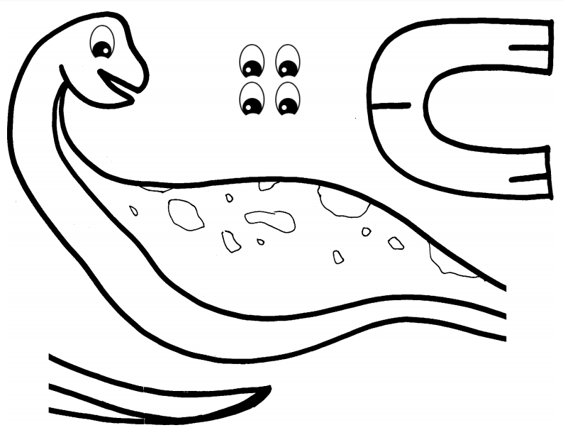

Activity 2
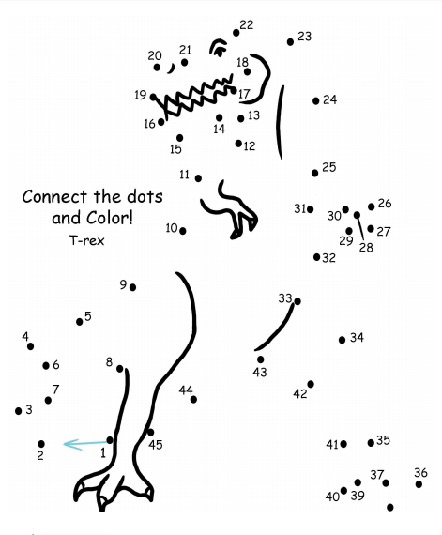

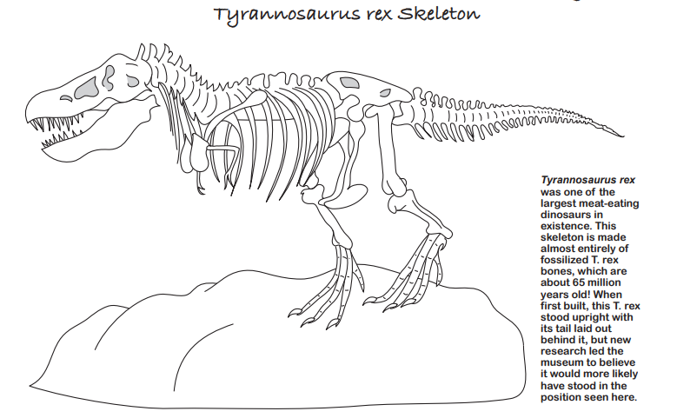

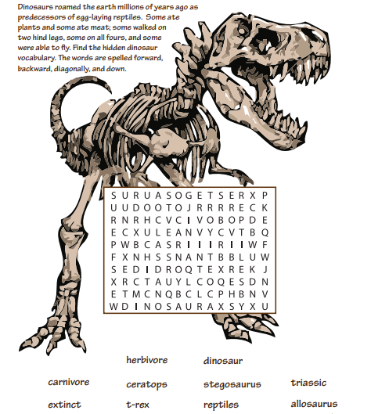

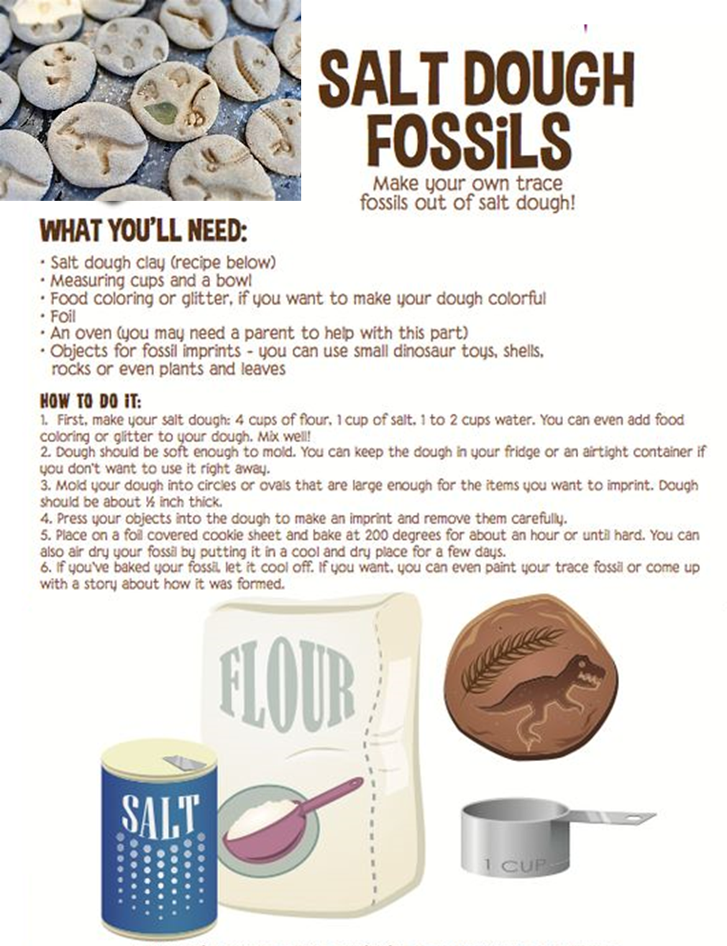

Closing Ceremony
Put all your toys and family in a circle and shout out ‘GOODBYE’ to end your beaver meeting.
Scouting at Home
What else can I do to link my activities to scouting?
Below is a list of some other activities that we could try to show the different skills we have through scouting.
Skill | Description | Achieved
communicator | Write a diary of your day and how it differs now to before the lockdown.
International | Draw the flags of 6 different countries you would like to visit.
Science | Carry out a science experiment
Health and Fitness | It’s an important to exercise even when you’re stuck at home. Make a video showing how you warm up in order keep fit in your house. Measure your heart rate before and after you do your exercise.
Creative | Make a shield that represents your family like they would do in medieval times
Health and Fitness | Test your fitness but seeing how your heartbeat changes after exercise
Cyclist | Find out what safety equipment you might need to look ride your bike

Please keep scouting and send in pictures of all you achieve to the group and district so we can all share in each other’s accomplishments.

Yours in Scouting
GSL

