Weekly Program
Week 4
Activity Booklet
Prayer and Reflection
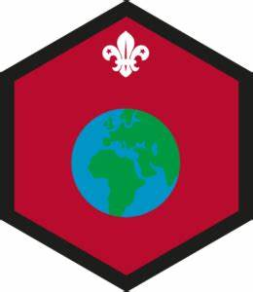

Dear All,
While we currently are unable to meet each week Thames Ridge will be producing a weekly program pack for you to share with each section offering a range of activities and challenges to keep us all scouting during this difficult time.
We will be using this to support all the young people in their continued efforts to work towards their top awards and to offer comfort to those whom scouting forms a vital part of their weekly routines. We will endeavour in this time to ensure no young person misses out on the values and support scouting provides.
If you have any suggestions of questions relating to what we are offering please send in your thoughts to ddc-program@thamesridgescouting.org.uk also please send in any photos of the activities that have been produced by your group for us to share with others in the district group to photos@thamesridgescouts.org.uk
Yours in Scouting
The District Team

Welcome
Make an England Flag from materials in your home to start your meeting

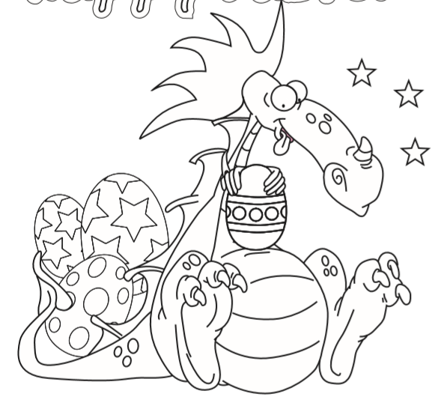
Activity 1
We have recently celebrated Easter and St Georges Day, both Stories teach the value of Bravery in the face of adversary and that we should all strive to do the right thing.

Prayer and Reflection
Why do you think people pray? What are we thinking about now, that we are thankful for?
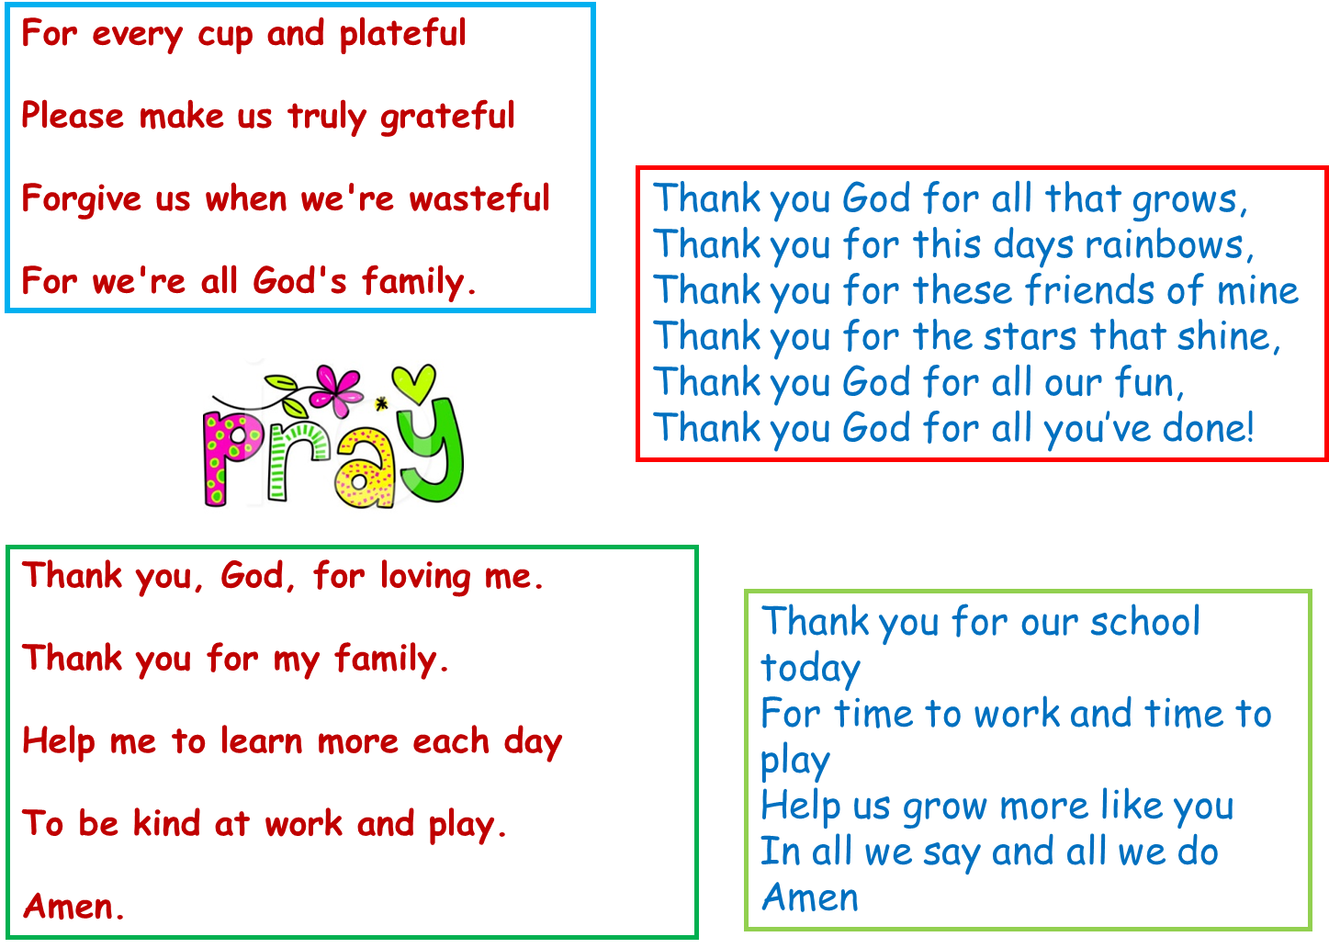

Write a prayer, to reflect on the things that are happening now.
You could write about you are thankful for now, about those working hard to support others or about you family at this time and when you can see them again. It maybe that one of your family is a key worker and you may want to write a prayer for them.

Activity 2
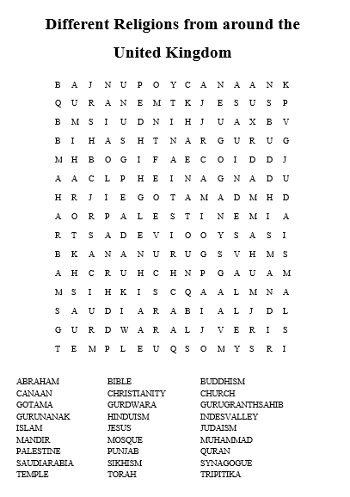

Think about when you have been helpful
St George slayed the Dragon to help the people of the near by village, and Jesus died on the cross to save people from their sins. Both these are stories of helping others, find another story about and write it out about doing your best and helping others.

Think about how this might link to your promise. What could you do to at the moment to show you are kind and helpful.

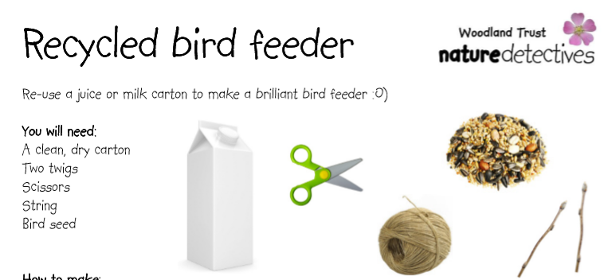
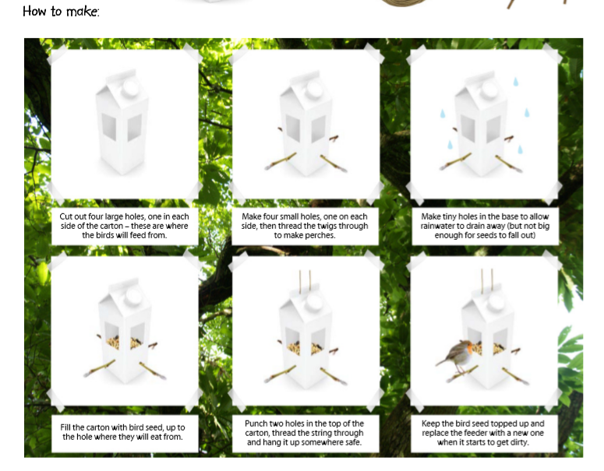When we think of others its not just other people, we should also think of the world around us and the different animals. By making a bird feeder we are helping to encourage birds to come into our gardens.

Closing Ceremony
Put all your toys and family in a circle and shout out ‘GOODBYE’ to end your beaver meeting.
Scouting at Home
What else can I do to link my activities to scouting?
Below is a list of some other activities that we could try to show the different skills we have through scouting, link to the international theme.
Skill | Description | Achieved
communicator | Write a diary of your day and how it differs now to before the lockdown.
International | Draw the flags of 6 different countries you would like to visit.
Science | Carry out a science experiment
Health and Fitness | It’s an important to exercise even when you’re stuck at home. Make a video showing how you warm up in order keep fit in your house. Measure your heart rate before and after you do your exercise.
Creative | Make a shield that represents your family like they would do in medieval times
Health and Fitness | Test your fitness but seeing how your heartbeat changes after exercise
Cyclist | Find out what safety equipment you might need to look ride your bike

Please keep scouting and send in pictures of all you achieve to the group and district so we can all share in each other’s accomplishments.

Yours in Scouting
GSL

