Scouting Program
Activity Booklet
Easter

Dear All,
While we currently are unable to meet each week Thames Ridge will be producing a weekly program pack for you to share with each section offering a range of activities and challenges to keep us all scouting during this difficult time.
We will be using this to support all the young people in their continued efforts to work towards their top awards and to offer comfort to those whom scouting forms a vital part of their weekly routines. We will endeavour in this time to ensure no young person misses out on the values and support scouting provides.
If you have any suggestions of questions relating to what we are offering please send in your thoughts to ddc-program@thamesridgescouting.org.uk also please send in any photos of the activities that have been produced by your group for us to share with others in the district group.
Yours in Scouting
The District Team

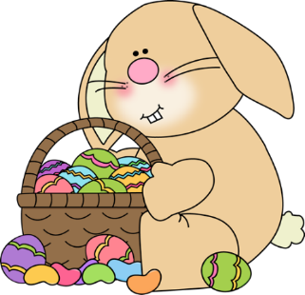
What is Easter?
- Easter is the most important Christian festival.
- Christians are followers of Jesus Christ who lived about 2000 years ago in a country called Palestine. They believe that Jesus was the son of God.
- At Easter time Christians remember the last week of Jesus' life.

Where does Easter get it’s name from?

- One belief is that Easter got its name from the Goddess of Spring called Eostre who some people worshipped long before Jesus was born.
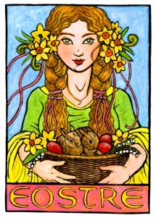
- At that time it was thought that the sun died in winter and was born again in spring when days would lengthen and the sun’s power would return.
- In Europe, Eostre was honoured as the bringer of spring.
When is Easter?

- Easter Day is always on a Sunday, but the date varies from year to year (unlike Christmas which is always on December 25).
- Many years ago Christians decided that Easter Day should be always be on the Sunday following the first full moon after the first day of Spring on March 21.
- This means that Easter can be as early as 22 March or as late as 25 April. For this reason Easter is called a movable feast.
What have eggs got to do with Easter?
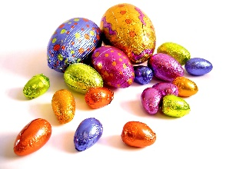

- The custom of giving eggs at Easter is celebration of new life.
- Eggs were always thought to be special because although they do not seem alive, they have life within them especially at springtime when chicks hatch out.
- Long ago people gave gifts of eggs carved from wood or precious stones.
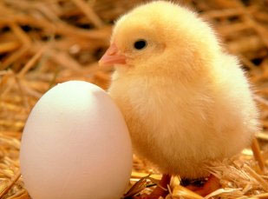
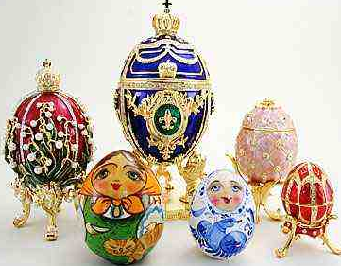

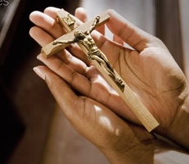
What is Good Friday?
(Apart from a holiday)
- On Good Friday Christians remember the day that Jesus was killed on the cross by Roman soldiers.
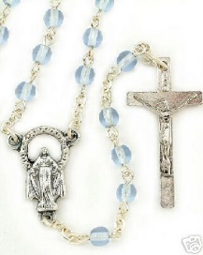
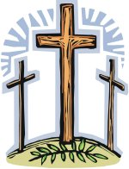
- This is the reason why the cross is an important sign for Christians today. There are crosses in churches and many Christians wear a cross on a chain.
Why is it called Good Friday?

- It is known as Good Friday because Christians believe that Jesus gave up his life for the good of everyone.
- At Easter people eat hot cross buns which have a cross shape on the top.
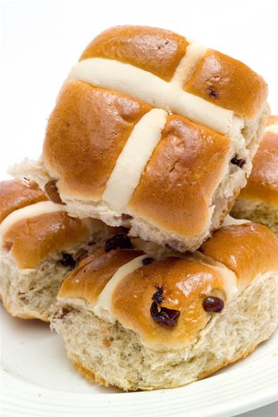
- Good Friday is a sad day and churches never have flowers or decorations on this day. The church is left dark and there is just a simple cross on the altar.
What do Christians celebrate on Easter Sunday?

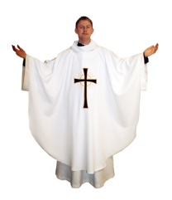

- Easter Sunday is a happy day for Christians because they believe that Jesus rose from the dead and ascended into heaven on this day
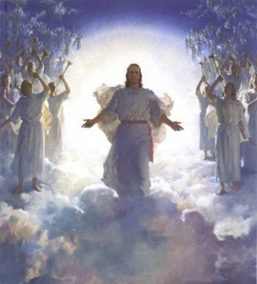
- They believe that Jesus' resurrection or coming alive shows that death is not the end of everything
How Christians celebrate on Easter Sunday?

- Many go to church to thank God for Jesus' life. Church bells are rung and churches are decorated with flowers such as white lilies which are associated with Easter.
- The colours in the church change to white or gold which are thought to be the best colours.

Key Parts of Easter

The Fair Trade Story and Traidcraft

At this time of year many people give chocolate as gifts, its important at this time to think about those who make this possible.
- Fair trade is about transformation and new life – just like the Easter story.
- Fair trade is about better prices, decent working conditions, local development and fair trading practices for farmers and workers in the developing world.

• Companies who support Fairtrade have to pay sustainable prices which will mean that producers always get a fair price for the things they’ve grown or made.
• Normal trading practices are often unfair and mean that poor farmers aren’t paid as much as they should be for their goods. Fair trade helps poor people to have more control over their lives, earn more money and work their way out of poverty.
• Traidcraft is a fair trade organization working with producers all over the developing world to help them flourish. They sell products, like the chocolate eggs that you’re eating now, which have come from some of the world’s poorest producers, and they have a charity which helps these producers to grow stronger.

What can you do?
Let’s think about what you could do If you have been inspired by the work of Traidcraft there are loads of things that you can do to support us.
- Why not get the group to use their talents to raise funds for Traidcraft?
- Perhaps you have an amazing baker or musician in your group. You could hold a Traidcraft Big Brew cake sale to raise funds and invite all of your families and friends.
- Pay it forward, by creating a Fair trade tuck shop

Who Benefits?
Stephanie is ten years old and lives on the Ivory Coast, in North West Africa. Her parents farm some of the cocoa used in Traidcraft’s More than just chocolate. Stephanie has been in school for six years now and she’s one of the brightest children in her village.
But cocoa farming’s not the future for Stephanie, she has much bigger plans.
“I want to be a scientist, to make sure the cocoa grows better and my mother and father don’t have to work so hard in the future.”
Science is already providing Traidcraft’s farmers with improved seed for better yields. The co-op is currently deciding how to use their Fairtrade Premium, and there is talk of a village water supply, bridges and a tractor to get cocoa from the farms to the co-op in the rainy season, and the recruitment of another 100 farmers to the co-op, with a focus on women – the premium will pay for their training.
Farmers in the Cote D’Ivoire often tell visitors from Traidcraft of their hopes for their children, hopes which they know can only be met through education, and took pride in telling us that all their children were in school.
With Traidcraft’s help thousands of people like Stephanie are seeing their incomes rise and their lives transformed.

Fairtrade Tuck Shop Idea

It could be great while we have time, to think about a way that you could help support fair trade. Why don’t you think about something that would benefit your group or community linked to fair trade. One Idea is to think about setting up a fair trade tuck shop.

- Think about your plan what to sell e.g. fruit, snack bars, biscuits, dried fruit snacks, juices, etc.
- Where can you get these – perhaps not supporting the large supermarket is a good plan in keeping with questioning the trade rules!
- Try the Traidcraft shop website…
http://www.traidcraftshop.co.uk/c-209-fair-trade-food-and-drink.aspx
where a discount is given to schools.

Posters and Prices:
You will need to make:
- Posters should be made to advertise tuck shop as well as give some information on Fairtrade.
- Price cards should be made so people know what each product costs.

Think about your audience as you create these items. Will the Beavers understand their poster? Can they read the prices? Are these clear?

Accounts:
You will need to be in charge of the accounts.
You will need to:
- Decide the pricing ensuring they are covering costs.
- Discuss what mark-up is appropriate (if any).
- Keep track of money spent and money taken. This needs to be written down and provided as a written record.

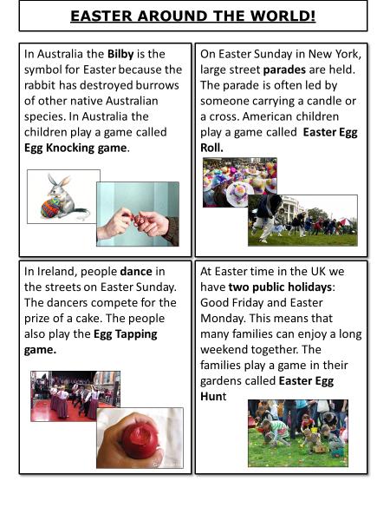
How is Easter celebrated in other countries across the world?

In what ways is it the same as in the UK and in what ways is it different.

Holy Week

Keep a diary of Holy Week from the point of view of a disciple, an onlooker or a Roman soldier.

Palm Sunday
Maunday Thursday
Good Friday
Easter Day

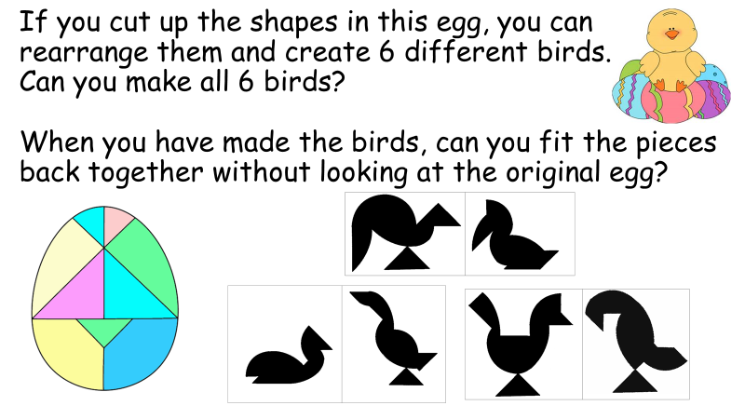

True or False

Are these statements about Easter true or false.

- Peter betrayed Jesus with a kiss.
- Mary Magdelene found the empty tomb.
- Jesus rose from the dead on Ascension Day.
- Judas fell asleep while Jesus was praying in the Garden of Gethsemane.
- The cockerel crowed four times when Peter denied knowing Jesus.
- After he died, Jesus appeared to his disciples many times.
- On Palm Sunday, people waved palm branches in the air.
- There were thirteen disciples.
- They ate the Last Supper on Maunday Thursday.
- Jesus was crucified on a Friday.

You could use your knowledge of Easter to plan a meeting for a younger section about the Easter Story, with activities such as:

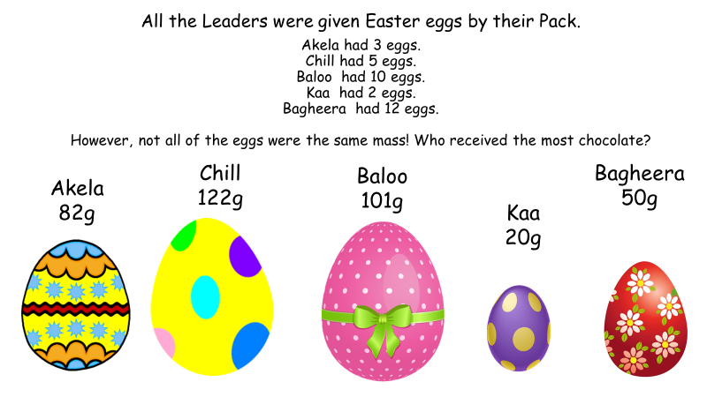

, and each stand for a different single digit.
+ =
is bigger than
is bigger than
What could , and be each time?

