Weekly Program
Week 3
Activity Booklet
Skills

Dear All,
While we currently are unable to meet each week Thames Ridge will be producing a weekly program pack for you to share with each section offering a range of activities and challenges to keep us all scouting during this difficult time.
We will be using this to support all the young people in their continued efforts to work towards their top awards and to offer comfort to those whom scouting forms a vital part of their weekly routines. We will endeavour in this time to ensure no young person misses out on the values and support scouting provides.
If you have any suggestions of questions relating to what we are offering please send in your thoughts to ddc-program@thamesridgescouting.org.uk also please send in any photos of the activities that have been produced by your group for us to share with others in the district group.
Yours in Scouting
The District Team

Opening Ceremony
Build a flagpole and make a flag to use on it to start your opening ceremony, take a picture/video and send it to your leader.

Activity 1

Explain why eating a sensible diet and getting enough sleep is important to us currently during the lock down. What could we do to make sure we eat the right foods and get the right balance of rest and activity.

Learn some new skills
Helping around the home is important at this time, it helps keep you active and will help out your family at this difficult time. By helping around the home, you will also learn some new skills. Pick 5 skills from the list below and get your parents to take pictures of you completing them then send them to your leader.
- Mend or customise an item of clothing
- Cook and serve a two-course meal, for at least four people
- Fix a puncture or a dropped chain on a bike
- Wash up after a meal, making sure everything is clean and dry
- Use a washing machine to wash a load of clothes
- Iron your uniform shirt
- Change a lightbulb, in a ceiling light
- Set a heating timer and thermostat as needed for the time of year
- Clean a toilet, hob or oven
- Do another similar home skill

Drug Awareness

Do some research so that you can explain the dangers and harmful effects of smoking, alcohol and drugs. You need to find out some graphs and statistics as well as some key facts about their use.

You should make a PowerPoint, poster, video or story board to show to a younger section to highlight the dangers of taking drug.

Remember the age range you are aiming this for

what type of graphics or characters could you use to keep them engaged

think about the use of language

Keep fit and active
Over the next 6 weeks you need to record when you have done 4 of some of the following types of exercise, you need to be doing one a day.
- circuit training
- football skills
- aerobic routine
- Zumba aerobics
- tap dancing
- long distance cycle ride
- hike
- dance

Activity | Week 1 | Week 2 | Week 3 | Week 4 | Week 5 | Week 6

Write a story or make use pictures to tell a story about a day in isolation, what are the good things and what are the things you want to remember about this time

Take a Trip
Explore the world take a virtual tour. Post on Facebook or send an email to Akela listing 5 interesting things you learnt on your visit.
- Ancient Rome Virtual Tour with Lessons
- Anne Frank House Virtual Tour
- Atlanta Zoo Panda Cam
- Berlin Philharmonic: Digital Concert Hall
- British Museum London
- Buckingham Palace
- Clearwater Marine Aquarium (home of Winter the dolphin)
- Discovery Virtual Field Trips
- Duke Farms Eagle Cam: New Jersey
- Eiffel tower virtual tour
- Explore.Org Live Cams
- FarmFood 360
- Field Museum: Chicago
- Great Wall of China 360
- Great Wall of China Virtual
- Great Pyramids
- Houston Zooj
- Kansas City Zoo Animal Cams
- Kennedy Center Digital Stage
- Liberty Science Center: New Jersey
- Louvre Museum
- Marine Traffic Around the World
- Musee d’Orsay, Paris
- NASA Mission Operations Room
- National Air & Space Museum – Smithsonian
- National Aquarium Live Cams: Baltimore
- National Aquarium Virtual Tour: Baltimore
- National Aquarium: Washington
- Natural History Museum London Virtual Tours
- National Museum of Modern and Contemporary Art, Korea
- National Park Service Virtual Tours (multiple options)
- Paris Museum Collections: Images and Tours
- San Diego Zoo
- Tate Modern UK Virtual Tours
- VanGogh Museum: Amsterdam
- Washington DC Architecture

Can you find out who sits where?

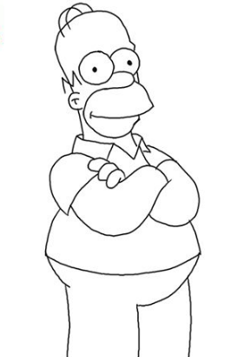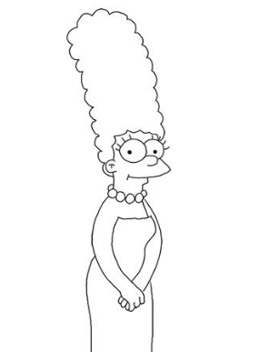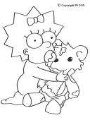
CLUES
- Grandpa does not sit at the ends of the table
- Bart sits between Homer and Maggie
- Maggie sits next to Grandpa but NOT next to Homer
- Lisa sits opposite Homer
- Grandpa sits between two females

Can you solve The Simpsons Challenge? Remember!
GUESS-CHECK-IMPROVE!!!

Find your way
Why don’t you try to create a problem-solving activity for a younger section

Closing Ceremony
Lower the flag you have made to signal the end of your scout meeting.

Scouting at Home
What else can I do to link my activities to scouting?
Below is a list of some other activities that we could try to show the different skills we have through scouting, link to the international theme.
Skill | Description | Achieved
communicator | Make a video diary of a day in your life that you could send to another scout in a different country.
International | Video yourself taking part in a traditional craft of creative activity from another country.
Science | Carry out a science experiment
Physical Recreation | It’s an important to exercise even when you’re stuck at home. Make a video showing how you warm up in order keep fit in your house. Remember to use all your muscles!
Entertainment | Create video of you highlighting the importance of washing your hands
Chef | Plan, cook, serve and clear away a 2-course meal for your family.
Cyclist | Go on a bike ride around your local area

Please keep scouting and send in pictures of all you achieve to the group and district so we can all share in each other’s accomplishments.

Yours in Scouting
GSL

