Scouting Program
Activity Booklet
St Georges Day

Dear All,
While we currently are unable to meet each week Thames Ridge will be producing a weekly program pack for you to share with each section offering a range of activities and challenges to keep us all scouting during this difficult time.
We will be using this to support all the young people in their continued efforts to work towards their top awards and to offer comfort to those whom scouting forms a vital part of their weekly routines. We will endeavour in this time to ensure no young person misses out on the values and support scouting provides.
If you have any suggestions of questions relating to what we are offering please send in your thoughts to ddc-program@thamesridgescouting.org.uk also please send in any photos of the activities that have been produced by your group for us to share with others in the district group to photos@thamesridgescouting.or.uk
Yours in Scouting
The District Team

Who is St George?
- St George is the patron Saint of England
- There are many stories about St George and ot all of them are true.
- Let us look at some of the facts and fictions about his life.

What are the facts?
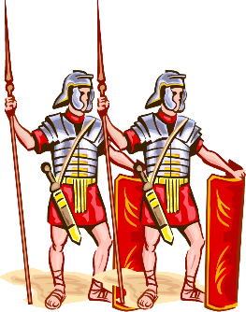

- George was born in a country that is now called Turkey nearly two thousand years ago. His parents were Christians and his father was a soldier. When George was old enough he joined the Roman army.
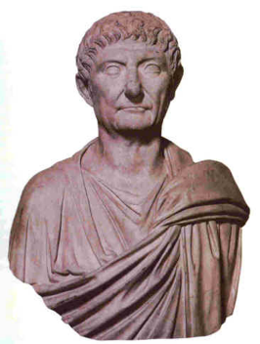
- George was a very good soldier and he was put in charge of many other soldiers. He was sent to a place called Nicomedia as a special guard to the Emperor Diocletian.
- Diocletian was not a kind emperor. He did not like Christians (people who prayed to Jesus) and made an order that they were all to be killed.
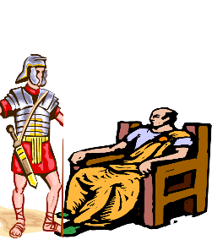
- George was ordered to kill Christians but he would not do it. He told the emperor that he was wrong to order him to and that he was a Christian too.
- The Emperor was very angry and ordered George to be killed.
He died on 23rd April.
- Many people heard how brave George was, they became Christians too. For hundreds of years people in different countries all over the world heard about George
What that meant?

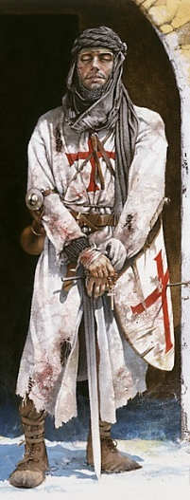
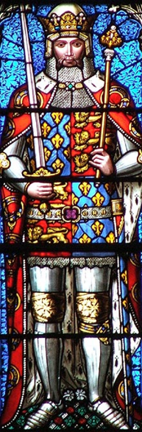
- After he died, George was called Saint George, which is a name given to some Christians to show they are special. All over the world’s churches were built and named after him.
- When English soldiers went to fight in different countries they heard about Saint George. They wore red crosses on their clothes and shields and called it the cross of Saint George.
- Over a thousand years ago The King of England, Edward the third ordered that Saint George should be the special Saint for England. He had a church built near his castle. The Queen still uses it today.
- Stories began to be told about Saint George. These stories were not true but some people believed them.
George and the Dragon?
What about the fiction or Myths?

- Once upon a time, there lived a very brave knight called George. He travelled through many lands on his horse until he came to a country called Libya. Here he met an old man who told George he was very frightened of a fierce dragon who had scared everyone
- The old man told George how the people in the village had given the dragon a pretty girl every day until there was just Princess Sabra, the Kings daughter left. She was to be given to the dragon the next morning unless a brave knight could kill it first.
- George was a very brave knight. He decided he would fight the dragon to stop it taking the princess.
- He found the dragon in a cave and he fought a long hard battle. His spear was broke into a thousand pieces on the dragons hard scales. George fell off his horse but used his sword to pierce the dragon’s skin under his wing and the dragon was killed.
- Everyone cheered when George killed the dragon. Their village was safe once again, this was the last dragon alive so no more people would be killed.
- George had been so brave the people of Libya made him a saint. He is now known as Saint George.
Whatever the truth everyone knows St George?

- In England we remember St. George on 23rd April every year. This is known as St. George’s Day.
- England’s flag is called the St. George’s Cross. It is a white flag with a red cross on it.
- All around England there are many statues of St. George and some churches, hospitals and schools are named after him.
- Other countries have St. George as their patron Saint too as they also think he was very brave.

Can you crack the code?

St Georges Day Colouring

The Story of Easter

Make a St George’s Day Cake

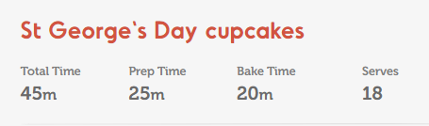

How is Easter celebrated in other countries across the world?
In what ways is it the same as in the UK and in what ways is it different.
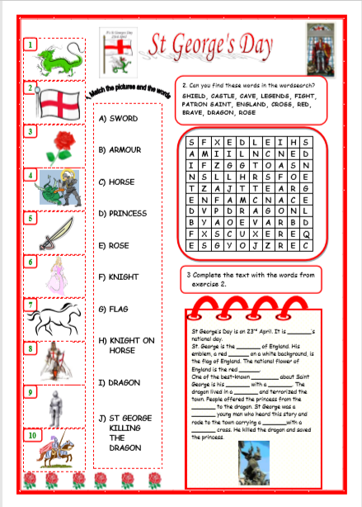

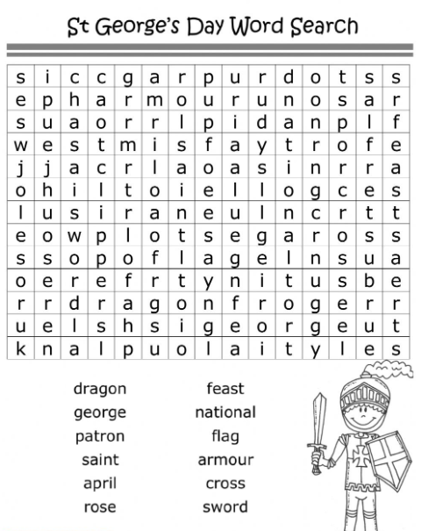

Design your own shield

