Scouting Program
Activity Booklet
Easter

Dear All,
While we currently are unable to meet each week Thames Ridge will be producing a weekly program pack for you to share with each section offering a range of activities and challenges to keep us all scouting during this difficult time.
We will be using this to support all the young people in their continued efforts to work towards their top awards and to offer comfort to those whom scouting forms a vital part of their weekly routines. We will endeavour in this time to ensure no young person misses out on the values and support scouting provides.
If you have any suggestions of questions relating to what we are offering please send in your thoughts to ddc-program@thamesridgescouting.org.uk also please send in any photos of the activities that have been produced by your group for us to share with others in the district group.
Yours in Scouting
The District Team

What is Easter?
- Easter is the most important Christian festival.
- Christians are followers of Jesus Christ who lived about 2000 years ago in a country called Palestine. They believe that Jesus was the son of God.
- At Easter time Christians remember the last week of Jesus' life.

Where does Easter get it’s name from?

- One belief is that Easter got its name from the Goddess of Spring called Eostre who some people worshipped long before Jesus was born.
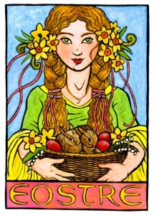
- At that time it was thought that the sun died in winter and was born again in spring when days would lengthen and the sun’s power would return.
- In Europe, Eostre was honoured as the bringer of spring.
When is Easter?

- Easter Day is always on a Sunday, but the date varies from year to year (unlike Christmas which is always on December 25).
- Many years ago Christians decided that Easter Day should be always be on the Sunday following the first full moon after the first day of Spring on March 21.
- This means that Easter can be as early as 22 March or as late as 25 April. For this reason Easter is called a movable feast.
What have eggs got to do with Easter?
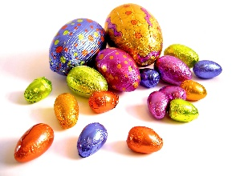

- The custom of giving eggs at Easter is celebration of new life.
- Eggs were always thought to be special because although they do not seem alive, they have life within them especially at springtime when chicks hatch out.
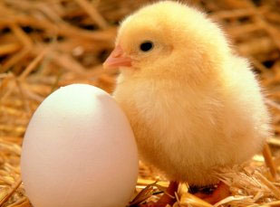
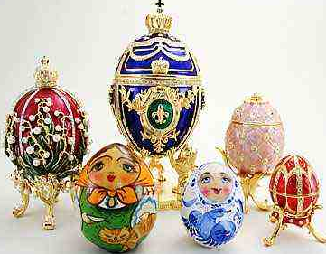
- Long ago people gave gifts of eggs carved from wood or precious stones.

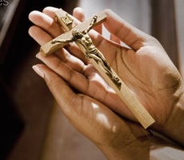
What is Good Friday?
(Apart from a holiday)
- On Good Friday Christians remember the day that Jesus was killed on the cross by Roman soldiers.
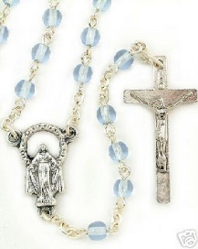
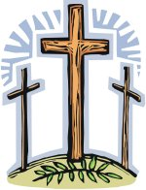
- This is the reason why the cross is an important sign for Christians today. There are crosses in churches and many Christians wear a cross on a chain.
Why is it called Good Friday?

- It is known as Good Friday because Christians believe that Jesus gave up his life for the good of everyone.
- At Easter people eat hot cross buns which have a cross shape on the top.
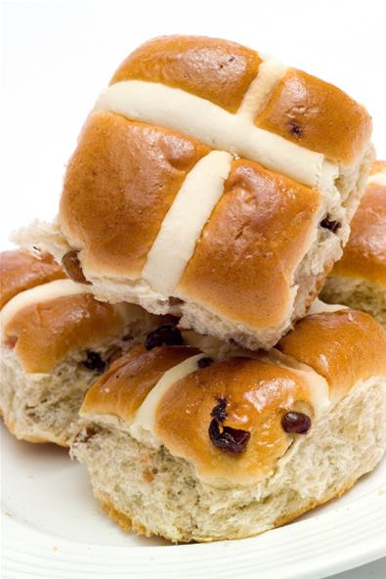
- Good Friday is a sad day and churches never have flowers or decorations on this day. The church is left dark and there is just a simple cross on the altar.
What do Christians celebrate on Easter Sunday?
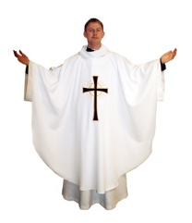

- Easter Sunday is a happy day for Christians because they believe that Jesus rose from the dead and ascended into heaven on this day
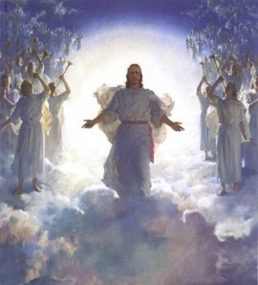
- They believe that Jesus' resurrection or coming alive shows that death is not the end of everything
How Christians celebrate on Easter Sunday?

- Many go to church to thank God for Jesus' life. Church bells are rung and churches are decorated with flowers such as white lilies which are associated with Easter.
- The colours in the church change to white or gold which are thought to be the best colours.

The Story of Easter
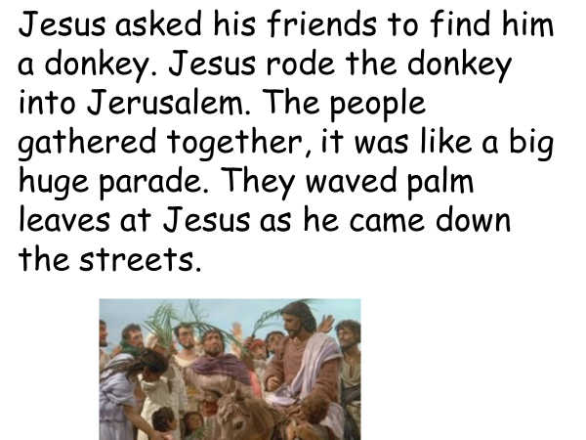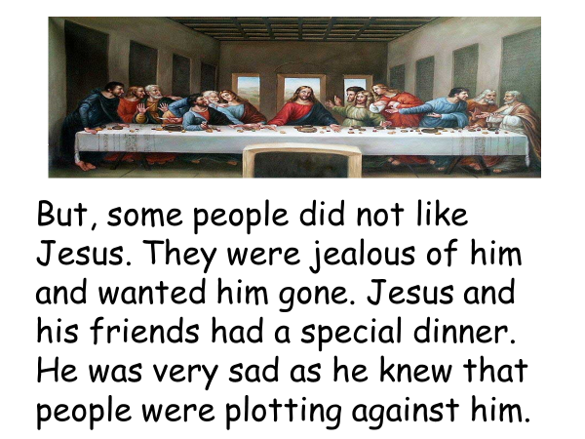
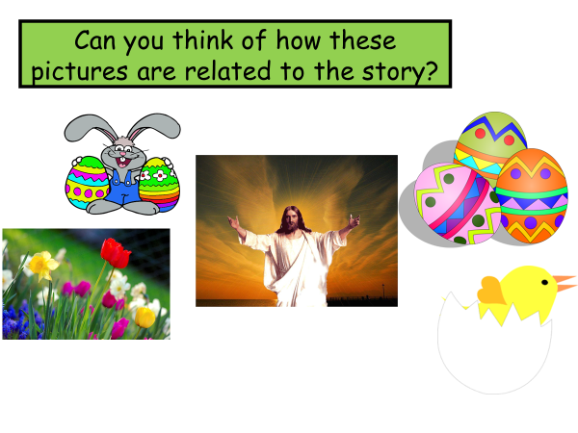
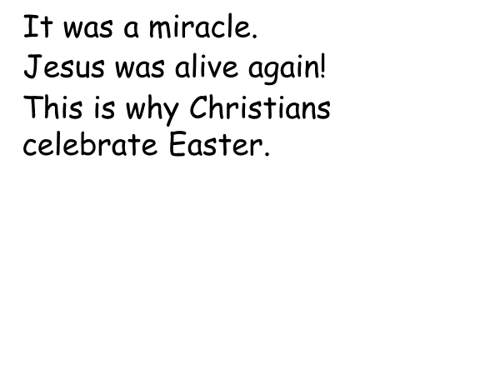
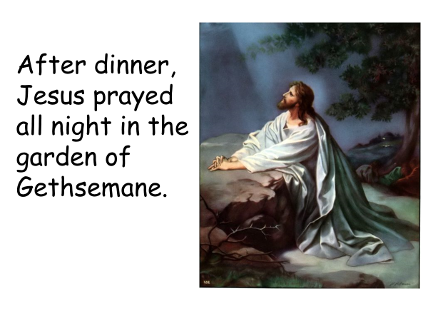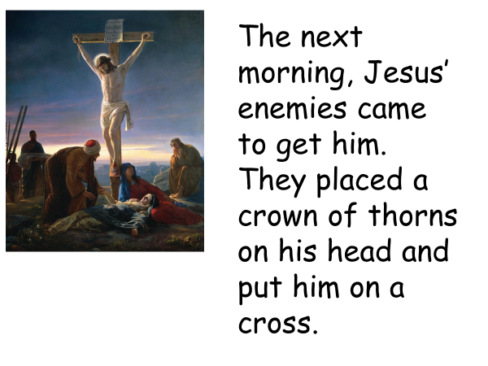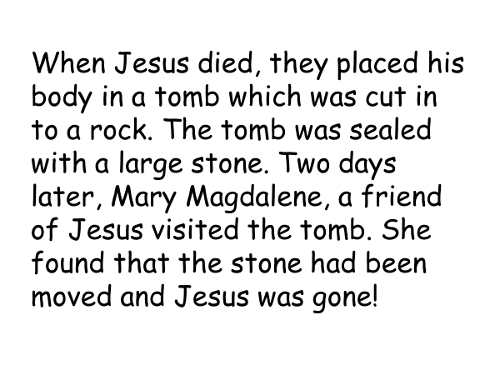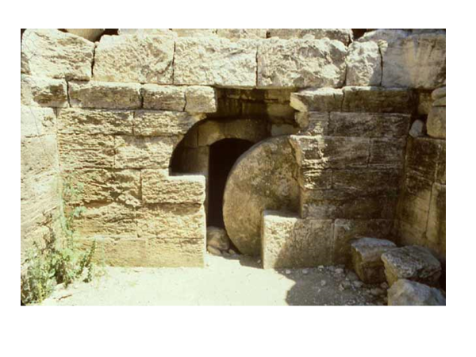

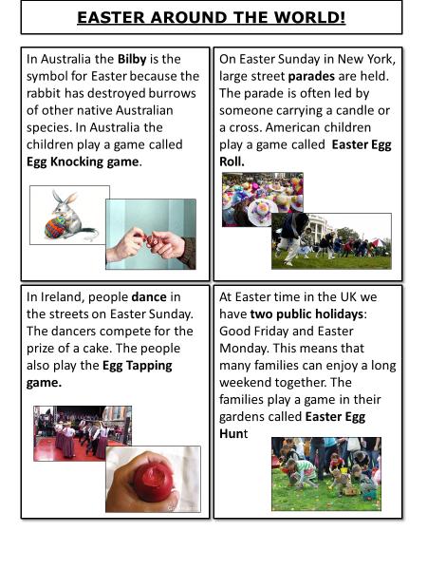
How is Easter celebrated in other countries across the world?
In what ways is it the same as in the UK and in what ways is it different.

Easter sequencing activity
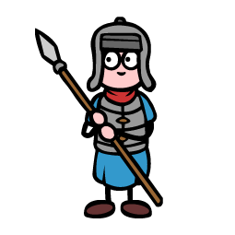
Put the events into the correct order
The soldiers seized Jesus and arrested him.
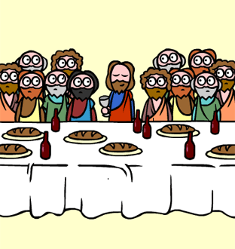
Jesus ate the Passover meal with his disciples, breaking bread and drinking wine, this is now known as the last supper. Jesus told the disciples that one of them would betray him.
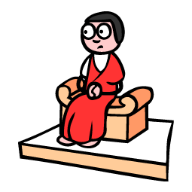
Jesus is tried and is sentenced to death.
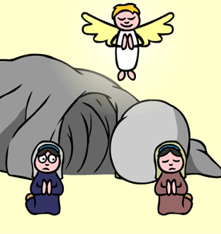
Mary went to the tomb followed by some disciples. They discovered that Jesus’ body had gone and the tomb was empty. An angel appeared and told Mary that Jesus had risen.
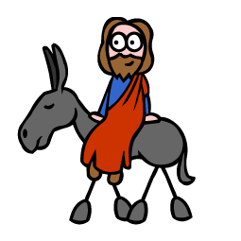
Jesus arrived in Jerusalem riding on a donkey. Crowds of people came to greet him.
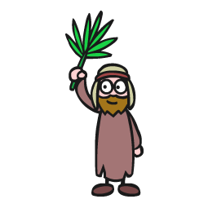
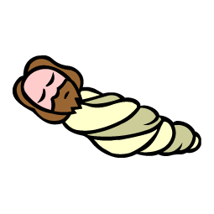
As Jesus rode past the people they waved palm branches at him and laid them on the floor.

Jesus’ body is taken to the tomb.
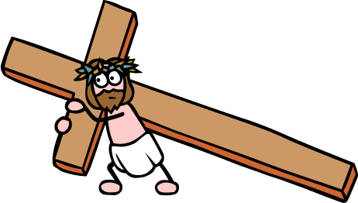
Jesus had to carry his own cross out of the town to a nearby hill.

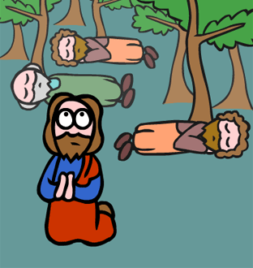
Jesus and his disciples went to the Garden of Gethsemane to pray.
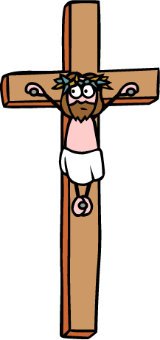
Jesus is nailed to the cross and dies
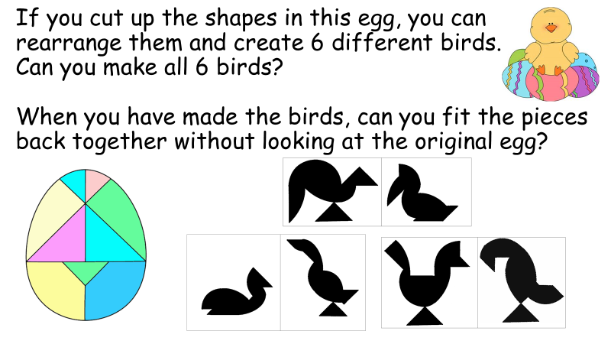

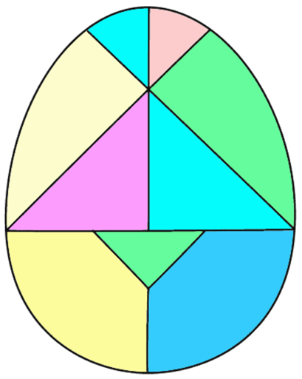
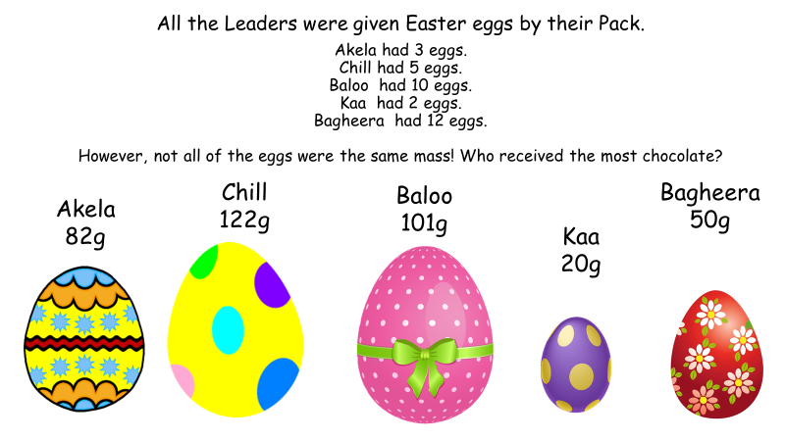

, and each stand for a different single digit.
+ =
is bigger than
is bigger than
What could , and be each time?

