Weekly Program
Week 2
Activity Booklet
International

Dear All,
While we currently are unable to meet each week Thames Ridge will be producing a weekly program pack for you to share with each section offering a range of activities and challenges to keep us all scouting during this difficult time.
We will be using this to support all the young people in their continued efforts to work towards their top awards and to offer comfort to those whom scouting forms a vital part of their weekly routines. We will endeavour in this time to ensure no young person misses out on the values and support scouting provides.
If you have any suggestions of questions relating to what we are offering please send in your thoughts to ddc-program@thamesridgescouting.org.uk also please send in any photos of the activities that have been produced by your group for us to share with others in the district group.
Yours in Scouting
The District Team

Opening Ceromony
Build a flagpole and make a flag to use on it to start your opening ceremony, take a picture/video and send it to your leader.

Activity 1
Pick a country and write out how to say your name and 4 things about yourself and your family in the language used there. Then film yourself practicing speaking that language and send to your leader.
Scavenger hunt
Find the following things around your house and take a picture and send to your leader
- Something Blue
- Something Soft
- An Animal
- Something You Made
- Something That Makes You Smile
- A Plant
- Something Noisy
- Something Special to You
- A Book.

Activity 2
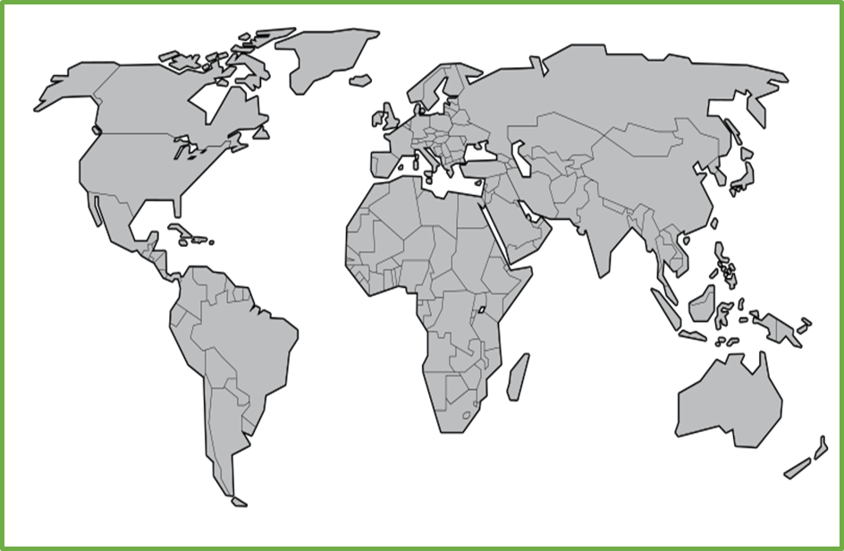

Colour in all the different countries where scouting takes place

Find out about the world scout movement and make a timeline of some of the key moments in its history. Did scouting start at the same time in every country?

Take a Trip
Explore the world take a virtual tour.
Post on Facebook or send an email to your leader listing 3 interesting things you learnt
- Ancient Rome Virtual Tour with Lessons
- Anne Frank House Virtual Tour
- Atlanta Zoo Panda Cam
- Berlin Philharmonic: Digital Concert Hall
- British Museum London
- Buckingham Palace
- Clearwater Marine Aquarium (home of Winter the dolphin)
- Discovery Virtual Field Trips
- Duke Farms Eagle Cam: New Jersey
- Eiffel tower virtual tour
- Explore.Org Live Cams
- FarmFood 360
- Field Museum: Chicago
- Great Wall of China 360
- Great Wall of China Virtual
- Great Pyramids
- Houston Zooj
- Kansas City Zoo Animal Cams
- Kennedy Center Digital Stage
- Liberty Science Center: New Jersey
- Louvre Museum
- Marine Traffic Around the World
- Musee d’Orsay, Paris
- NASA Mission Operations Room
- National Air & Space Museum – Smithsonian
- National Aquarium Live Cams: Baltimore
- National Aquarium Virtual Tour: Baltimore
- National Aquarium: Washington
- Natural History Museum London Virtual Tours
- National Museum of Modern and Contemporary Art, Korea
- National Park Service Virtual Tours (multiple options)
- Paris Museum Collections: Images and Tours
- San Diego Zoo
- Tate Modern UK Virtual Tours
- VanGogh Museum: Amsterdam
- Washington DC Architecture

World Scouting Celebrations
Name some events held across the globe that celebrate world scouting:

Write about what happens at one of these events.

Closing Ceremony
Lower the flag you have made to signal the end of your scout meeting.

Scouting at Home
What else can I do to link my activities to scouting?
Below is a list of some other activities that we could try to show the different skills we have through scouting, link to the international theme.
Skill | Description | Achieved
communicator | Make a video diary of a day in your life that you could send to another scout in a different country.
International | Video yourself taking part in a traditional craft of creative activity from another country.
Science | Carry out a science experiment
Physical Recreation | It’s an important to exercise even when you’re stuck at home. Make a video showing how you warm up in order keep fit in your house. Remember to use all your muscles!
Entertainment | Create video of you highlighting the importance of washing your hands
Chef | Plan, cook, serve and clear away a 2-course meal for your family.
Cyclist | Go on a bike ride around your local area

Please keep scouting and send in pictures of all you achieve to the group and district so we can all share in each other’s accomplishments.

Yours in Scouting
GSL

