Scouting Program
Badge Booklet
Environmental Conservation
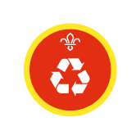
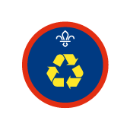

Environmental Conservation at Home:
The at home challenges:
- Make a poster explaining the separation of recyclable and non-recyclable rubbish
- Take a series of photos and create a real-life comic story on recycling
- Make a video explaining recycling
- Write a check list of how recycle
- Take pictures and email them to your leader
- Find out how to reduce the energy and water you use in your home
- Write about all the ways that we should try to reduce electricity use in the home
- Write about things we could do to save water use in the home
- Create a resource that you can share with your pack about one type of renewable energy
- Make a poster on a type of renewable energy
- Make a PowerPoint on a type of renewable energy
- Make a game about a type of renewable energy
- Design an environmentally friendly piece of land, bird feeder, bird table or nesting box
- Design on paper or digitally
- Explain the features you have added
- Send a copy to your leader
Leader Advice:
These activities should be enough to allow the Young People to achieve their environmental conservation badges for these sections.
- Lots of these activates can involves the usage of internet so YP should be briefed on online safety beforehand
- If you wish to direct any letters of advice regarding how our District could improve our Environmental footprint, please send them to the District Youth Commissioner
Environmental Conservation at Home:
The at home challenges:
- Find out about an environmental issue that is important in your community it could be linked to:
- Recycling and conservation
- Energy efficiency in the home
- The building of new homes and local land use
- Water, light, thermal, air or beach pollution
- Coastal erosion
- The impact of tourism on the local environment
- Develop a project that improves local conservation you could look at:
- Recycling
- Reducing energy usage or renewable
- Protecting important habitats or wildlife
- Pollution
- Erosion
- Flooding
- Start getting involved in a campaign to make others aware of an environmental issue you could:
- You could write to local agencies or record a video to them
- These could be directed to District thinking about how our District could improve our environmental footprint
Leader Advice:
These activities should be enough to allow the Young People to achieve their environmental conservation badges for these sections.
- Lots of these activates can involves the usage of internet so YP should be briefed on online safety beforehand
- If you wish to direct any letters of advice regarding how our District could improve our Environmental footprint, please send them to the District Youth Commissioner

