Weekly Program
Week
Activity Booklet
International

Dear All,
While we currently are unable to meet each week Thames Ridge will be producing a weekly program pack for you to share with each section offering a range of activities and challenges to keep us all scouting during this difficult time.
We will be using this to support all the young people in their continued efforts to work towards their top awards and to offer comfort to those whom scouting forms a vital part of their weekly routines. We will endeavour in this time to ensure no young person misses out on the values and support scouting provides.
If you have any suggestions of questions relating to what we are offering please send in your thoughts to ddc-program@thamesridgescouting.org.uk also please send in any photos of the activities that have been produced by your group for us to share with others in the district group.
Yours in Scouting
The District Team

Grand Howl
Create an opening ceremony with your family and toys, teach them how we start a cub meeting and take a picture/video to send to Akala.

Activity 1
Pick a country you have visited or would like to visit and draw their flag

Scavenger hunt
Find the following things around your house and take a picture and send to Akela
- Something Blue
- Something Soft
- An Animal
- Something You Made
- Something That Makes You Smile
- A Plant
- Something Noisy
- Something Special to You
- A Book.
Activity 2
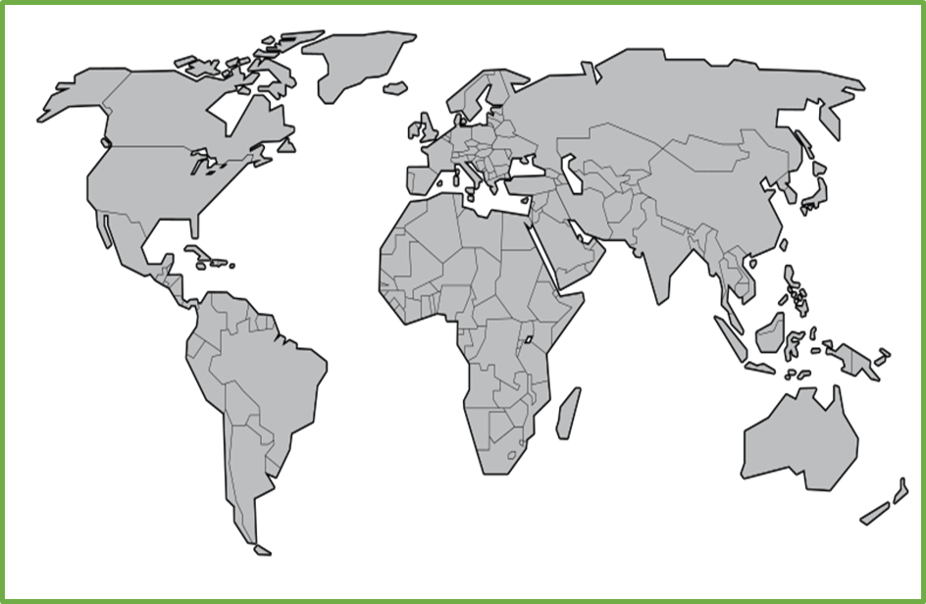
Find and colour the country you have chosen.
What is the national dress of the country? Draw a picture

What food is eaten there:

Take a Trip
Explore the world take a virtual tour.
Post on Facebook or send an email to Akela listing 3 interesting things you learnt
- Ancient Rome Virtual Tour with Lessons
- Anne Frank House Virtual Tour
- Atlanta Zoo Panda Cam
- Berlin Philharmonic: Digital Concert Hall
- British Museum London
- Buckingham Palace
- Clearwater Marine Aquarium (home of Winter the dolphin)
- Discovery Virtual Field Trips
- Duke Farms Eagle Cam: New Jersey
- Eiffel tower virtual tour
- Explore.Org Live Cams
- FarmFood 360
- Field Museum: Chicago
- Great Wall of China 360
- Great Wall of China Virtual
- Great Pyramids
- Houston Zooj
- Kansas City Zoo Animal Cams
- Kennedy Center Digital Stage
- Liberty Science Center: New Jersey
- Louvre Museum
- Marine Traffic Around the World
- Musee d’Orsay, Paris
- NASA Mission Operations Room
- National Air & Space Museum – Smithsonian
- National Aquarium Live Cams: Baltimore
- National Aquarium Virtual Tour: Baltimore
- National Aquarium: Washington
- Natural History Museum London Virtual Tours
- National Museum of Modern and Contemporary Art, Korea
- National Park Service Virtual Tours (multiple options)
- Paris Museum Collections: Images and Tours
- San Diego Zoo
- Tate Modern UK Virtual Tours
- VanGogh Museum: Amsterdam
- Washington DC Architecture

Celebrations
Name some festivals for your country and what religion they are from:

Draw a picture that represents the Festival.

Can you explain what happens at the Festival?

Closing Ceremony
Practice grand howl again to end your meeting
Scouting at Home
What else can I do to link my activities to scouting?
Below is a list of some other activities that we could try to show the different skills we have through scouting, link to the international theme.
Skill | Description | Achieved
communicator | Make a video diary of a day in your life that you could send to another cub
International | Create the world scout badge out of materials in your home and take a picture to show your leader
Science | Carry out a science experiment
Athletics | It’s an important to exercise even when you’re stuck at home. Make a video showing how you warm up in order keep fit in your house. Remember to use all your muscles!
Entertainer | Create video of you singing while you wash your hands.
Chefs | Plan, cook and serve a balanced 2 course meal for your family
Cyclist | Go on a 5 mile bike ride around your local area

Please keep scouting and send in pictures of all you achieve to the group and district so we can all share in each other’s accomplishments.

Yours in Scouting
GSL

