Weekly Program
Week 1
Activity Booklet
Science and Nature
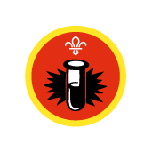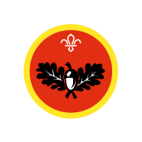

Dear All,
While we currently are unable to meet each week Thames Ridge will be producing a weekly program pack for you to share with each section offering a range of activities and challenges to keep us all scouting during this difficult time.
We will be using this to support all the young people in their continued efforts to work towards their top awards and to offer comfort to those whom scouting forms a vital part of their weekly routines. We will endeavour in this time to ensure no young person misses out on the values and support scouting provides.
If you have any suggestions of questions relating to what we are offering please send in your thoughts to ddc-program@thamesridgescouting.org.uk also please send in any photos of the activities that have been produced by your group for us to share with others in the district group.
Yours in Scouting
The District Team

Candle Fizz
The Experiment
What is the effect of Bicarbonate of Soda and Vinegar on a Candle Flame?
Instructions:
1. Take a bowl and place a tealight candle in the centre.
2. Put about ½ to 1 teaspoon of Bicarbonate of Soda into the bowl.
3. Pour over enough vinegar to cover the Soda.
4. Watch what happens to the candle flame.

The Science
If you look closely (it helps to repeat the experiment a few times) you might notice that the flame is extinguished from the bottom of the wick. This is the key to the experiment and what we are hoping to identify. What is happening is a simple chemical reaction between the Vinegar and the Bicarbonate of Soda, the outcome of which is Carbon Dioxide (CO2) gas being released into the bowl. The gas is denser than the air surrounding it, so it does not get released into the atmosphere like one might expect. Instead, the gas will pool like a liquid until it fills the bowl up to the point whereby it flows over the candle and displaces the Oxygen the flame requires to remain alight. Hence the flame is extinguished from the bottom up, as though a liquid was poured into the bowl. This experiment can also be conducted with the reaction being completed in a glass tumbler and the gas ‘poured’ onto the candle.

The Conclusion
What happens to the candle flame?

The Results

Why do you think this happens?

Salt and Water
The Experiment
Investigate what happens when you add Salt to Water
Instructions:
1. You will be given a cup of water and some salt.
2. Pour the salt into the water and stir.
3. Record your findings.

The Science
As we might expect, the salt is dissolved into the water and creates a new solution: Saltwater. The experiment shows that the chemical reaction of water dissolving something like salt can create a solution that looks just like clean drinking water, but is in fact something different that has its own unique properties (such as higher boiling and lower freezing temperatures than just water) and is not nice to drink. The experiment can be extended to include things like food dye and sugar if you wish to show how show how the different densities of liquid can be visible for a short period and add more of the salt/sugar to show what happens when the water reaches its limit of solubility. This is a good experiment to lead on to showing different densities of liquids

The Conclusion
What happens to the Salt and the Water?

The Results

Why do you think this happens?

Compass
The Experiment
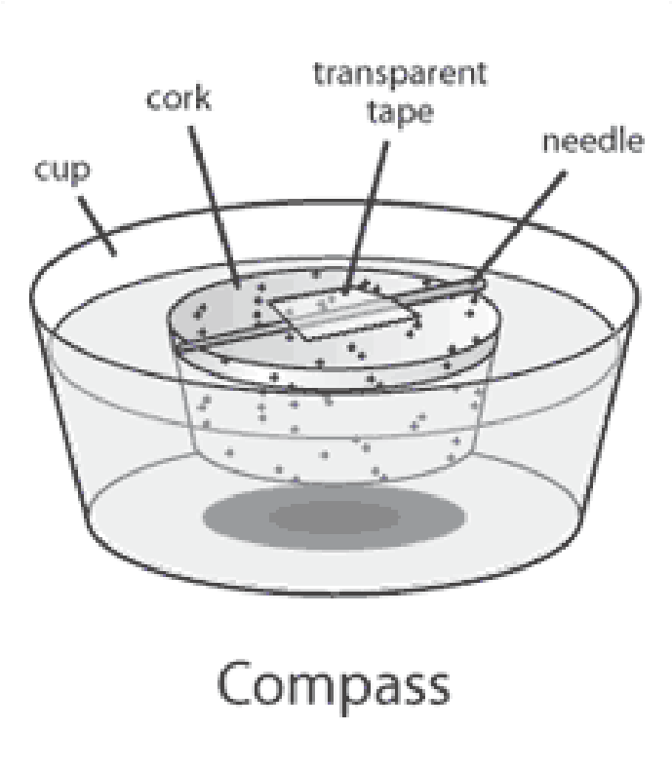
Make a Compass
Instructions:
1. You will be given some cork and a needle/paperclip.
2. Using the provided magnet, stroke the needle/paperclip in the same direction 40-60 times.
3. Secure the needle/paperclip on top of the cork.
4. Put the device into a bowl of water and observe what happens

The Science
Using the Magnet, the needle/paperclip is ‘magnetised’ and will now have some of the same behaviour as a magnet will. It will be attracted to other ferrous metal objects and will respond differently towards a magnet (try using different sides of the magnet to ‘push’ rather than ‘pull’ the object once it is magnetised). This sensitivity towards magnetic fields is the key ingredient to this experiment, as when left in a frictionless environment (such as when floating on water or suspended by a thread with nothing touching it) the object will ‘seek’ magnetic north. This is how a compass works. By moving a metal or another magnetic object near the needle/paperclip you should notice that the closer, stronger attraction is irresistible to it and it will seek that out in place of the earth’s magnetic force.

The Results
What happens to the device?

What happens when you move a magnet near the device?

Does the device behave in the same way as a shop-bought compass?

Growing both ends
The Experiment
Investigate growth of leaves and roots from a potato
Instructions:
1. Fill a drinking glass with water
2. Stick some cocktail sticks in the middle of the potato so they poke out
3. Put the potato into the drinking glass, the cocktail sticks will stop the potato touching the bottom of the glass. Make sure the bottom part of the potato is touching the water.
4. Leave it for a few days, the bottom of the potato will sprout roots, and leaves will grow out the top.

The Science
Potatoes are known as root vegetable; this means that they grow from the roots of the plants underground. They are an energy store, filled with glucose in the form of starch which is used by the plant to grow. As plants are totipotent, they can grow from a cell from the main plant, this means that the potato will grow a new potato plant in the right conditions.

The Results

The Conclusion
Track the growth of the plant making daily observations?

What conditions do you think are needed for a plant to grow?

Colourful Celery
The Experiment
Investigate how water moves through a plant
Instructions:
1. Cut 6 pieces of celery into pieces the same length, chop off the bottom and the leaves.
2. Fill each of the 6 drinking glasses with same amount of water and add 10 drops of food colouring to each glass.
3. Place one piece of celery in each glass.
4. After one hour remove one piece of celery from a beaker, peal the round part of the celery back and measure how far up the celery the coloured water has travelled.
5. Remove further pieces of celery every couple of hours and overnight and measure the movement of the water over time.
6. Record what you find below

The Science
Just like people plants need water to survive, plants get water from soil through their roots. Inside the plant are capillaries that allow the water to travel up the plant. Over a period of time the plant draws up the water from its roots to its leaves, this is called transpiration.

Why do you think this happens?

The Results

Scouting at Home
What else can I do to link science to scouting?
Below are a list of some other activities that we could try to show the different skills we have through scouting, link to the theme of science, nature and the environment.
Skill | Description | Achieved
Communicator | Change the lyrics of any song and sing it. Upload a video of you singing this  newly-adapted song
Artist | Create the scout logo out of recycled materials
Scientist | Carry out a science experiment
Naturalist | Make a feeding station for birds. Get permission to hang it in a good position.
Artist | Design a machine that could help us find a cure for a disease or remove pollution from the environment.
Artist | Learn how to identify 12 different living things, make a video or PowerPoint to show what you have found out
Naturalist | Design a frame out of natural materials and take a photo of it with the previously made recycled logo

Don’t forget to try one of our badge booklets to find out all that you will need to carry out to complete a badge, a different badge will be issued each week along with the weekly program.
This week we have the photography badge to link into our District photography competition.
Please keep scouting and send in pictures of all you achieve to the group so we can all share in each other’s accomplishments.

Yours in Scouting
GSL

