Weekly Program
Week 2
Activity Booklet
International

Dear All,
While we currently are unable to meet each week Thames Ridge will be producing a weekly program pack for you to share with each section offering a range of activities and challenges to keep us all scouting during this difficult time.
We will be using this to support all the young people in their continued efforts to work towards their top awards and to offer comfort to those whom scouting forms a vital part of their weekly routines. We will endeavour in this time to ensure no young person misses out on the values and support scouting provides.
If you have any suggestions of questions relating to what we are offering please send in your thoughts to ddc-program@thamesridgescouting.org.uk also please send in any photos of the activities that have been produced by your group for us to share with others in the district group.
Yours in Scouting
The District Team

Welcome
Put all your toys and family in a circle and shout out ‘WELECOME’ to start your own beaver meeting, take a picture and send it to your leader.

Activity 1
Pick 5 countries you have visited or would like to visit and draw their flags
Scavenger hunt
Find the following things around your house and take a picture and send to your leader
- Something Blue
- Something Soft
- An Animal
- Something You Made
- Something That Makes You Smile
- A Plant
- Something Noisy
- Something Special to You
- A Book.

Activity 2
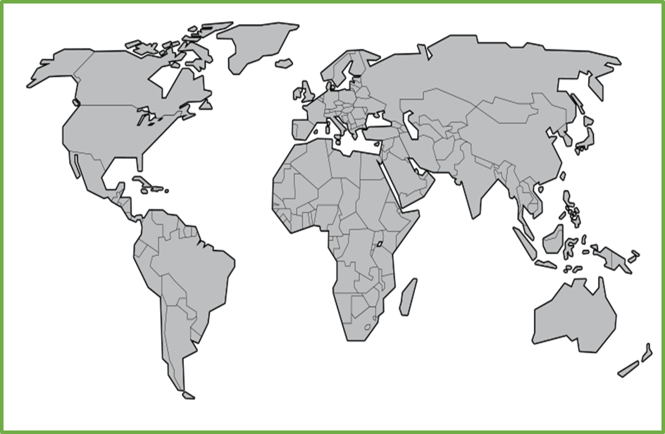
Colour in all the different countries you and your family have visited in one colour.
Colour in all the countries you would like to visit in another

Try different food from other countries and list your 3 favourites

Why have you chosen these foods?

Draw a picture of a beaver from a different country, what are the called and what is their promise.

Take a Trip
Explore the world take a virtual tour.
Post on Facebook or send an email to your leader listing 3 interesting things you learnt
- Ancient Rome Virtual Tour with Lessons
- Anne Frank House Virtual Tour
- Atlanta Zoo Panda Cam
- Berlin Philharmonic: Digital Concert Hall
- British Museum London
- Buckingham Palace
- Clearwater Marine Aquarium (home of Winter the dolphin)
- Discovery Virtual Field Trips
- Duke Farms Eagle Cam: New Jersey
- Eiffel tower virtual tour
- Explore.Org Live Cams
- FarmFood 360
- Field Museum: Chicago
- Great Wall of China 360
- Great Wall of China Virtual
- Great Pyramids
- Houston Zooj
- Kansas City Zoo Animal Cams
- Kennedy Center Digital Stage
- Liberty Science Center: New Jersey
- Louvre Museum
- Marine Traffic Around the World
- Musee d’Orsay, Paris
- NASA Mission Operations Room
- National Air & Space Museum – Smithsonian
- National Aquarium Live Cams: Baltimore
- National Aquarium Virtual Tour: Baltimore
- National Aquarium: Washington
- Natural History Museum London Virtual Tours
- National Museum of Modern and Contemporary Art, Korea
- National Park Service Virtual Tours (multiple options)
- Paris Museum Collections: Images and Tours
- San Diego Zoo
- Tate Modern UK Virtual Tours
- VanGogh Museum: Amsterdam
- Washington DC Architecture

Celebrations
Name some festivals from around the world and what religion they are from:

Draw a picture that represents one of the Festivals.

Can you explain what happens at the Festival?

Closing Ceremony
Put all your toys and family in a circle and shout out ‘GOODBYE’ to end your beaver meeting.
Scouting at Home
What else can I do to link my activities to scouting?
Below is a list of some other activities that we could try to show the different skills we have through scouting, link to the international theme.
Skill | Description | Achieved
communicator | Make a video diary of a day in your life that you could send to another beaver.
International | Video yourself performing a song or dance from a different country
Science | Carry out a science experiment
Health and Fitness | It’s an important to exercise even when you’re stuck at home. Make a video showing how you warm up in order keep fit in your house. Measure your heart rate before and after you do your exercise.
Creative | Create video of you singing while you wash your hands.
Health and Fitness | Learn about a variety of healthy foods and make a snack for yourself using some of these foods.
Cyclist | Go on a bike ride around your local area

Please keep scouting and send in pictures of all you achieve to the group and district so we can all share in each other’s accomplishments.

Yours in Scouting
GSL

